学校_______________班级 ____________ 姓名_________ 考号

2014-2015学年第二学期小学六年级英语期末测试题
2015.6（60分钟）

听力部分
I. Listen and choose.（听录音, 选出你听到的单词或词组。每小题读两遍。）10分
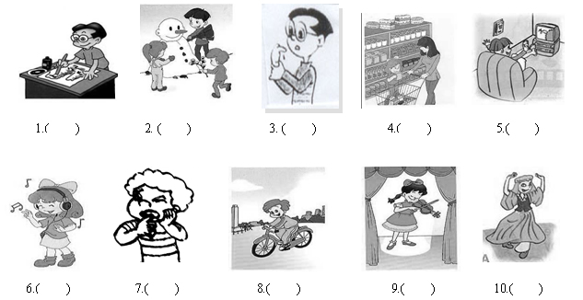
( ) 1. A. plant B. plane C. play
( ) 2. A. seed B. see C. sick
( ) 3. A. eat B. ate C. arm
( ) 4. A. math B. thin C. thank
( ) 5. A. prepare B. parent C. present
( ) 6. A. feel B. feet C. will
( )7. A. doctor B. hamburger C. worker
( ) 8 A. meter B. matter C. match
( ) 9. A. watches B. watched C. watch [来源:Z&xx&k.Com]
( ) 10. A. have a headache B. have a fever
C. have a toothache
II. Listen and choose.（听录音, 判断图片是否正确，“√”
或“×”。每小题读两遍。)10分
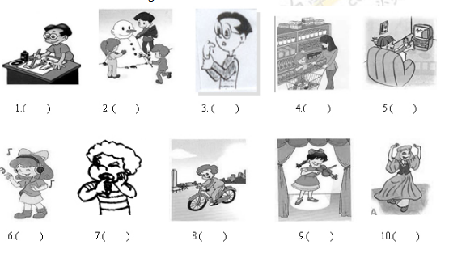

III. Listen and number. （听录音, 排序。每小题读两遍。）
5分
1.  2  3.

( ) ( ) ( )
4. 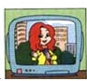 5.

( ) ( )
IV. Listen and answer.（为下列问句选择合适的答语。每小题读两遍。）10分
( ) 1. A. Yes, I can't. B. Yes, I can. C. No, I can.
( ) 2. A. They're yellow. B. It's green. C. It's 50 yuan.
( ) 3. A. She goes to school on foot.
B. She goes to the cinema on bus.
C. She goes to the hospital by bike.
( ) 4. A. It's summer. B. It's Monday. C. It's sunny.
( ) 5. A. We are happy. B. He's sick. C. You look sad.
( ) 6. A. Collecting stamps. B. Playing football.
C. Watching TV
( )7. A. 76cm. B. I wear size 35. C. I'm 50kg.
( )8. A. She did my homework yesterday.
B. Mike cleaned the table. C. She had a fever.[来源:学*科*网Z*X*X*K]
( )9. A. We're going to take a trip.
B. We read books. C. They rowed boats.
( )10. A. Yes, he did. B. No, he doesn't. C. No, he isn't.
V. Listen and write.（听录音，填入句子中所缺的单词，每题读两遍。)5分
1. We _____________many ___________on our holiday.
2. I was ___________yesterday. I had a ________________.[来源:学科网]
3. Jim ____________presents for his _____________.[来源:Z&xx&k.Com]
4. --- Did you go __________________ last weekend?
--- No, I _____________ hiking.
5.I can speak______________ and ________________ well.
笔试部分[来源:学+科+网Z+X+X+K]
VI. Read and choose.（读一读，选出不同类的单词。）5分
( ) 1.A．sunny B．windy C．rainy D．family
( ) 2. A . river B . eat C . worry D . stay
( ) 3. A .taller B . stronger C .heavy D . longer
( )4. A . third B . ninth C . eight D . twelfth
( ) 5. A. angry B. sad C. play D. happy
VII. Read and choose.（读一读，选择正确答案。)15分
( ) 1. does she feel?
A. What B. How C. Where
( )4. Tim returned the eraser me.
A. to B. for C. at
( )5 . Lily is 165 cm tall. Sarah is 162 cm tall. Sarah is than Lily.
A. 3cm taller B. shorter 3 cm than C. 3cm shorter
( )6. Ben's sister often a bike on Sundays. Look! riding a bike now.
A. ride,He B. rides,She is C. rides,He is
( ) 7. We usually stay _____ home ____ Saturday afternoon .
A. at…in B. at…on C. in…at
（ ）8.-- Excuse me, can you tell me the way to the Garden Cinema?
-- Let me see. You can ______ the No. 5 bus.
A .by B. take C. go
（ ）9 .Sarah ________ this morning.
A. learned Chinese B. go skiing C. goes fishing
（ ）10.--It’s time __________lunch.
A. to B. for C. have
( ) 11. He cleaned __________ bedroom last Sunday.
A. he's B. his C. he
( ) 12. How _________ is your sister?
A. taller B. tallest C. tall
( ) 13 --- I have a sore throat。 --- ________________[来源:Zxxk.Com]
A. Excuse me. B. You are sad. C. I am sorry to hear that. ( ) 14. Sarah _____sad. What's the matter _______ her?[来源:学科网ZXXK]
A. look, and B. looks, and C. looks, with
（ ）15. What did you ________for breakfast this morning?
A. have B. has C. had
VIII. Read and choose.（根据问句选择正确答句。)10分

（ ）7．What did you do on your holiday?
（ ）8．Are you and Lucy in the same class?
（ ）9．Where are your pencils?
（ ）10．Do you like English ?
A．My nose hurts. B. Yes, I do. C．No, I didn’t.
D．I feel sick E．I visited my grandparents. F．Yes, we are.
G．I think he is Li Lei. H．They are in the box.
I．Yes,I’d like a pencil-case. J．I’m 48 kg.
IX. Rearrange the sentences.（连词组句。)10分
1.do, homework, your, yesterday evening, you, did ?

2.hear, sorry, I, to, am, that .

3.have, does, a, throat, she, sore ?

4.did, holiday, on, where, your, you, go ?

5. mother is my now cooking （.）

X. Read and choose.（阅读短文，选出正确答案。）5分

1.根据短文大意选择正确答案。
American children like K Day. K is for kites. March 7 is the day. On that day, many children take their kites to go out. Some kites are small and others are very big. They are in different colours. Every kite has a long string. The children run and the kites are in the air. How nice they look!
（ ）1．－Who likes K Day very much?－______ .
A．Children B．Teachers C．Parents
（ ）2．K Day in America is on ______.
A．March 6 B．May 1 C．March 7
（ ）3．The kites have different ______.
A．colours B．size C．colours and size
（ ）4．The kites fly in ______.
A．the air B．the tree C．the house
（ ）5．We know that ______.
A．children in China like K Day very much
B．all children go out in K Day
C．on K Day many kites are in the air
2. 阅读短文，判断下面句子与短文内容是否相同，对的写T, 否则写F。5分
Alice is a good girl. She has two brothers. One works in Tianjin. The other works in Beijing. They often come home. Alice's mother is a school teacher. She teaches English. She has no classes on Saturday. She goes shopping to buy her family something to eat and something to drink, too. Alice's father is a doctor He works in a hospital. He is always on time. He doesn't want to be late. He works very hard. This is a happy family.
( ) 1. There are four people in Alice's family.
( ) 2. Alice lives in Beijing.
( ) 3. One of her brother works in Tianjin.
( ) 4. Her mother works on Saturday.
( ) 5. Her father is a doctor.
XI. Writing.（写作。）10分
请根据文字提示，续写短文,不少于5句话。
Last weekend, Amy's family were very busy.

