六 年 级 英 语 2013年1月
（全卷共三个部分，60分钟完卷，满分100分）
题号 | 第一部分 | 第二部分 | 第三部分 | 总分 | 总分人
满分 | 50 | 40 | 10 | [来源:Z|xx|k.Com]
得分[来源:学&科&网Z&X&X&K] | [来源:Z_xx_k.Com][来源:学#科#网Z#X#X#K] |  | [来源:Z,xx,k.Com] | [来源:Z|xx|k.Com]
得分 | 评卷人

第一部分 听力 （满分50分）

第一节、听辨单词和短语（共15小题；每小题2分，满分30分）
A）请你仔细听以下单词，从A、B、C三个选项中选出你所听到的选项，并将其字母标号填入题前括号内。（每小题听两遍）
( )1.. A. bag B. cat C. cake
( )2. A. bike B. kite C. like
( )3. A. desk B. bed C. pen
( )4. A. bird B. hair C. girl
( )5. A. fat B. fish C. foot
B）请你仔细听，判断所给的图片是否与你所听到的短语相符。如相符，请在每小题下面的括号内划“√”；如不相符，则划“×”。（每小题听两遍）
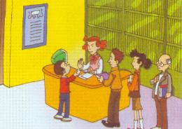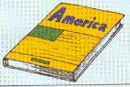
6.

7. 8.

( ) ( ) ( )
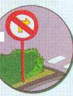
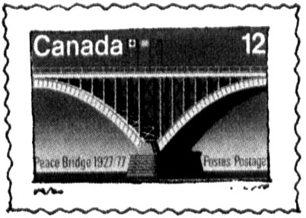
9. 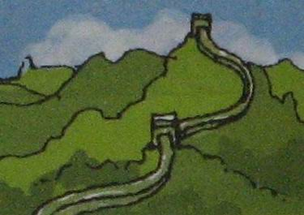 10. 11.
( ) ( ) ( )
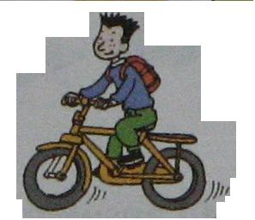
12. 13. 14. 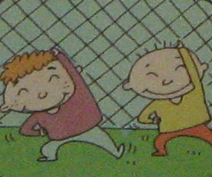 15. 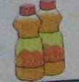
( ) ( ) ( ) ( )
第二节、听辨句子 （满分10分）
A）请你根据听到的句子的先后顺序，用数字1-5为图片标号。（每小题听两遍，5分）
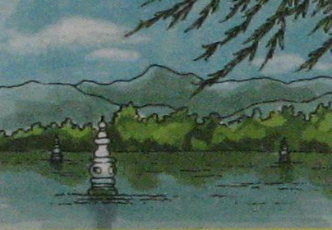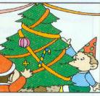
( )
( )
2.


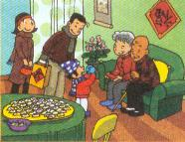
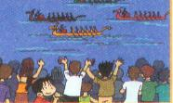

3..
5..
4..

( ) ( ) ( )
B) 请你仔细听下面的句子，判断下面的图片是否与你所听内容相符。如相符划“√”，不相符划“×”。（每小题听两遍，5分）
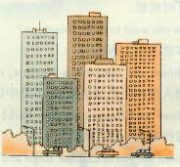
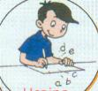
6.

( ) 7.

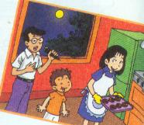
( ) ( )
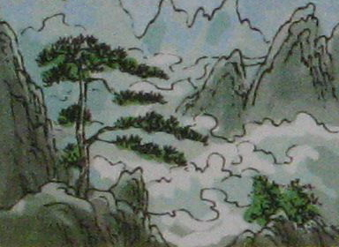
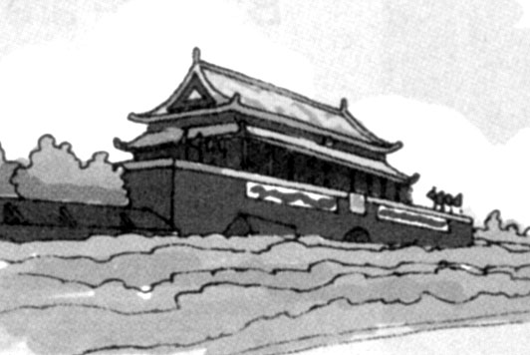
9..
8.
10.

( ) ( ) ( )
第三节、对话、短文理解（满分10分）
听以下对话，找出与所听内容一致的图片，并把字母番号填入题前括号内。（每段对话听两遍）
（ ）1. A . 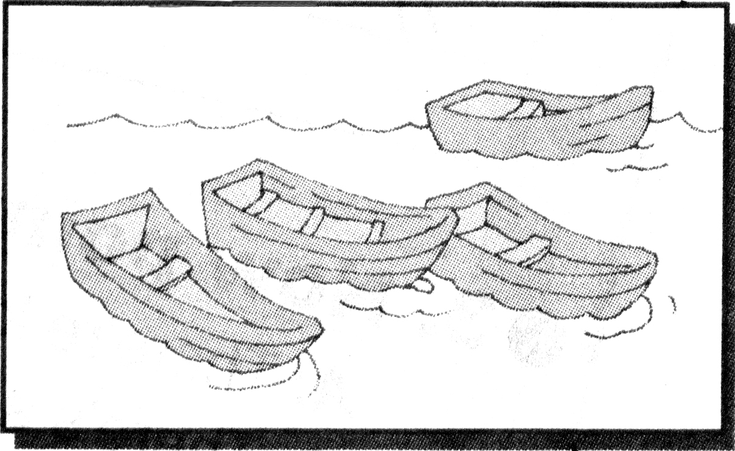 B 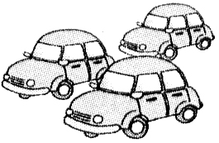 C 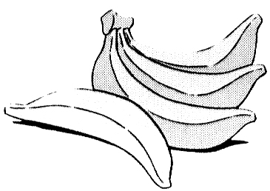
( )2. A 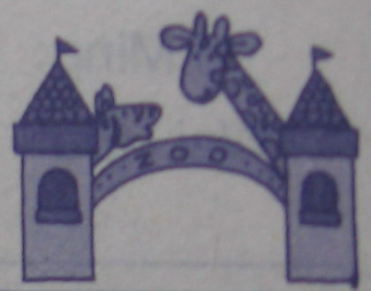 B 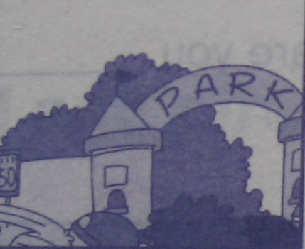 C 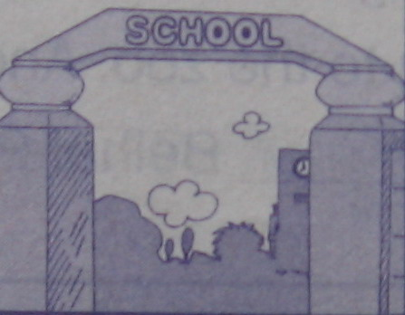
( )3. A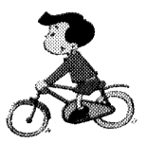 B  C

( )4. A  B 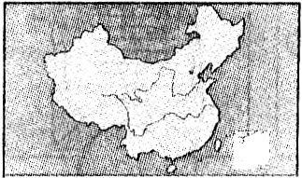 C 
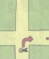
( )5. A 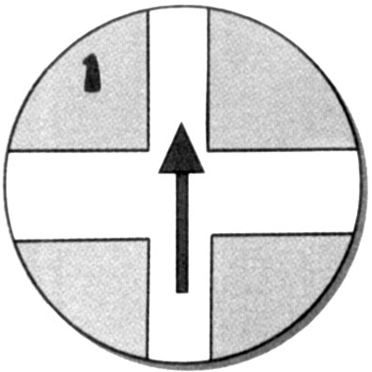 B 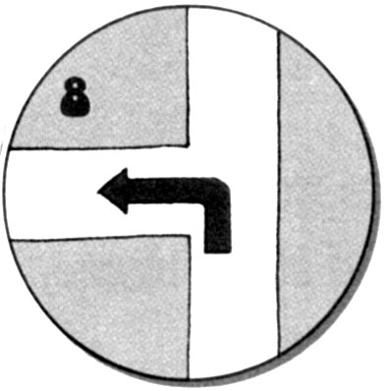 C
第二部分 笔 试 （满分40分）
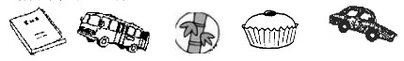第一节 单词。请你选出下列图片对应的单词, 将图片前的字母填入相应的单词前的括号内。（满分5分）
A B C D E

( ) 1. car ( ) 2. bamboo ( ) 3. cake ( ) 4. bus ( ) 5. book
第二节 选择填空 （满分5分）
( )1. The snakes sleep _____ the winter.
A. at B. on C. in
( )2. I want to show ________ the present from Sichuan.
A. he B. him C. his
( )3. –What’s your favourite festival?
-It’s _________.
A. table tennis B. the Great Wall C. the Spring Festival
( )4. –Do you often clean your room?
- ________.
A. I’d love to. B. No, I didn’t. C. Not very often.
( )5. I’ve got some chopsticks, _______ they are difficult.
A. but B. and C. so
第三节 交际运用 （满分10分）

A)请在II栏中找出I栏对应的答句，并将其前的番号填在对应问句前的括号内
I
( )1. How many bananas do you want?
( )2. Did you wash Lingling’s T-shirt?
( )3. Can you control the ball?
( )4. What time do you get up?
( )5. Where did you go?
II
A. Very badly.
B. We went to Tai Ping.
C. Six, please.
D. At half past seven.
E. No, I didn’t.
B) 情景交际
( )6. 当你想获得对方帮助时应说：
A. Excuse me, can you help me? B. Can I help you?
( )7.当你看到朋友的明信片，你会称赞说：
A. Look at my postcards. B. Your postcards are great.
（ ）8.当你想知道对方要去哪里时应说：
A; Where are you going? B. Where are you doing?
（ ）9.“Pleased to meet you”还可以怎么表达：
A. I am sorry. B. Nice to meet you.
( )10.当你想知道对方是否会说英语时应说：
A. Can you say English? B. Can you speak English?

第四节、组词成句 （满分10分）
1. can’t, he, see
2. back, did, come, when, you
3. enough, are, pencils, there
4. went, yesterday, to, you, the park

5. does, start, time, school, what

第五节、阅读理解 （满分10分）
Simon is a good boy. Today is Sunday and it is fine, so Simon’s father takes him to visit the Great Wall. The Great Wall is far away from his home. So they are going there by bus. The Great Wall is about six thousand seven hundred kilometers. It’s very long and great . Simon is very happy and his father is happy, too.
根据短文内容，判断下列句子的正（T）误（F）。
( )1. Simon is a good girl.
( )2. Simon’s father takes him to visit the zoo.
( )3. The Great Wall is far away from Simon’s home.
( )4. Today is Saturday.
( )5. Simon is very happy, but his father is not happy.
得分 | 评卷人

第三部分 口试。（10分）

任课教师根据该生本学期课堂内外的英语口语表达水平给分。
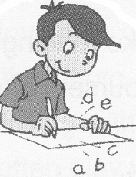
做完了！我还要仔细检查一遍。你呢？

六年级英语听力材料
第一节1. cake 2.kite 3. bed 4. girl 5. fat 6. three pandas 7. stand in line 8. a Chinese book 9. the Great Wall 10.a Canadian stamp 11. turn left 12. send an email 13. riding a bicycle to work 14. play football 15. two bottles of oranges
第二节 A)1. I love the Spring Festival. 2. We all go to see the Dragon Boat race. 3. He gives presents to the children. 4 Merry Christmas! 5. Let’s go to the West Lake. B) 6. He often writes letters. 7. The buildings in Leshan are beautiful. 8. Tell me more about the Tian’anmen Square. 9. We always have a special meal. 10. I have got a stamp of Changjiang River.
第三节 1. A :Have you got any bananas ?
B :No, I have got some boats .
2. –Do you often go to the park?
-No. We often go to the zoo.
3. A : What’s your hobby?
B :Reading books is my hobby
4. A : Have you got any books from England ?
B : Yes ,I have .
5．A :Where is the school?
B : Go straight on.

参考答案
第一节 1-5 CBBCA 6-10 ×√×√√ 11-15×√√×√
- A）5 4 2 1 3 B）7-10 √√√××
- AABCA
笔试
第一节 ECDBA 第二节CBACA 第三节1-5 CEADB 6-10 ABABB

