六年级英语期末测试卷
英语部分

得 分 | 评卷人[来源:学*科*网] | - 看哪个南瓜宝宝站错队了。（选出不同类的单词）。  （6分）[来源:学科网ZXXK]
[来源:学.科.网Z.X.X.K][来源:Zxxk.Com] |  | - 看哪个南瓜宝宝站错队了。（选出不同类的单词）。  （6分）[来源:学科网ZXXK]
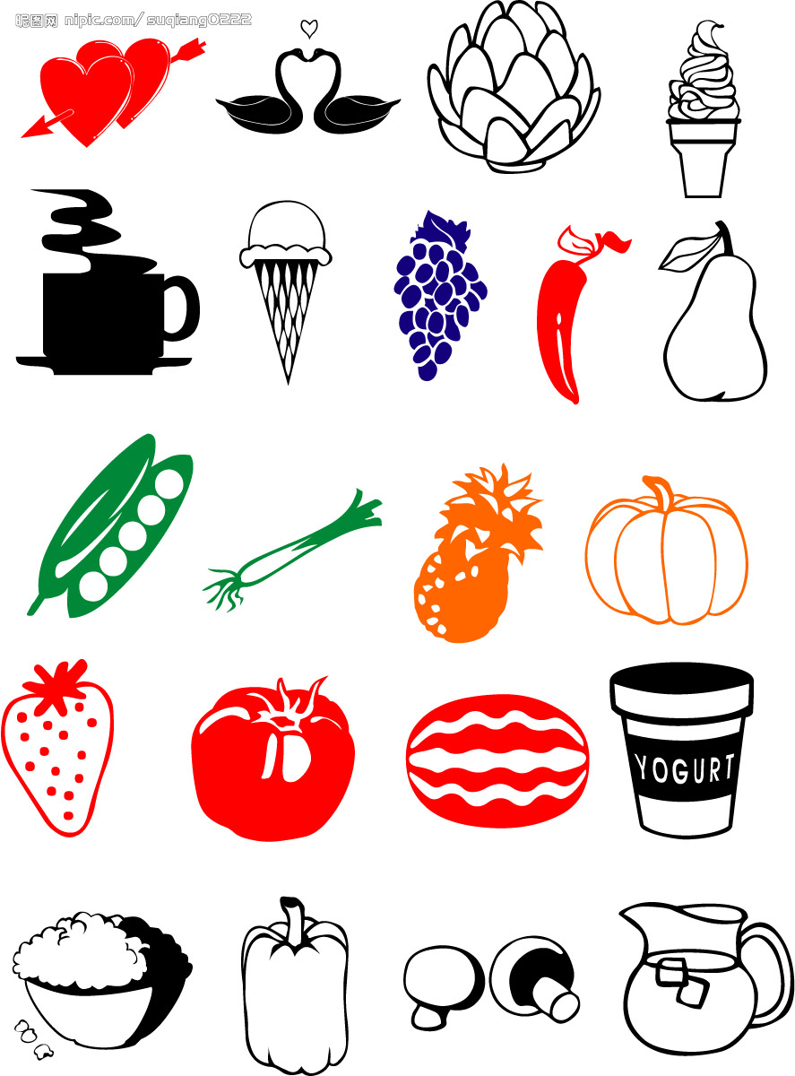

floor fifth  first

snow warm rain

teach worker student

bridge window drive

March June Canada

sea shirt lake
得 分 | 评卷人 | 二、根据句意和图片提示，选择合适单词完成句子，并把它规范地写在四线格里。（10分）（有一项是多余的）

young doctor born fastest cold bus

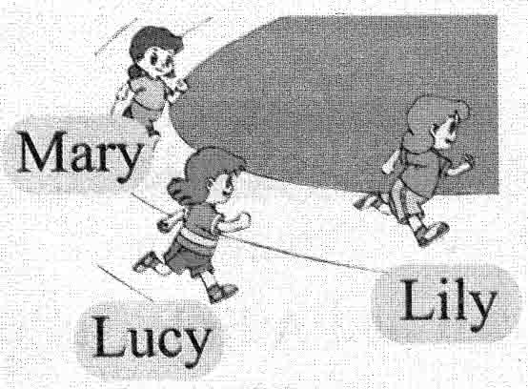

- Who runs in your class?
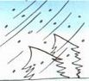
2. What’s the weather like tomorrow? It will be .


3. When I grow up, I will be a .
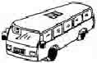

4. I usually go to school by or by bike.
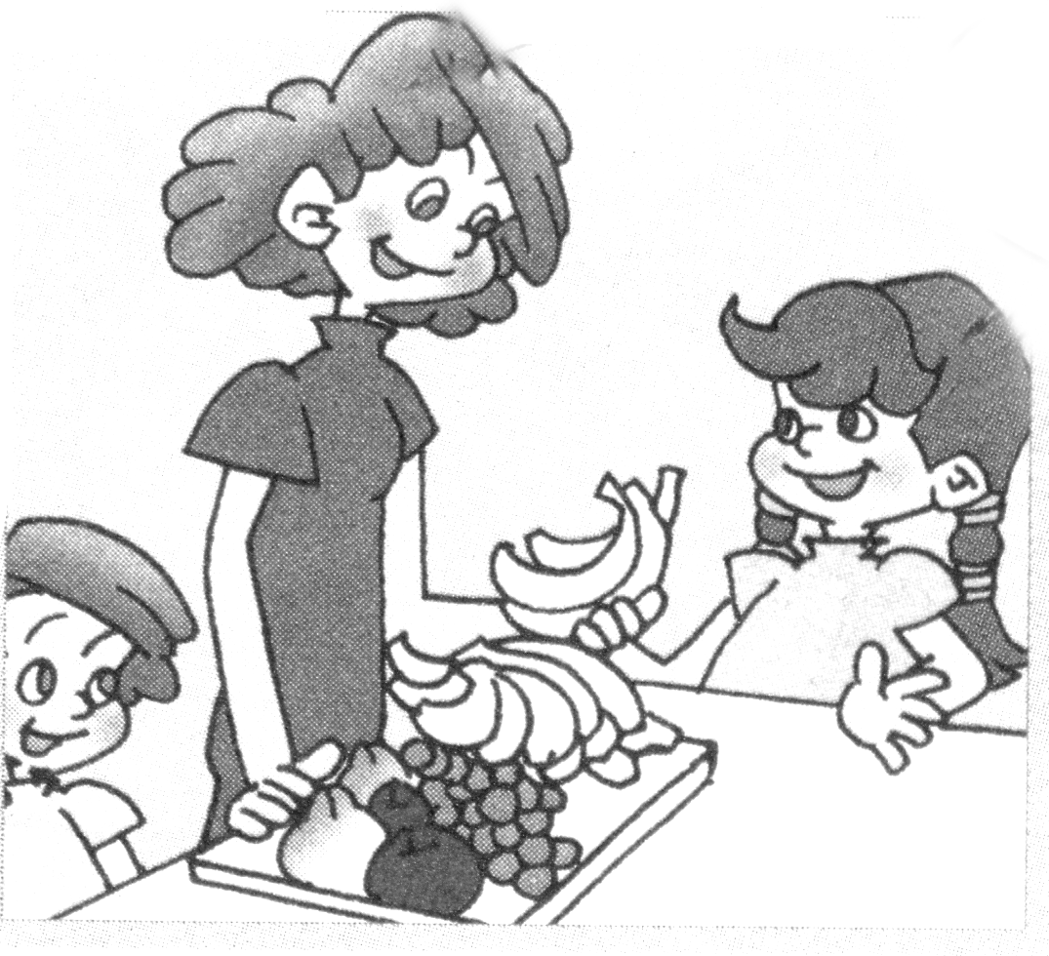

5. My mother has long hair. She is and pretty.

得 分 | 评卷人 | 三、给句子配图片，只填序号。（10分）
( ) 1.I don’t like winter at all. I like summer. I love swimming.
( ) 2.Eve is the tallest of the three.
( ) 3.On Tree Planting Day, we’ll plant trees.
( ) 4.I was born in June, in 1999. What about you?
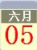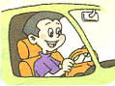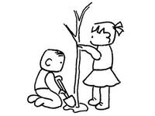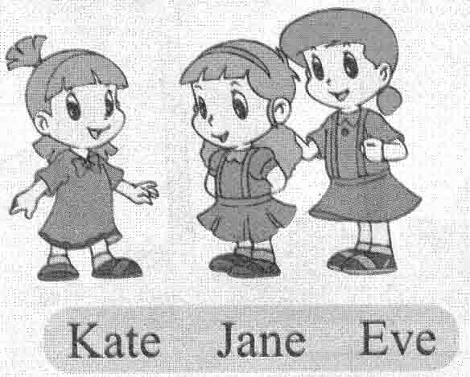( ) 5.I’ll be a driver. I’ll drive a large bus for the people.

A B C D E
得 分 | 评卷人 | 四、情景对话。给左边问句选择正确答语，将其代号填在括号里。（10分）
( ) 1. How old are you? A. He was born in April.
( ) 2. Did you play football yesterday? B. I’m thirteen.
( ) 3. What did you do last Sunday? C. I live in Shenzhen.
( ) 4. Where do you live? D. Yes, I did.
( ) 5. When was your father born? E . I went to the zoo.

得 分 | 评卷人 | 五、阅读。（14分）

A.阅读下面的对话，选用文中合适的单词填空。(每小题1分)
Five students are talking about their future( 未来 ).
Tom: When I grow up, I’ll be a teacher. I’ll teach students to read and write.
Eve: I’ll be a farmer. I’ll grow rice and wheat for the people.
Lulu: When I grow up, I’ll be a nurse. I’ll take care of the patients ( 病人 ) .
Dongdong: When I grow up, I’ll build a large( 大的) school for the students in
our town. I’ll build a big house for my parents, too.
Bill: I like children. When I grow up, I’ll be a teacher, too. I’ll teach the
children to sing and dance.

Lulu is very kind and lovely. She wants to be a ____1____ when she grows up. Bill loves ____2______. He wants to teach the children to _____3____ and dance when he grows up. Tom wants to be a __4______ too. Dongdong wants to build a large school in his _____5____ for the students. Eve wants to grow rice and wheat for the people. He wants to be a _____6____.
1. ____________ 2. ____________ 3. ____________
4. ____________ 5. ____________ 6. ____________
B.阅读下面的短文，判断正（T）误（F）。（每小题2 分）
Last Sunday morning, it was a fine day. Dali went to the zoo. There’s a big park and a forest in it. Their bus could drive very near to the tigers. So they could see the tigers clearly. One of the tigers even jumped onto their bus. On Sunday afternoon, Dali visited a friend. They had a good time. His friend likes keeping birds. She showed Dali different kinds of birds. When he got home, it was 7:00 o’clock, and it was time for supper.
( )1. It was windy on Sunday morning.
( )2. One tiger jumped onto the bus.
( )3. Dali likes keeping birds.
( )4. It was time for lunch when Dali got home.

六年级英语参考答案

一、ABACCB
二、fastest cold doctor bus young
三、BEADC
四、BDECA
五、nurse children sing teacher town farmer FTFF

