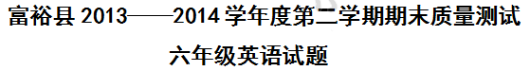【卷首语】亲爱的同学们，这里是English知识的蓝天，欢迎你这只勇敢地小鹰来尽情的展翅飞翔，我相信，只要你努力，你就可以飞的很高很高!
项目 | 笔试部分  (110) | 口语展示  (10) | 综合评价  (120) | 等级
正确点数
一.选出划线部分的读音与众不同的一项。(5点)
( ) 1.A. flower B.window C.brown
( ) 2.A. autumn B.monkey C.drink
( ) 3.A. put B.cut C.bus
( ) 4.A. hard B.park C.warm
( ) 5.A. word B.first C.walk
( ) 6.A. yours B. just C. yet
( ) 7.A sleep B.east C.head [来源:学+科+网][来源:Zxxk.Com]
( ) 8.A.horse B.for C.box
( ) 9.A wood B.moon C.zoo
( )10.A.begin B.become C.letter

二、根据要求写出所给单词的适当形式。（5点）
1 .three (序数 ) 2. see (过去式）
3. right(反义词) 4.do( 第三人称单数)
5. father (对应词) 6.those (单数)
7.have(过去式) 8. foot(复数)
9. my(名词性物主代词) 10.read（过去式)
三.选择填空。(15点)
（ ）1.Do you to go to Hainan?
A.want B.wanting C.wanted
（ ）2.I learned to do things.
A.a lot of B.a lot C.lot of
（ ）3. There are many trees front of the buildings.
A.on B.at C.in
（ ）4. was yours holiday?
A.What B.How many C.How
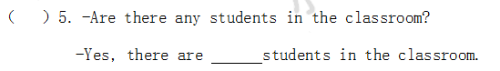
A.any B.some C.a
（ ）6.- Excuse me, can you tell me the way to the Garden Cinema?
-Let me see. You can bus No. 5.
A.by B.take C.go[来源:学*科*网Z*X*X*K]
（ ）7.-I usually get up seven o’clock in the morning.
A.at B.on C.of
（ ）8.It fantastic!
A.were B.was C.are
（ ）9.-Were you born in Beijing?
- .
A.Yes, I were B.No, I wasn’t C.Yes, I am.
（ ）10.-Did you go to plant trees last Saturday？
- .
A.Yes，I did. B.No，I don’t. C.Yes, I didn’t.
（ ）11.Dinosaurs lived years ago.[来源:学科网ZXXK]
A. million of B.million C.millons of
（ ）12.Welcome my neighbourhood.
A.to B.of C.on[来源:Z|xx|k.Com]
（ ）13.Where are you ?
A.go B.going C.went
（ ）14.I’m good making things.
A.in B.at C.on
（ ）15.Tony is brother.
A.Jim’s B.Tom C.James
四.用所给单词的适当形式填空。(10点)
1.There (be) many birds there.
2.-What does Bob do on Sundays?[来源:学+科+网]
-He often (watch) the cartoons.
3.We’re going (visit) Shanghai.
4.They are (write) stories.
5.She learned (obey) the rules.
6.Thank you for (help) me.
7.-How did you learn English?
-I (teach) myself.
8.The boy (name) Mike is my brother.[来源:学.科.网]
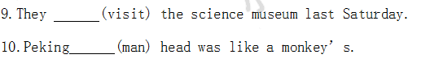
五.连词成句。（10点）
1．should water keep we the clean
2. was holiday how your
？
3. is a near home there park my [来源:Zxxk.Com]
.
4. a lot form textbooks learned I our
.
5. is park there near home my a
.
六.句型转换（20点）
1. Tom and his classmates watered twenty young trees.
(对画线部分提问)
young trees Tom and his classmates ？
2.They went to Beijing last summer. (对画线部分提问)
they last summer?
3.We should obey the school rules.(改为否定句)
We the school rules.
4.I can take photos at home（改为一般疑问句）
take photos at home?
5.She played the guitar yesterday.(改为否定句)
the guitar yesterday.
6.I will tell you something about my hobbies( 改为一般疑问句)
me about your hobbies?
7. We are going to visit the Great Wall next Sunday.
(对画线部分提问)
we going to visit the Great Wall?
七.英汉互译。（10点）
1.书店里有很多新书。
There were a lot of in the bookshop.
2.你的假期是在哪里度过的？
you during your holiday?
3.Excuse me, how can I get to the City Libuary?

4.People are trying to protect them.

5.你是在哪里出生的？
you born？
八.阅读理解。（20点）
Now I’m in China. I live in Shanghai. It’s a very beautiful city. I study in a school here. I usually go to school by bus. 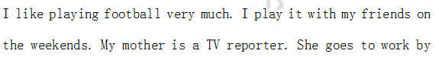subway. She likes singing very much. She often listens to music on TV. My father is a teacher. He teaches P.E. in a school. He goes to work on foot. He likes art. He often draws pictures on Saturday.
( ) (1) Mike lives in now.[来源:学科网ZXXK]
A. Shanghai B: Beijing C: America
( ) (2) Mike is a now.
A. teacher B. a reporter C. student
( ) (3) Mike’s hobby is .
A. playing football B. listening to music
C. painting
( ) (4) His father goes to work
A. by subway B. on foot C. by bus[来源:学科网ZXXK]
Last weekend we had a birthday for our classmate Zhang Xiaohui. She is younger than me, but I am shorter than her. And 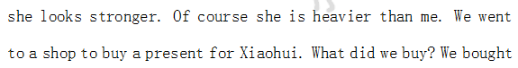a doll for her. Because she told me “ I haven’t got a lovely doll.” When she got our present she looked excited. She was very happy. We went to the zoo. We saw elephants. We wanted to row a boat in Jingming park, but it was later, we had to went home. We had a good time on that day.
( ) 1. Xiaohui is taller than me.
( ) 2. I bought a doll for Xiaohui.
( ) 3. We went to a shop last month.
( ) 4. They had a good time on Xiaohui’s birthday.
( ) 5. We rowed a boat in the park.
( ) 6.Xiaohui is older than me, so she is heavier than me.
九.书面表达。（15点）
仔细观察下图，请以“Planting Trees”为题写一篇文章，不少于30词。
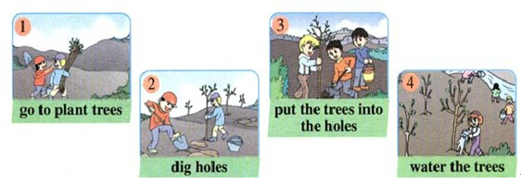
Planting Trees

