2014-2015学年第二学期期末质量检测
六年级英语试题
PartⅠ Listening
（听力部分，共40分）
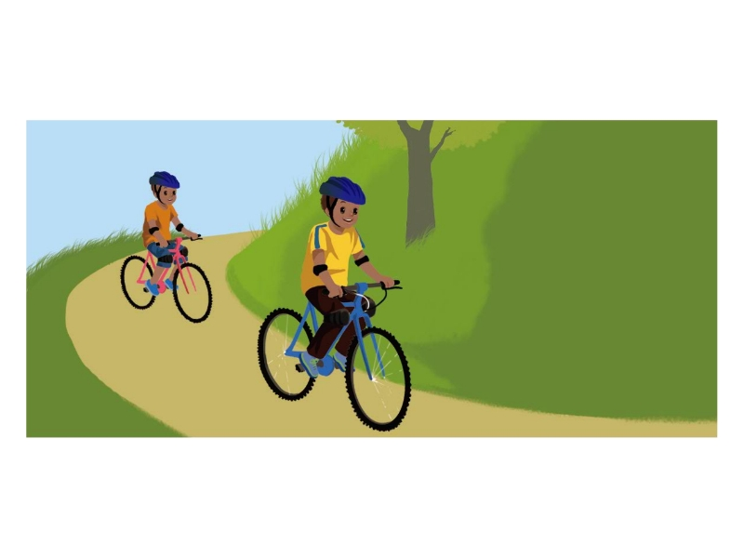
一. 听音，排序。(Listen and rank) (共10分)听句子，将下列图片按所听到的顺序排序。每个句子读两遍。
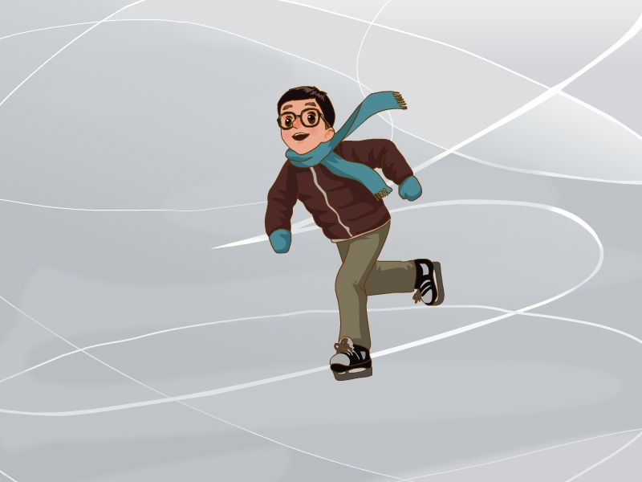
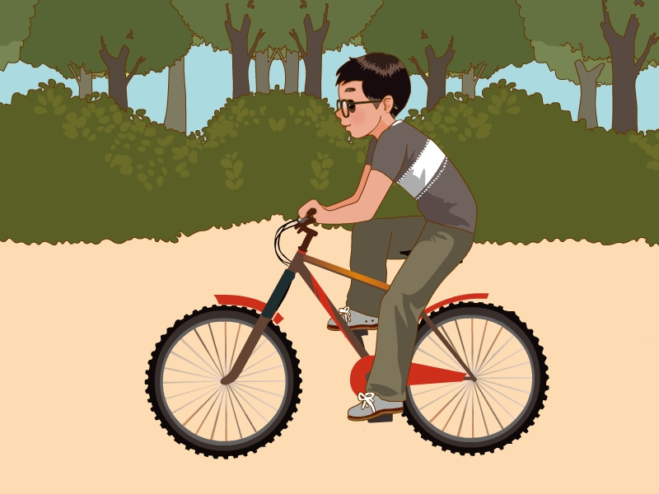

[来源:Z_xx_k.Com]

（ ） （ ） （ ）[来源:学科网]
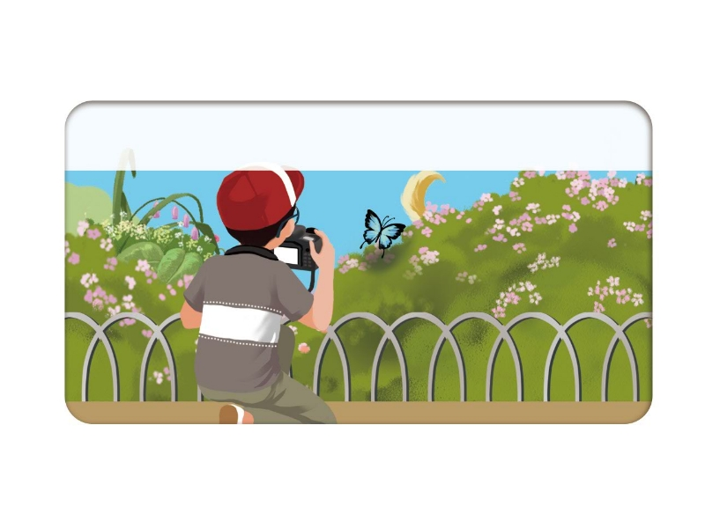
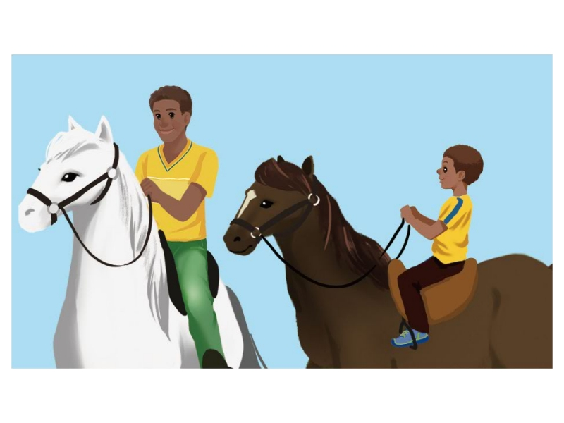

（ ） （ ）

二.听音，选择。(Listen and choose) (共10分)
听录音，选出你所听到的单词。每个单词读两遍。
（ ）1.A.camp B.catch C.cake
（ ）2.A.skirt B.hurt C.nurse
（ ）3.A.book B.caught C.bought
（ ）4.A.fall B.fell C.feel
（ ）5.A.beach B.teach C.beside
三.听音，写单词。(Listen and write) (共10分)
听录音，补全句子。每个句子读两遍。[来源:学。科。网Z。X。X。K]
1.There is a new ______ ______in my school.
2.Keep off from the ______.
3.Do you like to______ ______?
4.I don’t like ______. ____________ you?
5.He couldn’t swim______ ______ ago.
四.听录音，根据听到的问句选择合适的答语。（Listen and choose） (10分)
( )1.A.I went to Sichuan. B.I went by plane.
( )2.A. I learned Chinese with David.
B.We are going to have a party next week.
( )3.A.Yea,Ihad a lot of fun. B.No,she can’t.
( )4.A.He went to the bookstore yesterday.
B.He went to the park by bus.
( )5.A.No, he doesn’t. B.Yes,she did.
Part Ⅱ Writing （笔试部分，共60分）[来源:学科网ZXXK]
五、根据中文意思写单词。(共10分)
1、We feed the cows with _________________ (草).
2、My brother didn’t like to play _________________ (羽毛球) before.
3、We have lunch at 12 o’clock in the _________________ (食堂).[来源:学科网]
4、 us (告诉) your school, please.
5、I it (查阅)on the Internet.
6、There is a building in my school (二年前)
六、根据要求写单词。
1. small_______（反义词） 2. happy_______（反义词）
3. big_______（比较级） 4. strong________ （比较级）
5. listen_______（过去式） 6. walk_______ （过去式）
7. visit_______ （过去式） 8. do________ （过去式）
9. read______ （过去式） 10. swim_______ （ing形式）[来源:学科网]
七. Read and choose. 选词填空。(共10分)
A.go B.be C. a D.went to E.by

1. I __________ a forest park.
2.It looks like mule!
3.Did you to Turpan?
4.We went there plane.
5.They won’t ready till Audust.
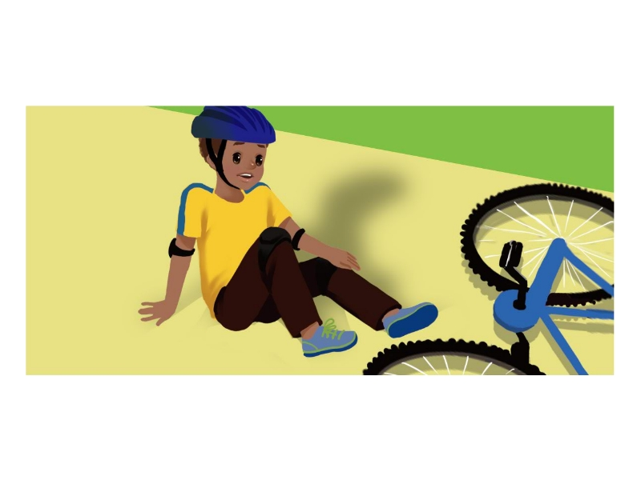
八.Read and write. 看图，根据句意及提示填写单词或短语，完成句子。每空一词。(共10分)
1.I fell off my bike and ____________________

2.At that time, there were no_____
3.Now I love to __________ , so I like winter.

4. Mt. Tianshan, xinjiang. I ______________.
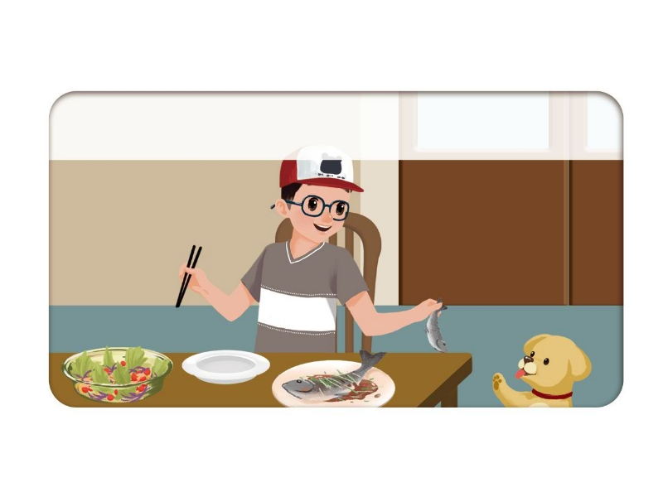
5. I __________________ every weekend and went swimming.

九.Read and choose. 根据上下文，选择恰当的句子完成对话,注意书写。(共10分)[来源:学科网ZXXK]
A. I had a race with Dad and Max
B. What a dream!
C. I had an interesting dream last night.
D. What happened then?
E. I drink it and then could run very fast.
[来源:学.科.网]

Wu Yifan : Mum, _________________________________________________
Mum: What did you dream about?
Wu Yifan : ________________________,but I couldn’t run fast.
Mum: ________________________
Wu Yifan: Robin gave me some water. ________________________ ___________. Suddenly I tripped and fell. Then I woke up
Mum: ________________________

[来源:学科网]
2014-2015学年第二学期期末质量检测
六年级英语试题
（卷面清楚工整、书写规范美观3分）
PartⅠ Listening（听力部分，共40分）
听力材料：
一. 听音，排序。(Listen and rank) (共10分)
听句子，选图片，将选项写在题前括号内。每个句子读两遍。[来源:学。科。网]
1. My brother and I rode a bike.
2. I love to ice-skate. So I like winter.
3. I thought it was too cold, and I couldn’t go cycling..
4.I went swimming every weekend and took lots of pictures.
5. John rode a horse with his father.
二.听音，选择。(Listen and choose) (共10分)
听录音，选出你所听到的单词。每个单词读两遍。
1.catch 2.hurt 3.bought 4.fell 5.beach
三.听音，写单词。(Listen and write) (共10分)
听录音，补全句子。每个句子读两遍。
1.There is a new dining hall in my school.
2.Keep off from the grass.
3.Do you like to go cycling?
4.I don’t like winter . How about you?
5.He couldn’t swim ten years ago.
四.听录音，根据听到的问句选择合适的答语。（Listen and choose） (10分)
1.Where did you go?
2.What did you do yesterday?
3.Did you have a good time?
4.How did he go?
5.Did she eat good food?
参考答案：A A A B B
Part Ⅱ Writing
（笔试部分，共60分，含卷面3分）
五 共10分，每词1分。
1.grass 2. badminton ; 3. dining hall; 4.Tell about; 5.Looked up
6.two years ago
六、共20分，每题2分。
1. big 2. sad 3. bigger 4. stronger 5. listened
6. walked 7. visited 8. did 9. read 10. swimming
七. 共10分，每小题2分。
1.D; 2.C; 3A; 4.E; 5.B
八. 共10分，每空2分。
1.hurt my foot; 2.gym; 3.ice-skate; 4.rode a horse; 5.ate fresh food
九. 共10分，每小题2分。
1.C 2.A 3.D 4.E 5.B

