PEP新版2015-2016学年第二学期期末质量检测
六年级英语试题
听力部分
一、听录音，选出你所听到的单词或词组，并将其所选答案的字母代号填入题前括号内。注意，每小题听两遍。（每小题1分，共10分）。
( )1、A、active B、actor C、ant
( )2、A、coffee B、chicken C、cinema
( ) 3、A、shorter B、stronger C 、spring
( )4、A、go hiking B、go shopping C 、go fishing
( )5、A、watching TV B、washing the dishes C 、writing a letter [来源:学.科.网Z.X.X.K]
( )6、A、took pictures B、take pictures C 、ate good food
( )7、A、February B、September C、 August
( )8、A、tofu B、tomato C、eggplant
( ) 9、A、What time is it now? B、What day is it today ?
C、What’s the date today?
( )10、A、Where did you go on you holiday?
B、When did you go there? C、What did you do there?
二、听录音，选出正确的答语，并将其所选答案的字母代号填入题前括号内。注意，每小题听两遍。（每小题2分，共10分）。
（ ）1. A. I’m fine. B. I’m nine. C. No, I did.
( )2. A. The elephant. B. The cat. C. The dog.
( )3. A. I’m five. B. I have a cold. C. You are a good boy.
( )4. A .Yes, I do. B. Yes, I did. C. No, I did.
( )5. A. It’s black. B. It’s a clock. C. It’s four o’clock.[来源:学.科.网]
三、听录音，选出与所听内容意义相符的图片，并将其代号填入题前括号内。注意，每小题听两遍。（每小题2分，共10分）。
1.
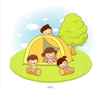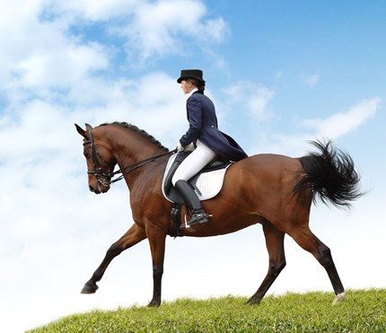
A B
2.

A B
3.

A B
4.
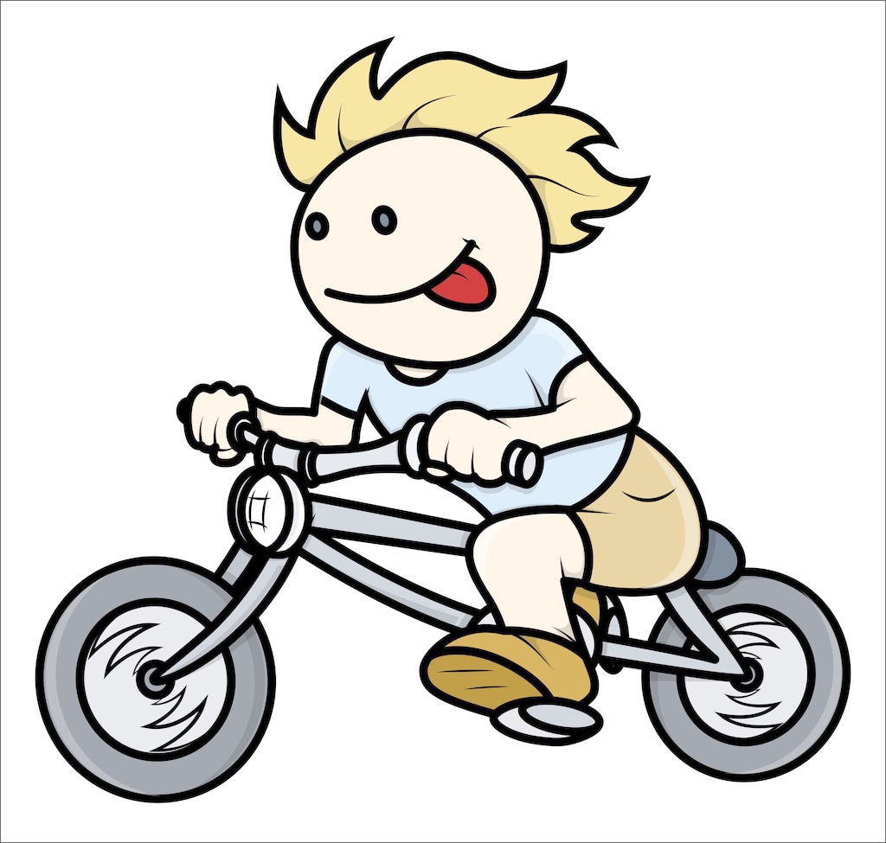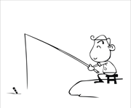
A B
5.
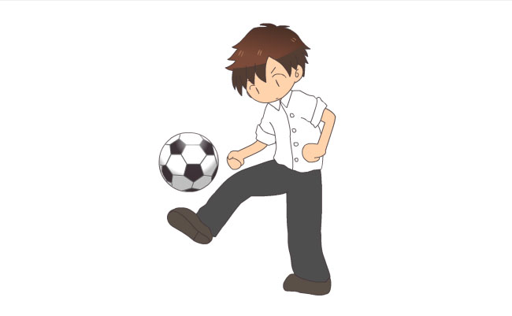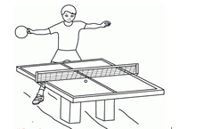
A B [来源:学&科&网Z&X&X&K]

笔试部分
四、看图写单词（看图片后只能用词的原形填写，否则不给分）。（每小题2分，共12分）。
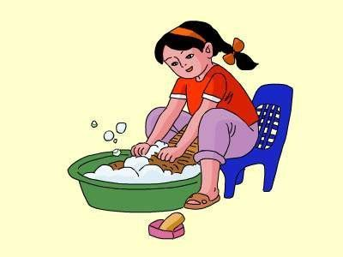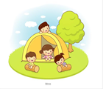

the clothes go
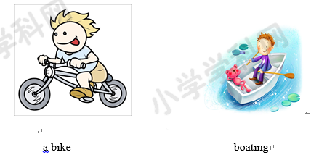

TV [来源:学科网][来源:学科网]
五、从Ⅰ部分中选出与Ⅱ部分句子相对应的正确答案，并将其代号填入题前括号内。（每小题2分，共20分）
Ⅰ Ⅱ
( )1.Whendo you usually go to bed? A. By bus.
( )2. What’s the weather like today? B.I feel sick.
( )3. What’s your favourite season? C. I bought a book.
( )4.Where is the computer room? D. October 1st.
( )5.What did you do yesterday? E. Yes, I did.
( )6.How do you feel? F. I went to Xinjiang.
( )7.What’s the date? G. It’s on the third floor.
( )8.Where did you go? H. At 9:00.
( ) 9.Did you learn English? I. It’s rainy.
( )10.How do you get home? J. Winter.
六、观察下列单词或词组，将它们与其正确汉语意思配对，并将其字母代号填入题前括号内。（每小题1分，共10分）
( )1.play badminton A. 以前
( )2.go cycling B. 看
( )3.watched C.上一个的
( )4.yesterday E.饭厅
( )5.ride F.去野营
( )6.heavier G. 打羽毛球
( )7.went camping H.骑（马，自行车）
( )8.dining hall I. 昨天
( )9.last J.去骑自行车
( )10.ago K. 更重的
七、读一读，选一选。将正确答案的字母代号填入题前括号内。（每小题2分，共10分）
1、I often go to work foot.
A. by B. take C. on
2、——How are you?
——I’m160cm tall.
A. old B. tall C. heavy
3、We have a football match tomorrow.
A. are going B. are go to C. are going to
4、My brother is 4cm than me.
A. taller B. tall C. older
5、What Amy last weekend?
A. did, do B. do, do C. does, do
八、连词成句（注意标点的使用，缺标点或标点用错每个扣0.5分）。（每小题2分，共8分）
1. likes he listening music to

2. did you there how go

3. my brother am than I stronger

4. on go school usually I to foot

九、阅读理解。（每小题1分，共10 分）
A
Dear Amy,
How are you ? I miss you. I want to Hainan with Dad and Mom Last weekend. It is really a wonderful place. We walked on the beach, swam in the sea, ate good food and watched a very beautiful dance. It was so hot in Hainan, but we had a good time there. Here is a photo for you, Hope you like it. Please write me soon.
Yours,
Chen Jie
（ ）1、Amy went to Hainan with Dad and Mom last Monday.
（ ）2、Hainan is really a wonderful place.
（ ）3、Amy and her parents watched a very beautiful dance.
（ ）4、It was so cold in Hainan.
( ) 5、We had a good time there.
B
Jack and John are twins. They are good at English. They like to swim and ride bikes in their holidays. They like to fly kites too. They often fly kites near the lake. But they not all the same .Jack likes playing football, but John likes playing ping-pong. Jack likes listening to music, but Jonh likes drawing pictures. They often help each other.
1. What are they good at ？（ ）
A. English B. Math C. Chinese D. Science
2. What do they like to do in their holiday ? ( )
A. Play ping-pong and run. B. Swim and ride bikes.
C. Swim and play basketball. D. Play ping-pong and ride bikes.
A. Near the lake. B. In the park. C. On the beach. D. Near the river.
4.Who likes playing football ? ( )
A. Jack B. John C.Jack and John
5. Do they often help each other ? （ ）
A. Yes, he does. B. No, he doesn’t. C. Yes, they do. D. No, they doesn’t.

