2015年6B期末综合训练
一、会话配对。 I II
( ) 1. What did you do last night? A. I like reading.
( ) 2. Is that Yang Lin ? B. It’s cool and windy.
( ) 3.What’s your hobby? C. It’s very nice.
( ) 4. What’s the weather like ? D. Because I can eat ice cream.
( ) 5.What time shall we meet? E. There are two.
( ) 6. Why do you like summer? F. It’s on River Road.
( ) 7. Where is the No. 2 Bus Stop? G. At two in the afternoon.
( ) 8. How many stops ? H. Yes, speaking.
( ) 9. How about the red skirt? I . I did my homework.[来源:学_科_网Z_X_X_K]
( )10. Are you listening to me ? J. Of course I am.
二、 用所给词的适当形式填空。 （10分）
1. Can I _____ him my e-mail address? (give)
2. He is always __________ to come to school. (one)
3. It’s often _________ in summer in the south(南方) of China.(rain)
4. My mother brings me a _______________teddy bear.（love）
5. Please ___________ left or right in class (not turn) .
6. We don’t know how ___________ model planes. Can you help us ?(make)
7. Look, Wang Bin ____________ off the bus. Let’s wait for him here.(get)
8. Liu Tao _______ about an English boy last week.( read)
9. David ______ more friends than us.(have)
10. I ______________ my grandparents with my sister tomorrow. (visit)
三、选错并改正。 （6分）
( ) ________1. Who do you want to write ?
A B C
( ) _________ 2. The girl with glasses sings very good.
A B C
( ) _________ 3. Would you please to tell me everything about him?
A B C
( ) __________4. He doesn’t know the way in the History Museum.
A B C
( ) _________ 5. She tells me about her plan for the weekend yesterday.
A B C
( ) _________6. The bus stop is 200 metres away in your left.
A B C
四、按要求写句子。 (10分)
1. She came to school on foot this morning.（改为一般疑问句）
______ she _____to school on foot this morning?
2. Wang Bin’s mother does housework at home on Sundays.（否定句）
Wang Bin’s mother ______ _______ housework at home on Sundays.
3 .It’s very cold in New York in winter.（对划线部分提问）
_______ the ________ like in New York in winter?
4. My favorite day is Saturday.（改为同义句）
I ______ Saturday ________.
5. I’m 165cm. He is 170cm.（合并成一句）
He is 5cm ______ ______ me.
五、根据上下文，补全对话 (5分)
A: Mum, _____ I have some money?
B. ______ for, dear?
A: I want to buy a present .
B: Who do you want to buy presents ________?
A: For my father. Fathers’ Day is .
B:_______ great ! You are really a kind boy.
六、 根据中文提示，完成句子。 （12分）
1. 你们看起来一样，你们是双胞胎吗？
You ______ the _______. Are you _____ ?
2. 别担心，你可以慢跑去学校。
Don’t worry ! You can ______ _______ school .
3我怎样才能到达购物中心？
______ can I ______ _______ the shopping centre?
4. 他想在中国找一个笔友。
He wants ______ _______ a penfriend in China.
5.我们打算参加学校运动会。
We are going to ______ ______ in our school sports meeting.
七、选择
（ ）1._______ often go shopping at the weekends.
A . Mum and I B. I and Mum C. Me and Mum. D. Mum and me .
( ) 2. The film was so _________ .We all liked it .
A .excite B.excited C. exciting D. an exciting
( ) 3. My birthday is _______the 2nd of June .Nancy’s birthday is _____June ,too.
A. on,on B. in, on C. on, in D. in,in
( ) 4 .Are the sweaters yours? __Yes , ___________________.
A. It’s hers B. They’re theirs C. It’s ours. D. they’re ours .
( ) 5. I am 150cm ,Tom is 152cm .So Tom is _______ than me .
A. taller B. younger C.shorter D. lower
( ) 6 .They know a lot about animals ,but they want to know ______about them .
A. many B. much C.more D. some
( ) 7 Every morning Ben’s grandfather ________ for a walk around the lake.
A .go B.goes C. went D. is going
( ) 8 Walk into your bedroom _________ because your father is sleeping .
A. quiet B. quietly C. loud D. loudly
( ) 9 Can I have _______ writing paper ?
A .a B. an C. some D. any
( ) 10 There are ________ days .The ________ day is Saturday .
- seven ; seven B. seventh;seventh C. seven; seventh D. seven; sixth
( ) 11 My mother can ______ delicious food .
A. cooks B.cook C. cooked D.cooking
( ) 12 Let me _________ , please .
A. go home B. to go home C. to go to home D. to home
( ) 13 The pair of socks ________ very nice .
A. look B. looks C. is looking D. are looking [来源:学+科+网Z+X+X+K]
( ) 14 Where ______ you a moment ago ?
A. are B. is C. were D. was
( ) 15 .The days get ________ and the nights get ________ in winter .[来源:学*科*网Z*X*X*K]
A. shorter ;longer B.longer; shorter C. short; long D.long; short
( ) 16 在下列这组单词中，划线部分读音与其他单词不同的单词是：
A. blouse B. house C. cousin D. mouth
八、英汉互译
在周六上午________________ my e -mail address ___________
寻求笔友________________ Sounds great !_______________
关于天气 ______________ most of the time ______________
去野餐__________________ run out of the shop_____________
一位英国女孩____________ singing contest________________
九、用所给单词的设当形式填空（8分）
1. He likes _______ (listen) to music .Me ,too.
2. My English teacher often ________ (go) ________(jog) after school .
3. Your classroom is on the ________ (four) floor (层) .
4. My mother can ________(make) delicious food .She _______(make) some for us now .
5. Yesterday my mum _______(come) to our school .
6. __________(be) there any water in the bottle now ?
十、按要求完成下列句子。（6分）
1. He has a brother and a sister . （改为一般疑问句）
_______ he ______ any brothers or sisters ?
2. Open the windows .（改为否定句）
_______ ________ the window .
3. She is watching cartooons at home now .（改为一般现在时）
Sometimes she ________ ________ at home .
4. Jim is good at PE . （改为同义句）
Jim _______ _________ in PE.
5. We saw a play last Sunday . （用tomorrow 替换 last Sunday）
We are _________ _________see a play tomorrow .
十一、阅读理解。
I am from the USA . My name is Helen . I am Liu Tao’s penfriend . Liu Tao is twelve years old . I’m as old as him . There are four people in my family . My father is a doctor . My mother teaches English in a primary school . My brother Jack is only four years old . He is lovely . We all love him very much .
根据上下文内容，填入适当的单词。（每空一词）。（6分）
Liu Tao _________ a penfriend .________ name is Helen . She’s an __________ girl .There are ________ people in her family . Her father works in the ___________, and her mother is a _________ .

十二．按要求句型转换，每空一词。（每空0.5分，第二小题1分，共10分）
1. My father is a worker.（对画线部分提问）
______ _______ your father?
2. name, is, of, the, what, his, cat（连词成句）
________________________________________________?
3. I have two books in my bag. （同义句）
________ ________ two books in my bag.
4. There is a picture on the wall.（对画线部分提问）
________ ________ ________ ________ there on the wall?
5. Please feed the animals.（改为否定句）
Please ________ ________ the animals.
6. This sweater is Ben’s. (对划线部分提问)
________ _________ this sweater?
7. Nick doesn’t watch TV on Sunday.(对划线部分提问)
______ _______ Nick _______ on Sunday?
8. I want to buy a toy for her.（同义句）
I ________ ________ to buy ________ a toy.

十三、每题有一个错误，请找出并改正。
1. Let us to help you with your homework.
A B C D ( ) ________
2. My uncle can makes a lot of bikes.
A B C D ( ) ________
3. —Do you happy now? —Yes, I am.
A B C D ( ) ________
4. Millie often plays the tennis after school.
A B C D ( ) ________
5. Can I play computer game first?
A B C D ( ) ________
十四．根据句意及括号内所给的词，用其适当形式填空。
1.The card says “No ________（park）”. It means you can’t ________（park）here.
2.Is this ________ new pencil box? Yes, it is. Let ______ have a look at it.(他)
3. Don’t ________ ( close) the door.
4. Let’s ________ (play) football on the playground.
5. —Would you like ________（go）with me? —Yes, I’d love to.
6. On Sundays, I often do the ________(shop) with my mother.
7.Whose ____________(Walkman) are these ? They are Nick’s.
8.On the _________(twenty) floor, there are six classrooms.
6B综合练习
一、情景配对。 Ⅰ Ⅱ
( ) 1. How do they spend their weekend? A. I want to buy a present for Peter.
( ) 2. What’s the weather like today? B. National Day.
( ) 3. What for? C. I still feel ill.
( ) 4. Does the sign mean ‘Danger!’? D. Yes, I’d love to.
( ) 5. What shape is the sun? E. They often go climbing.
( ) 6. How do you feel now? F. I am, Miss Li.
( ) 7. Who’s on duty today? G. We did our homework.
( ) 8. Would you like to my birthday party? H. It’s a circle.
( ) 9. What did you do last night? I. It’s sunny. But hot.
( ) 10. What’s his favourite holiday? J. No. It’s means ‘No parking’.
二、按要求写句子。
1. There are some peaches in the basket. (改为否定句)
There ________ _______ peaches in the basket.
2. You can’t take photos here. (保持句意不变)
_______ ________ here!
3. That’s her calculator. (对划线部分提问)
_______ calculator is that?
4. David walks to school every day. (保持句意不变)
David _______ to school _______ _______ every day.
5. you, everything , I, like, about, know, would, to (.)(连词成句)[来源:学科网ZXXK]
________________________________________________________________

三、根据中文意思完成下列句子。(每空一词) (10分)
1. 本周末他们将在图书馆见面。
This weekend they’re _______ _______ meet in the library.
2.我想成为你的笔友。
I want _______ ________ your penfriend.
3. 12月25日是圣诞节。
_________ is __________ the 25th of December.
4.夏天南京比上海热。
In summer it is ________in Nanjing ________ in Shanghai.
5.—刚才你在哪里？ —我在电脑室。
Where _________ you just now? I _______ in the computer room.
五、看图写话。
要求：1．条理清楚，意思连贯，语句通顺，单词拼写正确，书写清晰、规范。
2.要将图中的内容全部体现在一段话中，可适当发挥自己的想像。
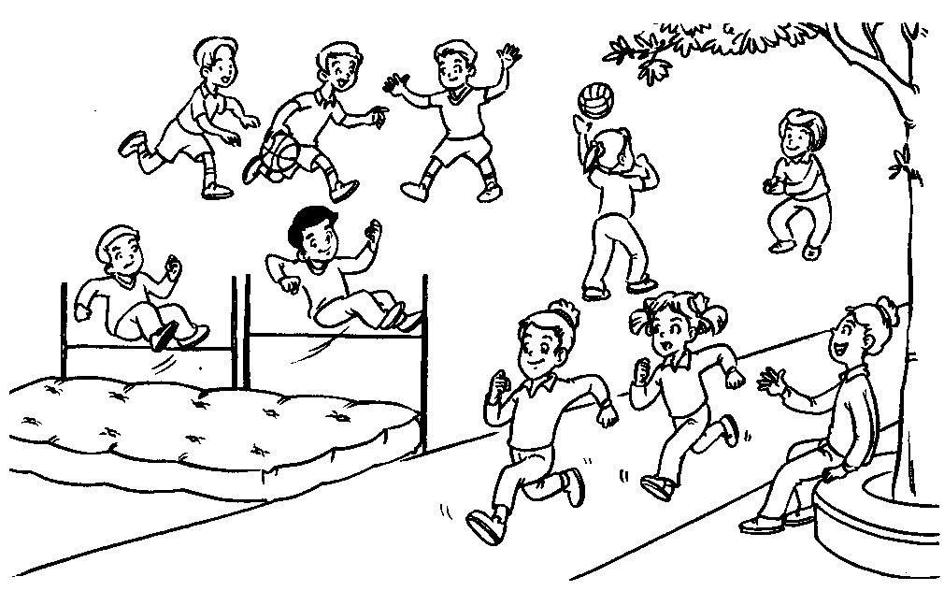
3.小短文不得少于50词。

六、重新排列下列句子组成一段合理的对话。（7分）
Me ,too. Where is he from? 2. Yes,I do. How about you?
3. No. She is from New York. 4. I see.
5. He is from London. 6. Do you have a penfriend?
Is your penfriend from London?
. . . . . . .
七、按要求完成句子（10分）
1. Mary is taller than Lily. (改为同义句) Lily than Mary.
2. I get up at six every day.（用yesterday 改写） I _______ at six yesterday .
3. I did my homework last Sunday. (划线提问) What you last Sunday?
4.Su Hai and Su Yang look the same. (改为一般疑问句)
Su Hai and Su Yang the same?
5. his ,is ,cousin ,Gao Shan, heavier ,than (连词成句)

八、英汉短语翻译。
1.去散步 2. take part in
3.在夏天 4. by the way
5.擅长唱歌 6.have school
7.要求得到 8.get on
9.一样强壮 10. Spring Festival
单项选择
( ) 1. Mr Smith is Nanjing now.
A. lives in B. lived C. living in
( ) 2. David jumps than Gao Shan.
A. father B. fast C. farther
( ) 3. — Do the girls in red jump higher than the girls in green? — ?
A. Yes, they do. B. Yes, they are. C. Yes, she does.
( ) 4.Go_____this street and turn left at the second crossing.
A long B along C longer
( ) 5.Nancy likes Music lessons. She the violin every morning.
A. having; plays B .having; play C. has; playing
( ) 6. Nancy wants some fruits for the camping trip.
A . to buy B. for buy C. to buying
( ) 7. Whose pencil is longer, ?
A. you or she B. your or hers C. yours or hers
( ) 8. — What`s the weather like here in summer? — It is often .
A. rain B. rainy C. rains
( ) 9．Mrs Black’s hobby is .
A. take photos B. takes photos C. taking photos
( ) 10．What are the twin sisters doing? — .
A. They’re joging. B. She’s jogging. C.They’re jogging.
( ) 11.Would you like orange juice?
A any B some C an
( ) 12. Tom Beijing tomorrow.
A. is going to B. will going to C. was going to
( ) 13. He runs than his classmates.
A. much faster B. much higher C. more faster
( ) 14. I think your bag is heavier than .
A. my B. mine C. me
( ) 15 .Can you tell me the shopping centre?
A. the way for B. the way to C. the way
十、阅读理解。
A)阅读短文，根据上下文及所给首字母提示填写所缺单词。
Lily and Lucy are t . They look the s . Lily likes singing but Lucy does well in d . N Sunday they are going to take part in the contests. So Lily would like a beautiful dress, and Lucy w a pair of dancing shoes. Yesterday was their birthdays. They h a big birthday party. Some of t friends came to the party. Lily and Lucy got the p they want f their friends. Everyone had a good t that day!
十一、口语运用。
A)根据上下文，在方框中选择合适的句子完成对话。A: ①
B: Yes, speaking.
A: This is Ben. What are you going to do tomorrow?
- Hello, are you Gao Shan?
- When shall we meet?
- I’m going to have a picnic with my friends.
- How do we go there?
- Hello，may I speak to Gao Shan?
- Sounds good!
- I’m having a picnic with my friends.
- See you soon.
B: ② . Would you like to join us?
A: ③ ____④_____
B: By bike.
A: ⑤
B: At half past seven.
A: All right. See you.
B: ⑥ .
① ② ③ ④ ⑤ ⑥
十二．用所给词的适当形式填空（共5分）
1. Who gets up ______ in your family, your father or your mother? (early )
2. There are many (visit) in the English Club.
3. Look! The little boy is sitting at the table (quiet).
4. Mike usually (go) to work by bike, but he (take) a bus this morning.
5. Look! The policemen (stop) a thief in the street.
6. I have many e-friends. They are in different ________(country)
7. Is it often ________ there in spring? (rain)
8. We _________________ a play soon. (see)
9. David is good at ___________ model planes. (make)
十三、选择填空。（共10分）
( ) 1. ——They have the same hobbies, I think they can be good friends.
——__________________________.
A. I hope so. B. I do C. I think is.
( ) 3. ——Who’s taller than Wang Bing? —— _________________.
A. I do B. I am C. Ben does
( ) 4. Liu Tao _____________ well in Maths.
A. doesn’t B. isn’t do C. doesn’t do
( ) 5. These books are ____________. Hers are in _________ school.
A. mine, her B. my, her mine, hers
( ) 6. Mike is telling his friends ___________his school ________ the phone.
A. about, in B. of, on C. about, on
( ) 7. There isn’t _______milk in the fridge now. Would you like _______ juice?[来源:学科网ZXXK]
A. some, any B. any, some C. any, any
( ) 8. Mr White is from _________. He is _________. He speaks _____________.
A. America, American, American B. America, American, English
C. USA, American, American
十四.选出画线部分读音与其他三个不同的选项（5分）
( ) 1. A. cage B. name C. have D. game
( ) 2. A. word B. forty C. walk D. short
( ) 3. A. buses B. oranges C. apples D. boxes
( ) 4. A. peach B. school C. chocolate D. chair
( ) 5.A. early B. near C. hear D. here
B)读下面的句子，将其排列成一段意义完整的对话，将句首题号填写在方框内(5分)
a. No, there isn’t. But there’s one on Zhongshan Road.
b. How far is it from here?
c. I’m ill. Is there a hospital nearby？
d. Oh. That’s a long walk.
e. About two kilometers away.
f. Yes. You can take a taxi then.
c

