东 台 创 新 学 校
2014年春学期小学六年级英语期末练习卷
一、根据所给汉语填入适当单词，使句意完整、正确。（10分）
1.I am (个子矮的), but I’m strong.
2.I like to go camping in (秋天).
3.The students are going to see a (演出) tomorrow morning .
4. Peter wants to find a (笔友) in China.
5.－What is your telephone (号码)? －It’s 85964328.
6.How many are there?(停车站)
7.It often (下雨) in spring in New York.
8.Please turn right at (第二个) crossing.
9.I （做）many cakes for his friend last week.
10.Helen (去学校) at six thirty every day.
二、词组互译。（10分）
1.看上去一样 2.go for a walk
3.擅长…… 4.as far as
5.下公共汽车 6.every three days
7.在春天 8.by the way
9.写封信 10.in the countryside
三、选词填空。（10分）
1.It’s time ( to, for ) lunch.
2.Liu Tao is as (thinner, thin) as me, but he can (runs, run) faster than me.
3.There is going to (be, have) a concert in the school tomorrow evening.
4. He wants ______ (play, to play) at the concert, because he likes _____(play, playing) the violin very much.
5. Which season do you like _______(better, best), spring or summer?
6. Liu Tao and Mike are good friends, _______(all, both) of them have the same hobbies.
7. (Who’s, Whose) comb is this? It’s hers, I think.
8.Nancy is good at dancing, she can dance (beautifully, beautiful).
四、用括号内所给单词的正确形式填空。（10分）
1.Look, Xiao Ming is (run).
2.He usually (play)football after school.
3.It’s time (have)lunch.
4.The blue box is (big) than the yellow box.
5.Yesterday evening I (do) my homework in my bedroom.
6.There are ten (box) in the classroom . [来源:学。科。网Z。X。X。K]
7.Children’s Day is on the (one) of June.
8.Tom’s schoolbag is (heavy) than Jim’s.
9.Please give this postcard to she).
10.Liu Tao and his mother (go)for a walk after dinner yesterday.
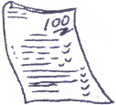
五、根据所给图片的提示，填入句中所缺单词 (10分)
1. Jack is __________ at English.

2. My fax ___________ is 86-025-3288906.
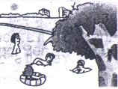
3 It’s very hot in ______________ in Hangzhou.
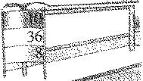
4. No. 8 ___________ ___________ is near our school.
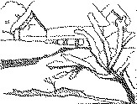
- _________ is coming. Ben will come back from Australia.

六、根据图和表格内容，完成对话，每空一词。（10分）
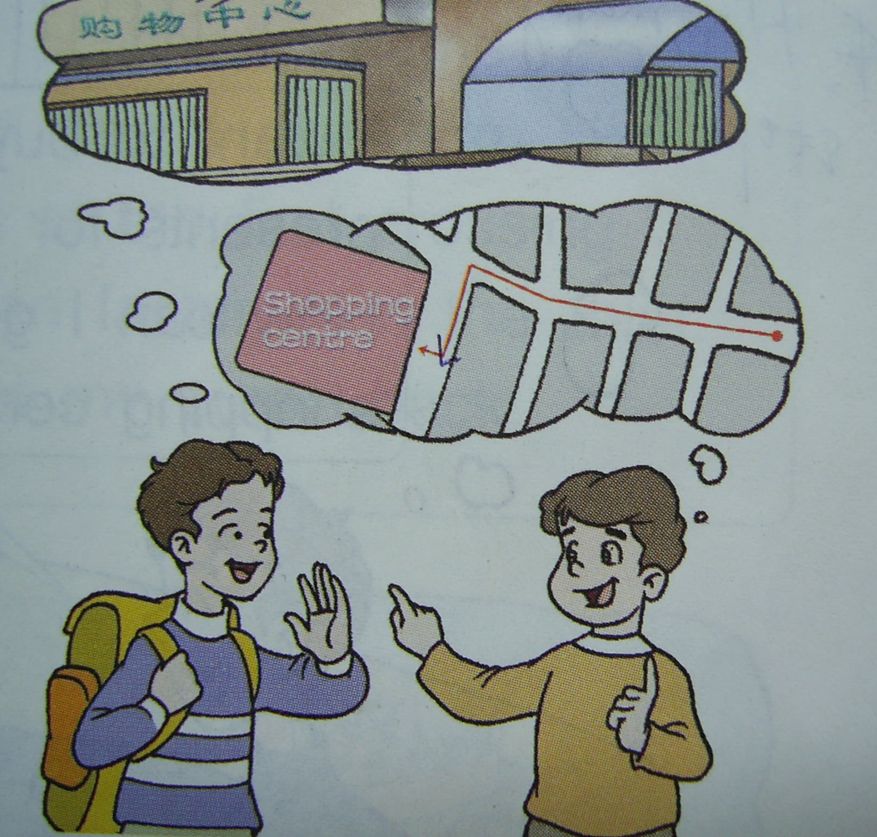
1.A: Excuse me, can you tell me the to the shopping centre?
B: Go this street, and then left at
the fourth crossing. The place is your .
You can’t miss it.
A: Thank you very much.
B: That’s all right.[来源:学科网ZXXK]
 | Tom | Nancy | Helen
Height (cm) | 160 | 155 | 150
Age | 12[来源:学。科。网] | 10 | 10
Long jump(cm) | 130 | 120 | 120
Chinese | 中 | 良 | 优
2.A: Who is than Nancy?
B: Tom is. And he is two years ________than Nancy and Helen.
A: Look. Nancy jumps as
as Helen.
B: Yes. Does Helen do________ __________Chinese?
A: Yes, she does.
七、连词成句。（10分）
1.to, do, who, want, to, write, you, [来源:学。科。网]
?
2. will, soon, finish, school, go, primary, to, middle, I, school, and,
___________________________________________________ .
3. a, is, there, in, school, tomorrow, concert, the, morning.
___________________________________________________?
4. is, what, weather, the, like, in, there, autumn,
____________________________________________________ ?
5. twenty, Su Hai, Su Yang, than, minutes, younger, is,
____________________________________________________?
八、按要求完成下列句子，每空一词。 (10分)
1. My mother does housework every day. (改为否定句)
My mother housework every day.
2. The red box is big. The green box is bigger. (用than 并成一句话)
The red box is the green box.
3. He often visits his grandfather. (把often 改为now)
He his grandfather now.
4. Nancy is going to play the piano at the concert.（对划线部分提问）
What is Nancy to at the concert?
5. There are three birds in the tree. （对划线部分提问）
birds are there in the tree?
九、改错。（10分）
( )1.Liu Tao is as stronger as Tom.
A B C
( )2.Do he have any problems with his homework?
A B C
( )3.Would you like go with me?
A B C
( )4.He wants to do better but do not know how.
A B C
( )5.Sam and I are in different class.
A B C
十、排序。(10分)
1. A. Yes, I’d love to.
B. I’m going to play cards with my friends.
C. What are you going to do this afternoon?
D. Would you like to go with us?

2. A. How about this blue one?[来源:学.科.网]
B. Yes, I’d like a coat for my daughter.
C. Can I help you?
D. It’s very nice. I‘ll take it.
E. It’s pretty, but it’s too big.
F. How about this yellow one? It’s smaller than the blue one.
_______

