2013年秋季学期期末测试六年级
英 语 科 试 题
（考试时间：90分钟 总分：100分）

听力部分(30分)
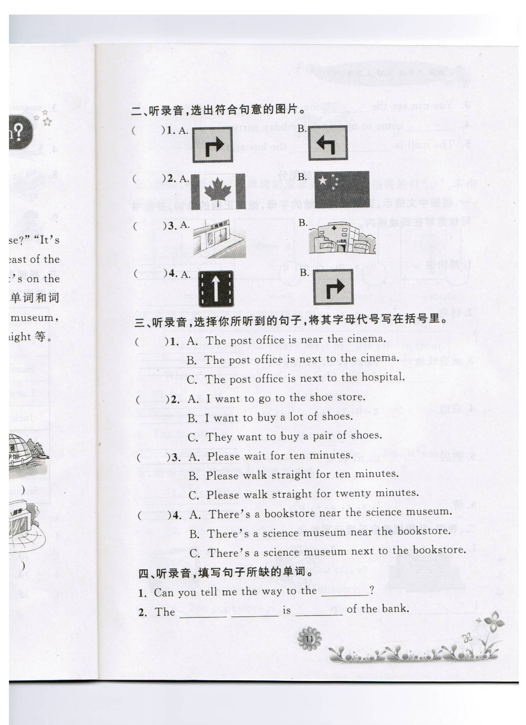
一、听句子，选图片。你将听到5个句子，请从下列每三幅图中选出符合你所听句子内容的图片，并将代表该图片的字母标号填在题前括号内。每个句子读两遍。（每小题1分，共5分）
( ) 1. A. B. C.

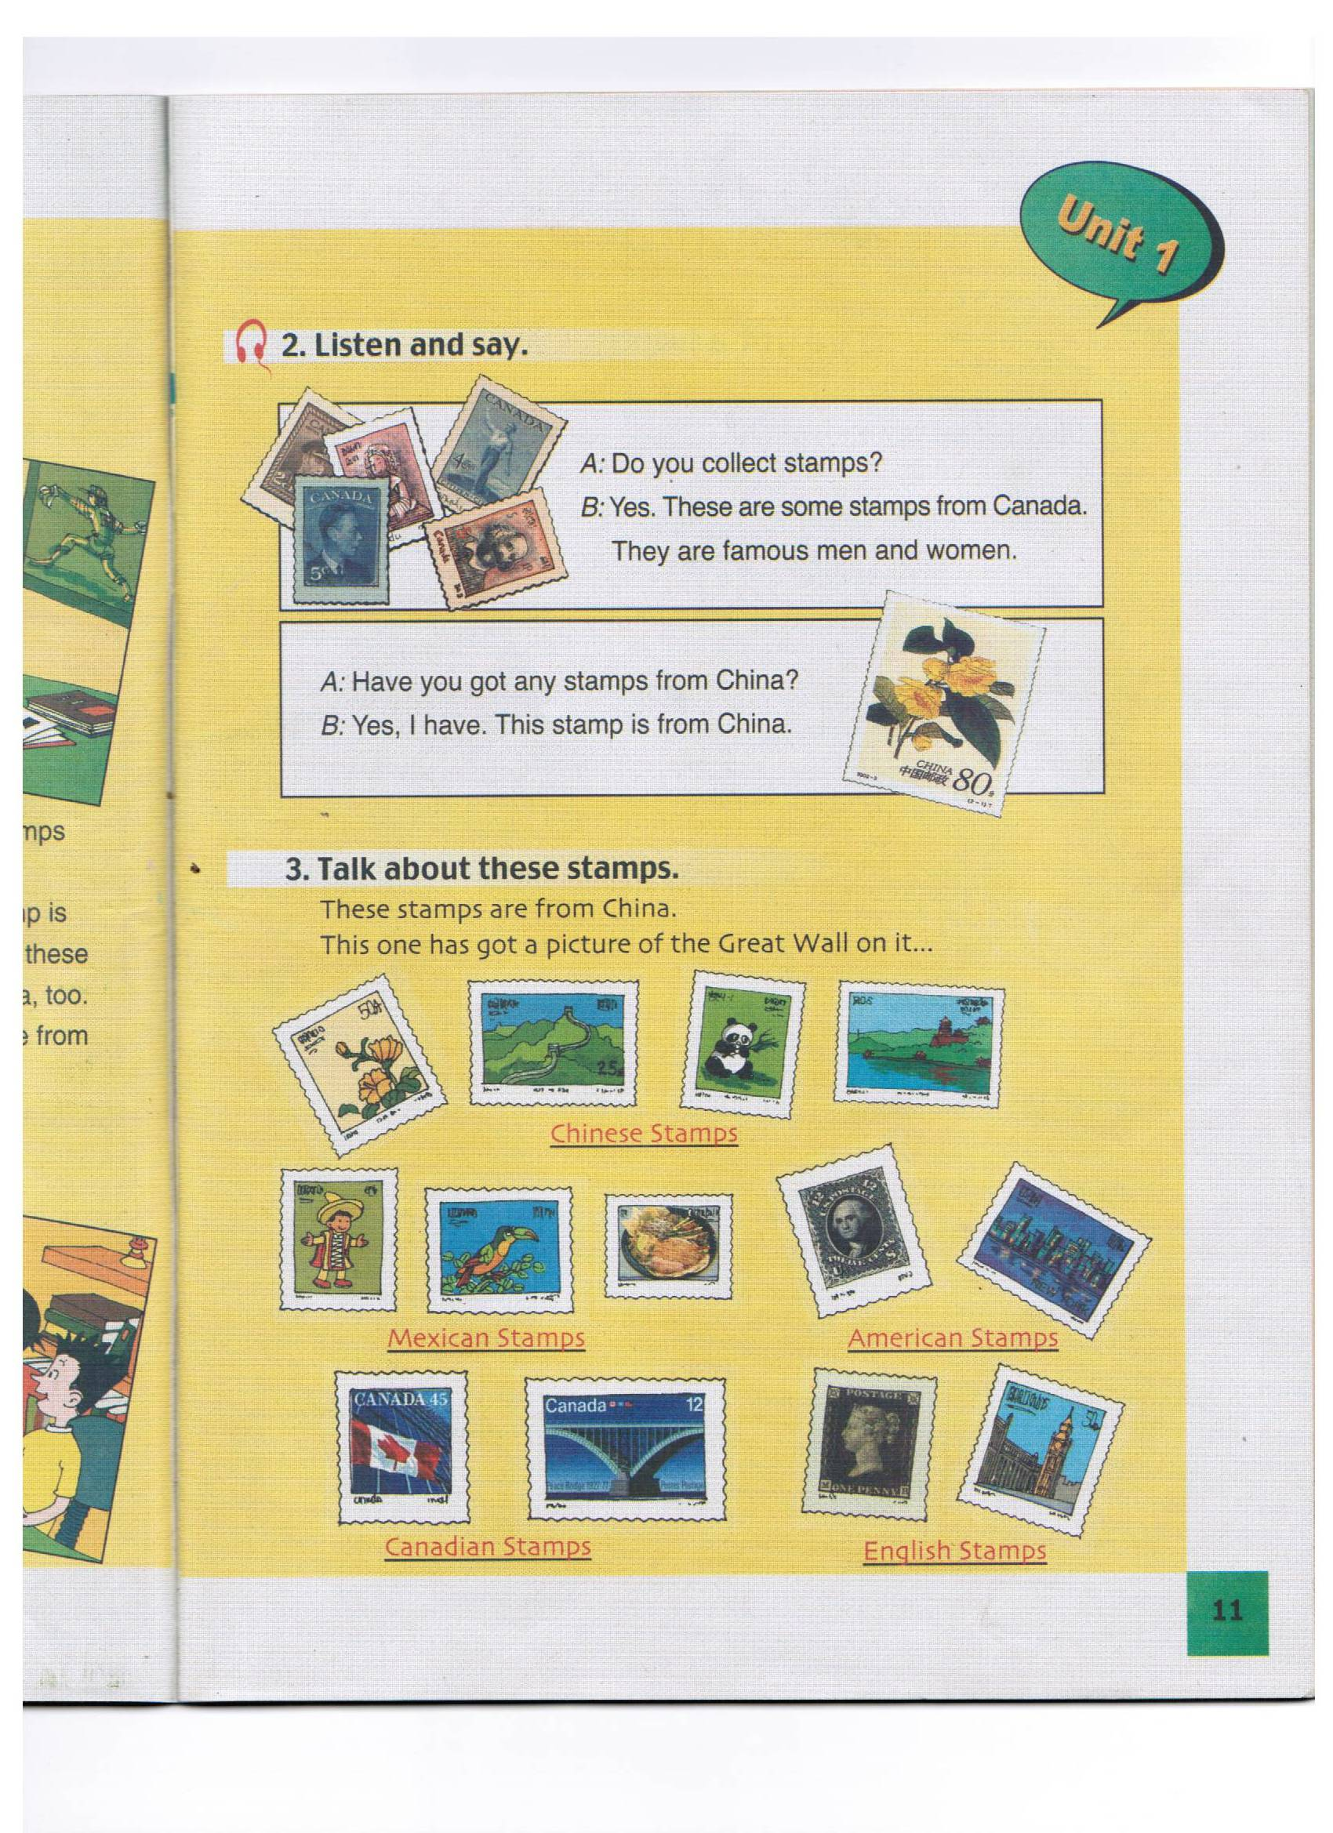
( ) 2. A. B. C.

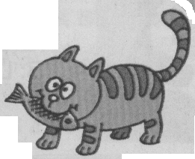
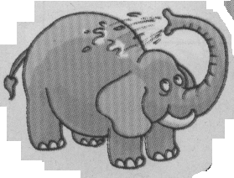

( ) 3. A. B. C.[来源:学*科*网]
B C

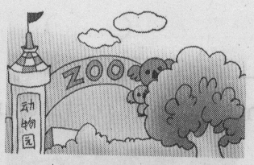
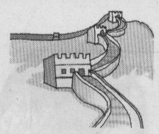
[来源:Z&xx&k.Com]
( ) 4. A. B. C.

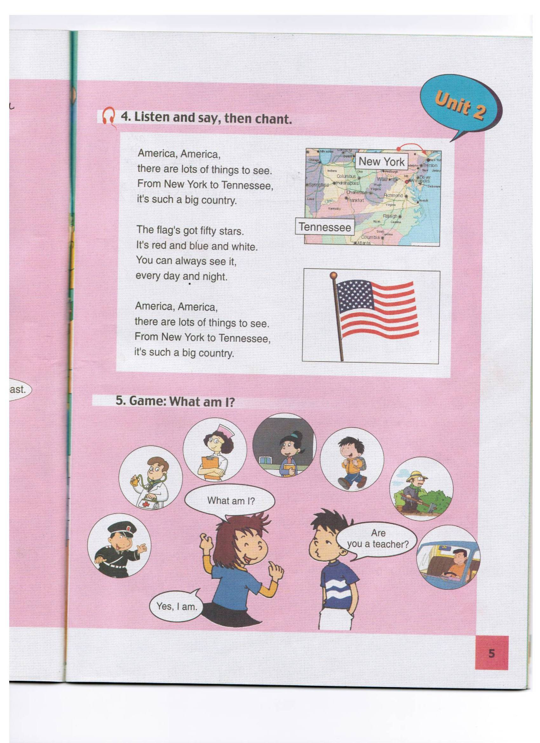
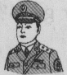
( ) 5. A. B.  C.

二、对话理解：你将听到5段对话，请根据你所听到的对话内容，分别从A、B、C三个选项中选出正确的答案，并将它的字母标号填在题前括号内。每段对话读两遍。（每小题2分，共10分）
( ) 1. A. Yes, he has. B. No, he hasn’t. C. Yes, he is.
( ) 2. A. It’s 9:00. B. It’s 11:00. C. It’s 10:00.
( ) 3. A. China. B. England. C. America.
( ) 4. A. Play the violin. B. Play football. C. Play the piano.
( ) 5. A. Not very often. B. Yes, she is. C. Yes, she does.
三、听录音连线。你将听到一段关于同学们喜欢的节日的短文，请根据所听到的内容，把名字与相应的图片配对，并将代表该节日的字母标号填在题前括号内。短文读两遍。（每小题1分，共5分）
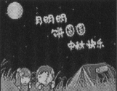

( ) 1. Sasa A.


( ) 2. Tom B.


[来源:学科网ZXXK]
( ) 3. Peter C.

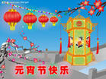
( ) 4. Lanlan D.

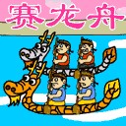
( ) 5. Lucy E.

四、听短文，排顺序。 你将听到一篇短文，请根据所听到的短文内容的先后，给下列图片按照A—E的顺序排列。短文读两遍。(每小题2分，共10分)

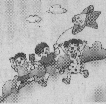




1.( ) 2.( ) 3.( ) 4.( ) 5.( )

笔试部分(70分)
一、看图认单词。请根据所给的图片，找出与它相对应的单词，并将该单词的
字母标号填入图下的括号内。（每小题1分，共5分）

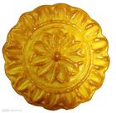

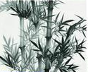
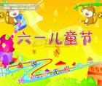

1.( ) 2.( ) 3.( ) 4.( ) 5.( )
A. moon cake B. building C. stamp D. festival E. bamboo
二、单词分类。请将下列单词按照所给单词的类别分别写在相应的横线上。（每小题1分，共10分）[来源:学#科#网]
thousand Mexico bear fork Christmas
snake million Thanksgiving knife Canada
1. elephant 2. China
3. hundred 4. chopsticks
5. Spring Festival
三、单项选择填空。请从下列各小题所给的A、B、C三个选项中选出最佳答案，并将它的字母标号填在题前括号内。（每小题1分,共10分）
( ) 1. ---- What do you do _______________ Flag Day?
---- We carry flags and we sing songs.
A. in B. of C. On
( )2. Let’s _______ to school now.
A. go B. going C. went
( )3. ---Can you _____ English? --- Yes, I can.
A. talk B. say C. speak
( )4. They _______ a beautiful house.
A. has got B. have got C. is
( ) 5. He often _______________ computer games.
A. plays B. play C. played
( ) 6. ---- ___________ are we going, Simon? ---- To the zoo.
A. What B. When C. Where
( ) 7. Linda wants to _______________ Guilin.
A. visits B. visit C. visited
( ) 8. Please _______________ quiet!
A. are B. is C. be
( ) 9. ---- Have you got _______________ picture books? ---- No, I haven’t.
A. any B. some C. a
( ) 10. I’ve got a violin, _______________ I can’t play it.
A. but B. and C. with
四、单词填空。请根据句子的前后内容，填入适当的单词，使句子完整与正确。（每小题1分，共5分）
1. is my hobby.
2. Do you like ?
3. Don’t in the library.
4. There are in this picture.
5. I can .
五、连词成句。用所给的词连接成为正确的句子，句子的第一个单词和标点符号已经给出。（每小题1分，共5分）
1. doing, what, you, are (?)
What _______________________________________
2. can, dragon, you, see, dance(.)
You ___________________________________
3. is, a, there, in, Chinatown, Now York (.)
There ________________________________________
4. want, go, inside, do, you, to (?)
Do______________________________________________
5.an, CD-ROM, interesting, what (!)
What ____________________________________________

六、情景会话。
A) 从B 栏中找出与A栏相对应的句子，并将它的标号字母写在题前的括号内。（每小题1分，共5分）
A B
( ) 1. Do you want to go to Guilin? A. It’s the Lantern Festival.
( ) 2. How long is the skip? B. No, thank you.
( ) 3. Is there a letter for me? C. Jim can.
( ) 4. What’s your favourite festival? D. It’s about two metres.
( ) 5. Who can be your pen friend? E. Yes, there is.
B) 根据对话内容，从方框中选出恰当的句子补全对话，并将它的字母标号填在题号后的横线上。（每小题2分，共10分）
A: Hi, Peter. 6
A. Have you got any stamps from England?
B. How many stamps have you got?
C. Do you collect stamps?
D. Nice to see you.
E. I’ll show you tomorrow.
B: Nice to see you, too.
A: 7
B: Yes, I do. I like stamps.
A: 8
B: About sixty stamps.
A: 9
B: Yes, I have. I’ve also got some stamps from Mexico.
A: That’s great. Can I have a look?
B: OK.
七、阅读理解（共20分）
A
Mr. White is a teacher in our school. He teaches English. He often gets up early （早早地）every day, and has breakfast at half past seven in the morning. Then he goes to school. He works very hard, and he also plays table tennis with us. After school, he goes home at five in the evening. He always has dinner at six. After that he reads newspaper or watches TV. He has a pet cat. It is black. He loves it very much.
根据短文内容，判断下列句子的正误，正确的在题前括号内写“T“，错误的写“F”。（每小题1分，共5分）
( ) 1. Mr. White is an English teacher.
( )2. He has breakfast at 7;30 in the morning.
( )3. He plays football with us.
( )4. He never has dinner at six.
( )5. Mr. White has a pet cat.

B
Dear Tony,
How are you? I write to you at school. We go to school from Monday to Friday. There are four classes in the morning and three classes in the afternoon. We often do our homework after school. I have two friends at school. One is from Australia, his name is Mike. The other is from America, her name is Linda. They speak English very well. I like playing games with them. What about you? Please write to me soon.
Yours,
Han Meimei
根据短文内容，选择下列各题的正确答案，并将它的字母标号填入题前括号内。（每小题1分，共5分）
( ) 6. Who write this letter?
A. Tony. B. Han Meimei. C. Mike.
( ) 7. How many classes are there in a day?
A. Three. B. Four. C. Seven.
( ) 8. How many friends does Han Meimei have at school?
A. One. B. Three. C. Two.
( ) 9. Is Linda from America?
A. No, she isn’t. B. Yes, she is. C. Yes. She does.
( ) 10. Can they speak English well？
A. No, they can’t. B. Yes, they do. C. Yes, they can.
C[来源:学+科+网]
My name is Bob. I live in England and I want a pen friend in China. I think China is an interesting country. I am 13 years old. I can speak English and a little Chinese. I like going to see films with my friends and playing sports. My favourite subject(科目) is PE. It’s fun. My hobby is collecting stamps.
根据短文内容,回答下列问题。（每题2分，共10分）
11. Does Bob live in China?
12. How old is he?
13. Does he like playing sports?
14. What is his favourite subject?
15. What is his hobby?

