2014—2015学年度下学期期末学业水平测试
六年级英语试题（pep新版第六册）
时间：50分钟 总分：100分
题号 | 一 | 二 | 三 | 四 | 五 | 六 | 七 | 八 | 九 | 十 | 总分
得分
听力部分（每个大题10分，共40分）
一、选出所听句子中包含的单词。每个小题读两遍。
( ) 1. A. me B. my C. mine
( ) 2. A. clean B. open C. closed
( ) 3. A. eating B. sleeping C. reading
( ) 4.A. spring B. summer C. autumn
( ) 5.A.September B. October C. November
二、听句子，判断句意是否与图片相符，相符打√，不相符打×。每个小题读两遍。
6.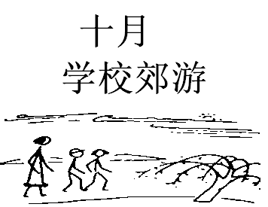7.8. 9.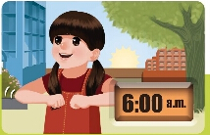10. 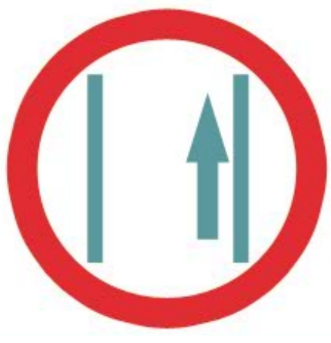 ( ) ( ) ( ) ( ) ( )
三、看图画，听句子，选择适当的答语。每个小题读两遍。
1.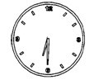 2.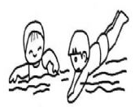 3.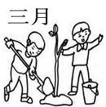 4.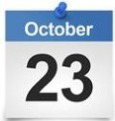 5.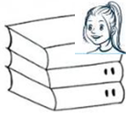
( ) 11. A. I usually get up at six thirty. B. I usually get up at seven forty.
( ) 12. A.I often go skating. B. I often go swimming.
( ) 13. A. It’s in March. B. It’s in April.
( ) 14. A. It’s on October 23. B. It’s on October23rd.
( ) 15. A. They’re his. B. They’re hers.
四、听对话，根据你听到的顺序给图画标序号。每个小题读两遍。
16.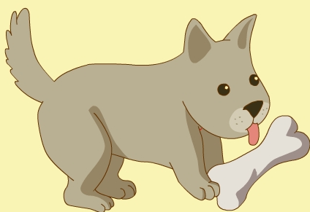17.18.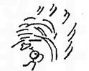19.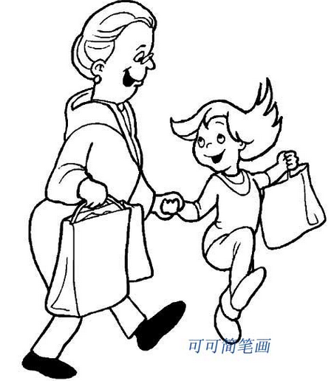20.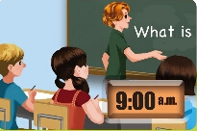
( ) ( ) ( ) ( ) ( )
笔试部分（每个大题10分，共60分）[来源:学+科+网Z+X+X+K]
五、语音和词汇。
A.仔细读单词，选出划线部分发音不同的选项。
( ) 1. A. now B. show C. snow [来源:学§科§网Z§X§X§K]
( ) 2. A. whose B. what C. where[来源:Zxxk.Com]
( ) 3. A. mouse B. young C. count
( ) 4. A. mother B. this C. three
( ) 5. A. read B. cheap C. healthy
B．选出每组不同类别的单词。
( ) 6.A. second B. fifth C. twenty
( ) 7.A. autumn B. August C. February
( ) 8.A. Easter B. holiday C. Christmas
( ) 9. A. I B. his C. theirs
( ) 10.A.has B. eating C. climbing
六、选择最佳答案填空。
( )1、I usually get up ________ 6:00 in the morning.
A. at B. in C. on
( ) 2、Children eat __________on Easter.
A. mooncakes B. noodles C. chocolate eggs
( ) 3、I like __________best. Because I can eat ice cream.
A. spring B. summer C. winter
( ) 4、October is the month of a year.
A. eighth B. ninth C. tenth
( ) 5、On___________ ,we always eat Zongzi（粽子）.[来源:Zxxk.Com]
A. National Day B. Dragon Boat Festival C. Mid-Autumn Day.
( ) 6、My birthday is on August__________.
A. twelve B. twelfth C. the twelfth
( ) 7、Whose picture is it? Ask Amy, maybe(大概) it’s___________.
A. she B. her C. hers
( ) 8、Look at my dog. It’s _________. It’s cute.
A. sleep B. sleeps C. sleeping
( ) 9、Shh, ____________. It’s in the library.
A. talk quietly B. keep to the right C. keep your desk clean
( ) 10、—Can I use your crayons? —OK.__________.
A. Take turns B. Have a look C. Thank you
七、从B栏中选择A栏中问句的答案，将其序号填在括号.
A B
( ) 1.Whose bike is that? A. I often take a trip.
( ) 2.When is Mother’s Day? B. It’s Zhang Peng’s.
( ) 3.Can I play with him now？ C. She is eating dinner.
( ) 4.What is Chen Jie doing? D. No, you can’t. He is reading.
( ) 5.What do you often do on summer vacation? E. It’s in may.
八、从方框内选择合适的疑问词填空,只填序号。
A. Which B. What C. Where D. Whose E. When
1. A: ________is your mother? B: She is in the kitchen.
2. A: ________pictures are these? B: They’re Amy’s.
3. A: ___________is the sports meet? B: It’ on April4th.
4. A: ___________season do you like best? B: Winter. I love snow.
5. A:_______ these rabbits doing? B: They are playing with each other.
九、阅读理解。读对话，根据题意，选择最佳答案。
Mike: Hello. This is Mike. Is that Wu Yifan?
Wu: Yes, this is Wu Yifan. What are you doing, Mike?
Mike: I'm watching TV. What are you doing? And how is everybody doing?
Wu: Just fine. I'm doing my homework. My father is reading books in the study. My mother is cooking in the kitchen. And my brother is doing kungfu and my sister is drawing cartoons.
Mike: What do you do on the weekend?
Wu: I visit grandparents and go shopping.
Mike: Do you want to go to the nature park?
Wu: Sure. What time?
Mike: At one thirty.
Wu: OK. See you later.
Mike: See you..
( ) 1.____________is answering the phone(接电话). [来源:学科网]
A. Mike B. WuYifan
( ) 2. WuYifan’s father is ___________in the study.
A. reading books B. listening to music
( ) 3.___________drawing cartoons.
A. WuYifan’s brother B. WuYifan’s sister
( ) 4.WuYifan often__________on the weekend.
A. plays football B. visits grandparents
( ) 5.WuYifan wants to go to________ at 1:30 with Mike.
A. the nature park B. the zoo
十、请根据自己的实际情况回答问题。
1.What do you usually do on the weekend?
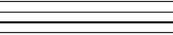
2.When is your mother’s birthday?
3.What will you do for your mum on her birthday?
4.Are you having an exam (考试)now?
5.Whose classroom is this? Is it yours?

