2012-2013学年小学英语六年级期末检测试题
姓名：________ 年级：_________
- 听力测试（共计15分）
I．听录音，判断下列图片与所听内容是否一致，如果一致，请在相应位置圈笑脸，如果不一致圈哭脸，每个句子读三遍。（5分）
例：笑— 哭--
1. 2. 3. 4. 5.
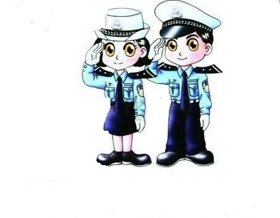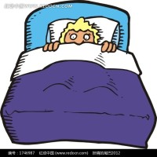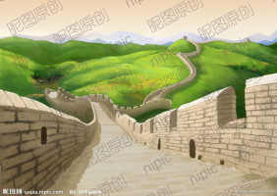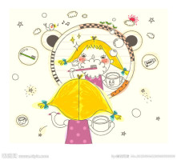
II.听录音，根据听到的每组对话，将相应的内容连接起来。每个句子读三遍。（5分）
6. Peter 7. Rose 8. Ting Ting 9. Jack 10. Summer

_______ _______ _______ _______ _______
on foot by train by car by ship by plane
(1) (2) (3) (4) (5)

Shanghai home France Zhongshan Park Chongqing
A B C D E
III.听录音，根据听到的先后顺序用A-E为下面的图片标号，并把排好的顺序号填写在相应的位置，每个句子读三遍。（5分）
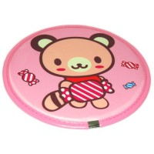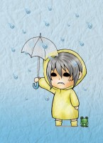
A B C D E
11-15_____________________________[来源:Zxxk.Com]

二、写（共计20分）
I．写出10个26个英文字母中只占中间一格字母的小写形式。（10分）
………… ………… ………… ………… ……………
………… ………… ………… ………… … ……….
16. ------------ 17. ------------ 18. ------------- 19 ------------ 20 --------------
………… ………… ………… ………… ……………

………… ………… ………… …………. …………..
………… ………… ………… ………… … ……….
21. ------------ 22. ------------ 23. ------------- 24 ------------ 25 --------------
………… ………… ………… ………… ……………

II.观察A栏的图片，从B栏中找出与A栏图片类型相同的单词，并将正确答案抄写在四线三格内。（6分）
A. strawberry 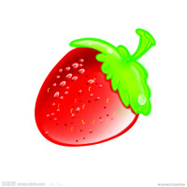
B. orange waiter date loquat
square grape kiwi fruit peach

…………….. ……………… ……………..
26 ……………… 27 ……………….. 28 ………………
----------------- ------------------ -----------------
…………….. ………………. ……………...

…………….. ……………… ……………..
29 ……………… 30 ……………….. 31 ………………
----------------- ------------------ -----------------
…………….. ………………. ……………...
III.根据问句，从A、B、C、D四个答句中选出合适的答语（每个只用一次），并将选出的答句抄写在四线三格内。（4分）
32.Can I help you? 33.What’s the weather like?
………………………………………… ………………………………………
………………………………………… ………………………………………
………………………………………… ………………………………………
………………………………………… ………………………………………
34.What time do you go to school? 35.How does it feel?
………………………………………… ………………………………………
………………………………………… ………………………………………
………………………………………… ………………………………………
………………………………………… ………………………………………
A. It feels round and smooth. B. Yes, I want an eraser.
C. It’s overcast. D. I go to school at 7:00.

三、单项选择。（共计35分）
I．选择出下面每组中不属于同一类的单词，并将选出的答案番号填写在题前括号内。（5分）
( )36. A. taller B. longer C. shorter
( )37. A. fruit B. longan C. peach
( )38. A.windy B. fine C. fog
( )39. A. oval B. shape C. triangle
( )40. A. lunch B. supper C. shower

II. 根据情景选择正确地表达方式，并将选出的答案番号填写在题前括号内。（10分）
( )41. 你想知道朋友每天几天钟上床睡觉，可以说：
A What time do you get up every day?
B What time do you go to bed every day?
( )42. 你想告诉别人它看起来像个椭圆形，可以说：
A It looks like a oval. B It looks like a diamond.
( )43. 你想告诉别人苹果吃起来很甜，可以说：
A The apple tastes sweet. B The apple feels sweet.
( )44. 你想告诉别人你爷爷是个书商，可以说：
A My grandpa is a farmer. B My grandpa is a bookseller.
( )45.朋友到你家做客，你想让她随便吃些芒果，可以说：
A Help yourself to some cherries. B Help yourself to some mangoes.
III.从A、B两个答案中选出一个，组成正确意思的答案，并将选出的答案番号填写在题前括号内。（10分）
( )46. I’m _____ nurse. He’s ______ engineer.
A. a, an B. an, an
( )47. The dress is on sale now. It’s _____ than usual.
A. cheap B. cheaper
( )48.---________ do they smell? ----They smell sweet.
A. How B. What
( )49.I have breakfast _____ seven thirty.
A in B at
( )50.This cake is ____ than that one.
A bigger B biger
( )51.I go to school _____.
A by foot B by bus
( )52.You’d better _____ in bed.
A staying B stay
( )53.—How can you get to Beijing? –Let’s go _____ plane.
A on B by
( )54.He _____ on night duty yesterday.
A was B is
( )55.It’s time _____ school.
A to B for
IV. 根据问句选择合适的答语，并将选出的答案番号填写在题前括号内。（10分）
( )56. Help yourself to some pears.
A Give them to me. B Thank you.
( )57. Which dress is better?
A The green one. B It suits you well.
( )58. What does your father do?
A He is a waitress. B He is an artist.
( )59. What’s the matter?
A I feel terrible. B You’d better not go to school.
( )60.Where are you going?
A She is going to visit China. B I’m going to visit France.
四、配对（共计10分）
I.将图片与相应的词语配对，并将配对好的答案番号填写在相应位置。(5分)
61.play computer games 62.by plane 63.take some medicine
64.brush my teeth 65.have a cough
61._____ 62._____ 63._____ 64._____ 65._____[来源:学,科,网Z,X,X,K]
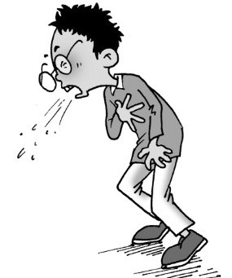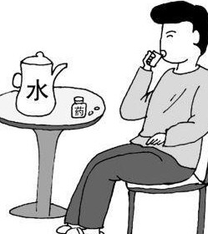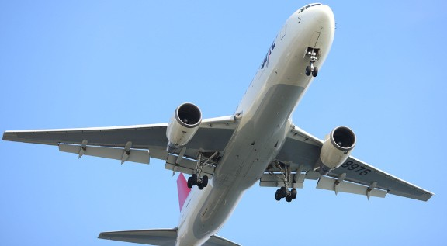
A B C D E
II.将B 栏的单词与A栏的单词配对，并将配好对的答案番号填写在相应位置。（5分）
A B
66. put A. foot
67.stay B. on more clothes
68. on C. in bed
69. take D. a taste
70. have E. a shower

66.______ 67.______ 68.______ 69.______ 70.______[来源:Zxxk.Com]
五、排序（共计10分）
I.下面单词的字母被打乱了顺序，请同学们将字母重新排序，使其组成一个与图片意思相符的正确单词，并将其填入相应位置。（3分）
71. 72. 73.
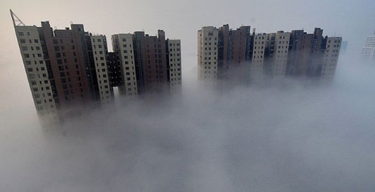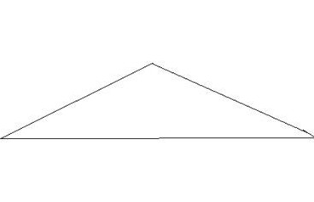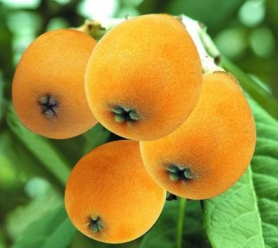
gyfog angtrile qutsaol

___________ ____________ _________

II.下面句子里的单词被打乱了顺序，请同学们找出正确地顺序，使其组成一个正确地句子，并将其写在下面横线上。（3分）
74. some and take medicine good have rest a (.)

____________________________________

75. half seven what tomorrow about morning (?)

_____________________________________

76. what with is wrong you (?)

_____________________________________
[来源:学科网ZXXK]
III．将B栏的表达组成一个小对话，并将小对话正确顺序的番号填写在A栏的横线上。（4分）
A B
77._______ a. Oh, great !I can’t wait.

78._______ b. How can we go there?.

79._______ c. We’re going to visit an orchard tomorrow.

80._______ d. We’ll go by boat first, then on foot

六、判断正误（共计10分）
I．看下列图片，并判断下列句子是否与图片意思相符，如果相符请在题前括号内填“T”，如果不相符就填“F”。（4分）
（ ）81.It looks like a rectangle. ( )82.-What does your father do?
–He is an shop assistant.
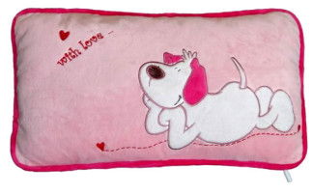

( )83.–What’s the weather like in Beijing? ( )84. -What fruit do you like best?
–It’s snowy. -I like apples.
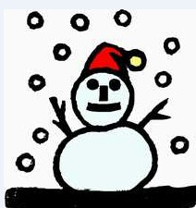 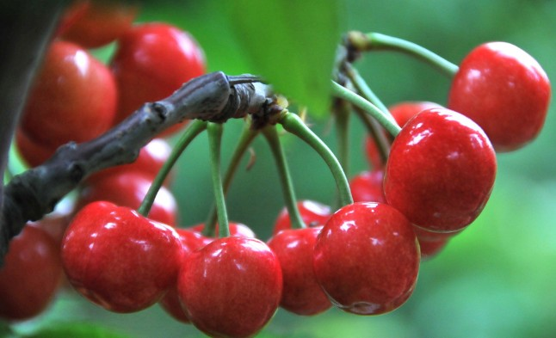[来源:Z+xx+k.Com]

II.阅读下面这则短文，判断下面句子的描述是否与短文内容相符，如果相符，请在题前括号内填“T”， 如果不相符就填“F”。（6分）
Jack and John are twine. They are good at English. They like to swim and ride bikes in their holidays. They often fly kites near the lake. But they are not all the same. Jack likes playing football, but John likes playing ping-pong; Jack likes listening to music, but John likes pictures. They often help each other.
( )85. They are good at Chinese.
( )86. They like playing ping-pong and riding bikes in their holidays.
( )87 They fly kites near the lake.
( )88 Jack and John like playing football.
( )89 They never help each other.

