英杰希望学校
2013年小学英语六年级期末检测模拟题

一、听力测试（共计15分）
1.听录音，判断下列图片与所听内容是否一致，如果一致，请在相应位置圈笑脸，如果不一致圈哭脸。每个句子读三遍。（5分）
例：笑→ 哭→
1. 2. 3. 4. 5.
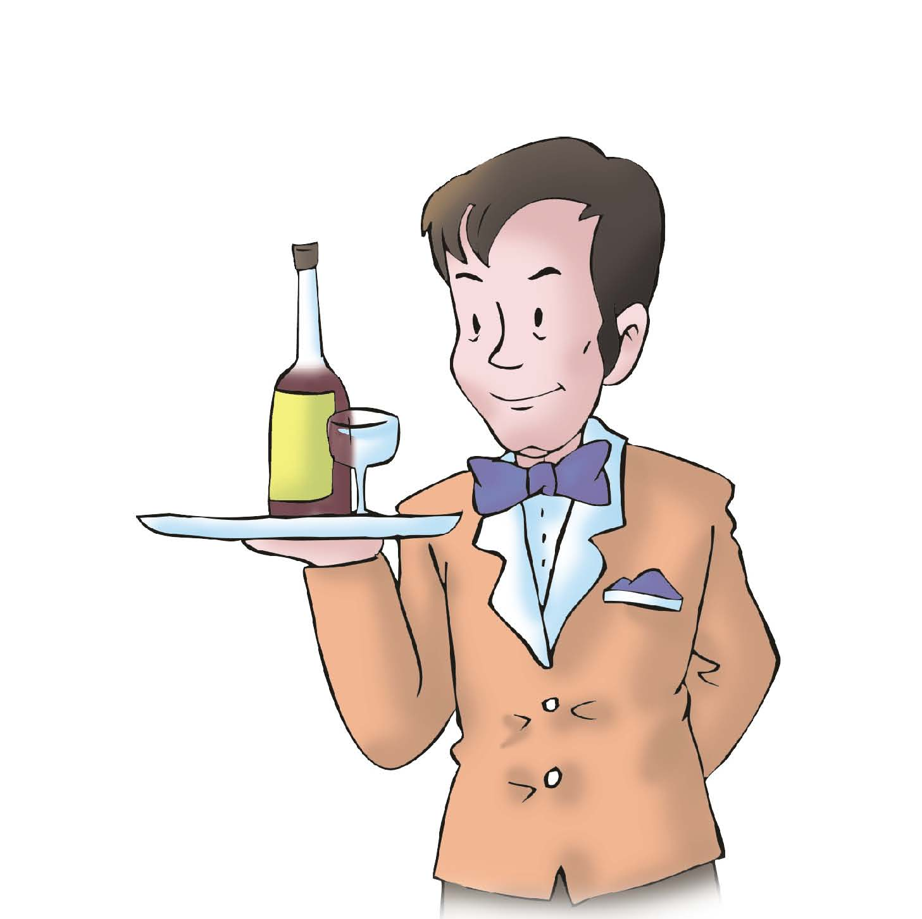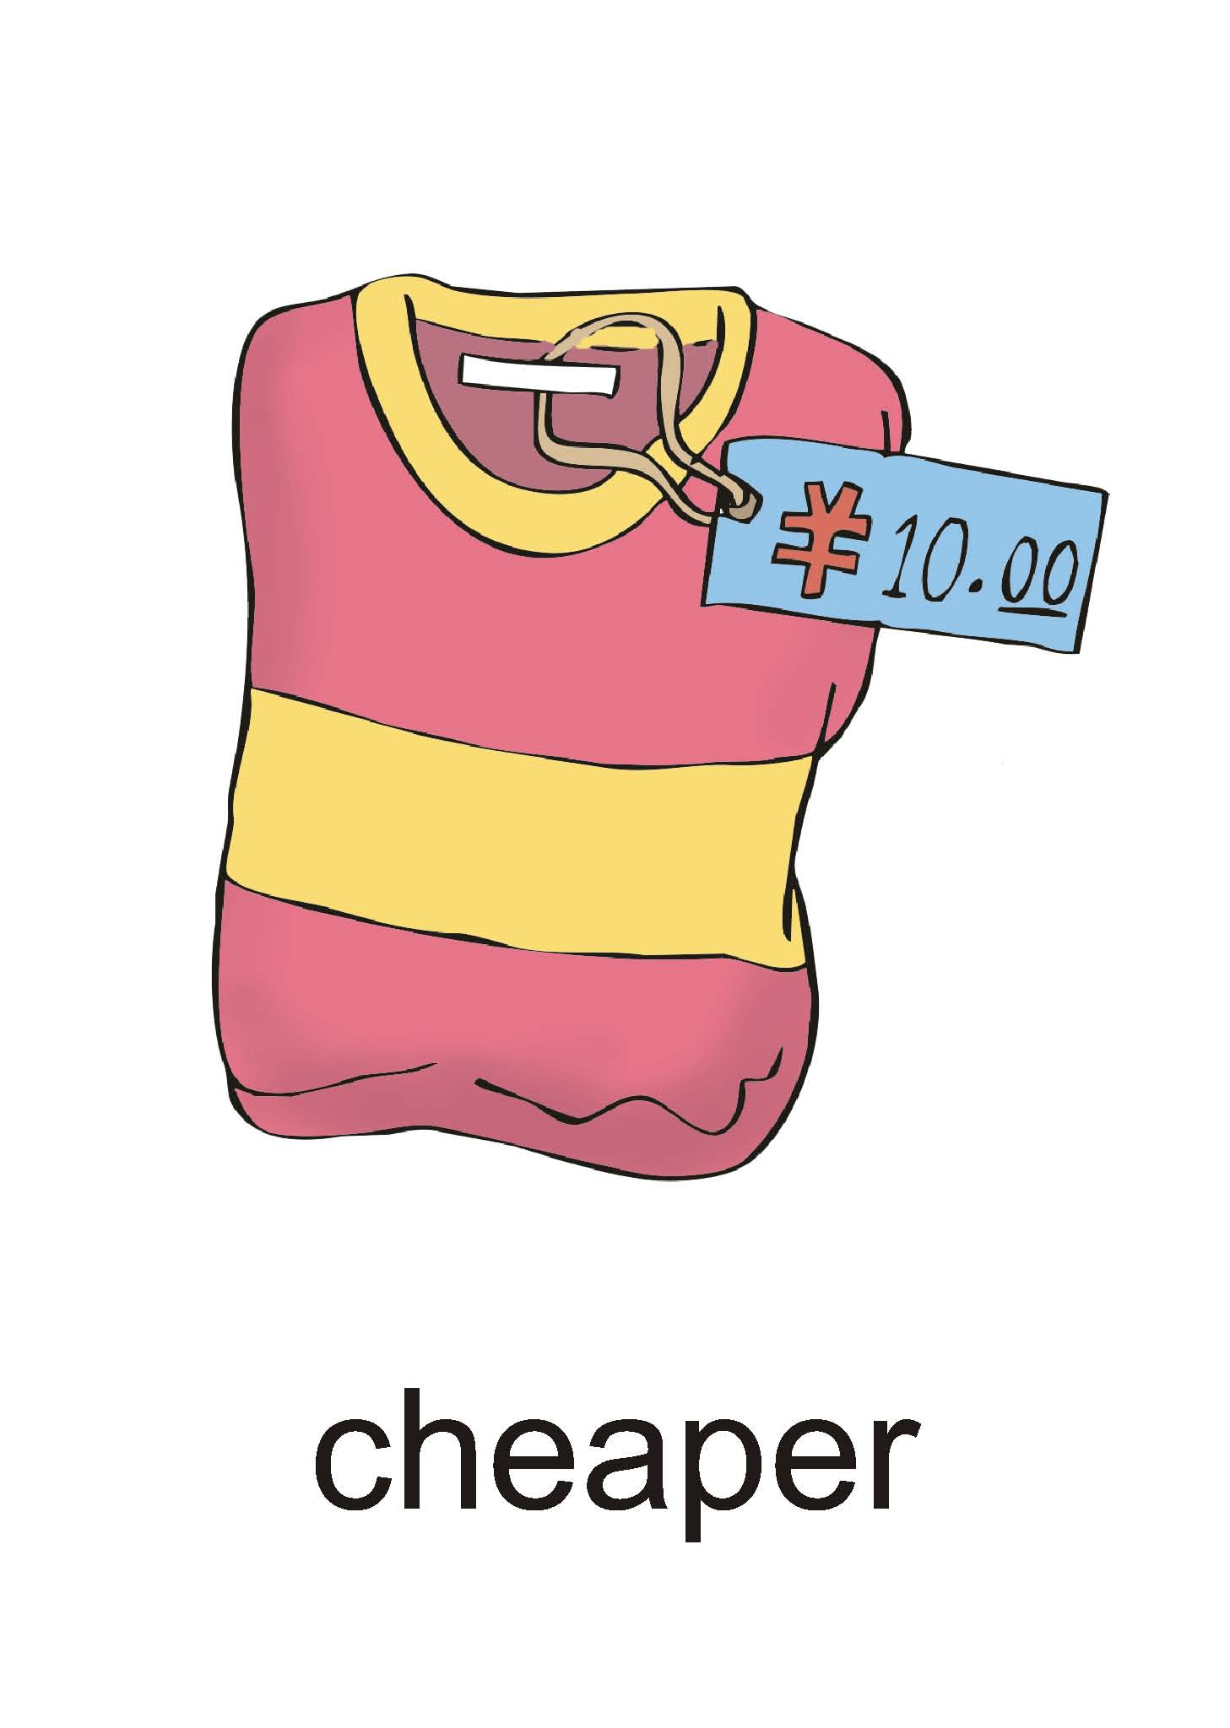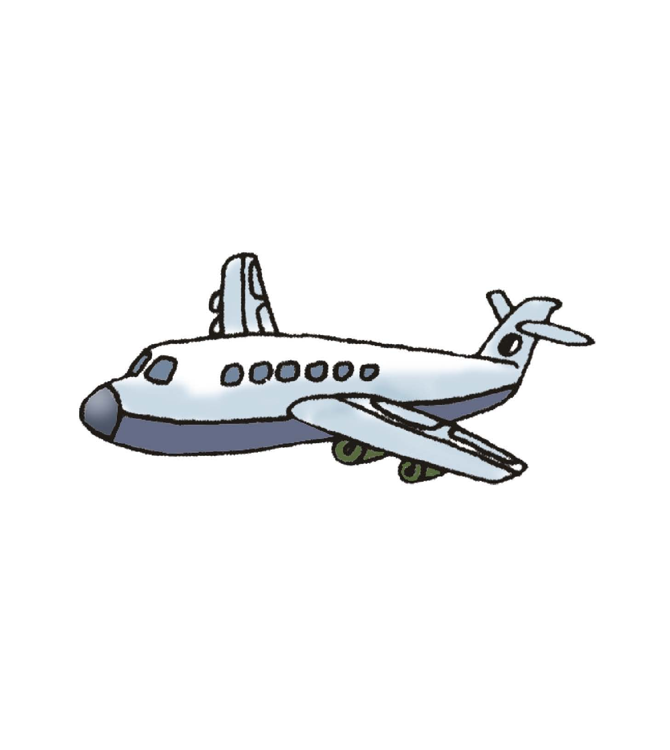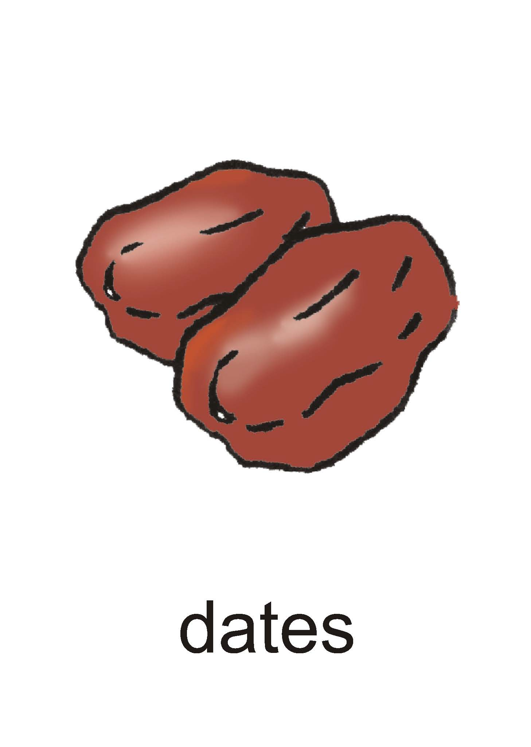

Ⅱ.听录音，根据所听内容配对，并将配好对的答案番号填在相应位置。每个句子读三遍。（5分）
6. Peter 7. Mary 8. Nancy 9. Summer 10. Sam

( ) ( ) ( ) ( ) ( )

tired terrible sleepy thirsty uncomfortable
① ② ③ ④ ⑤

watch TV work rest water eat
A B C D E

Ⅲ.听录音，根据所听到的先后顺序用A-E为下面的图片标号，并把排好的顺序号写在相应位置。（5分）
11. 12. 13. 14. 15.
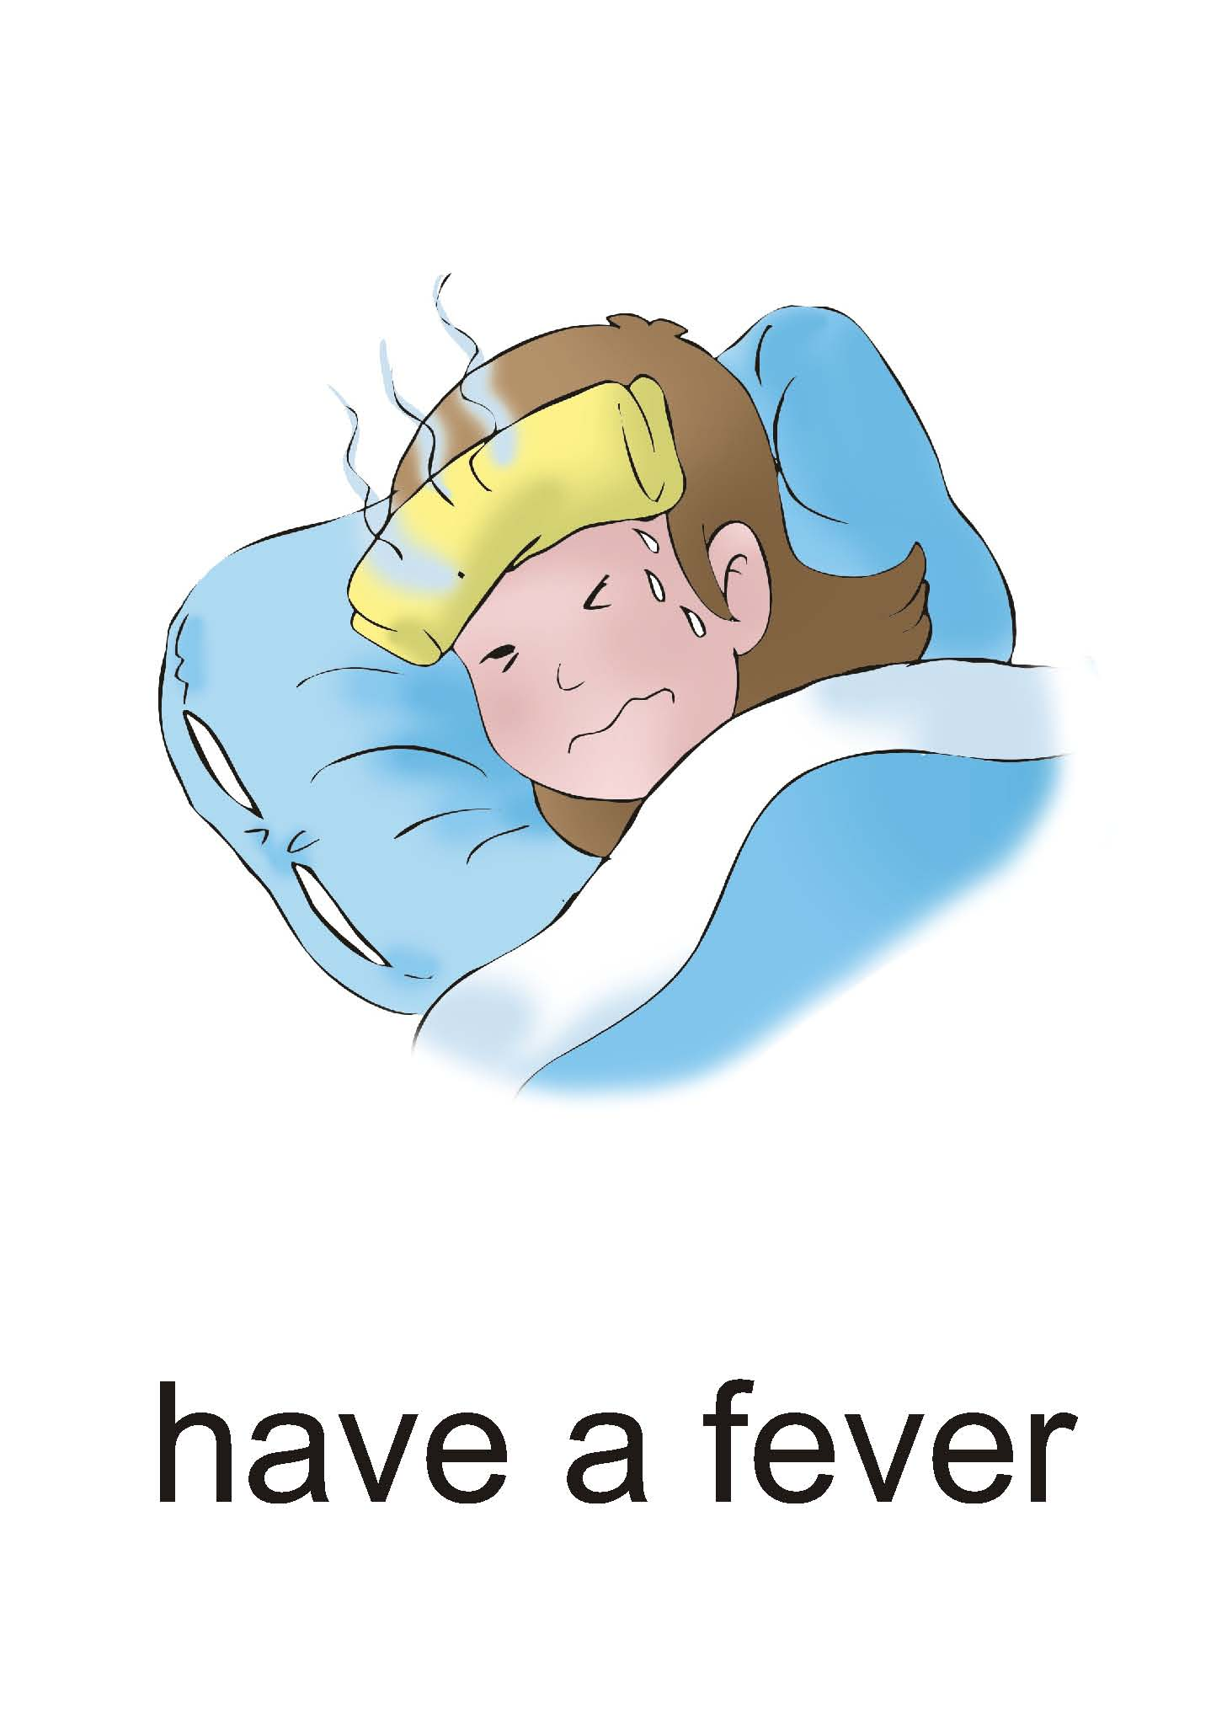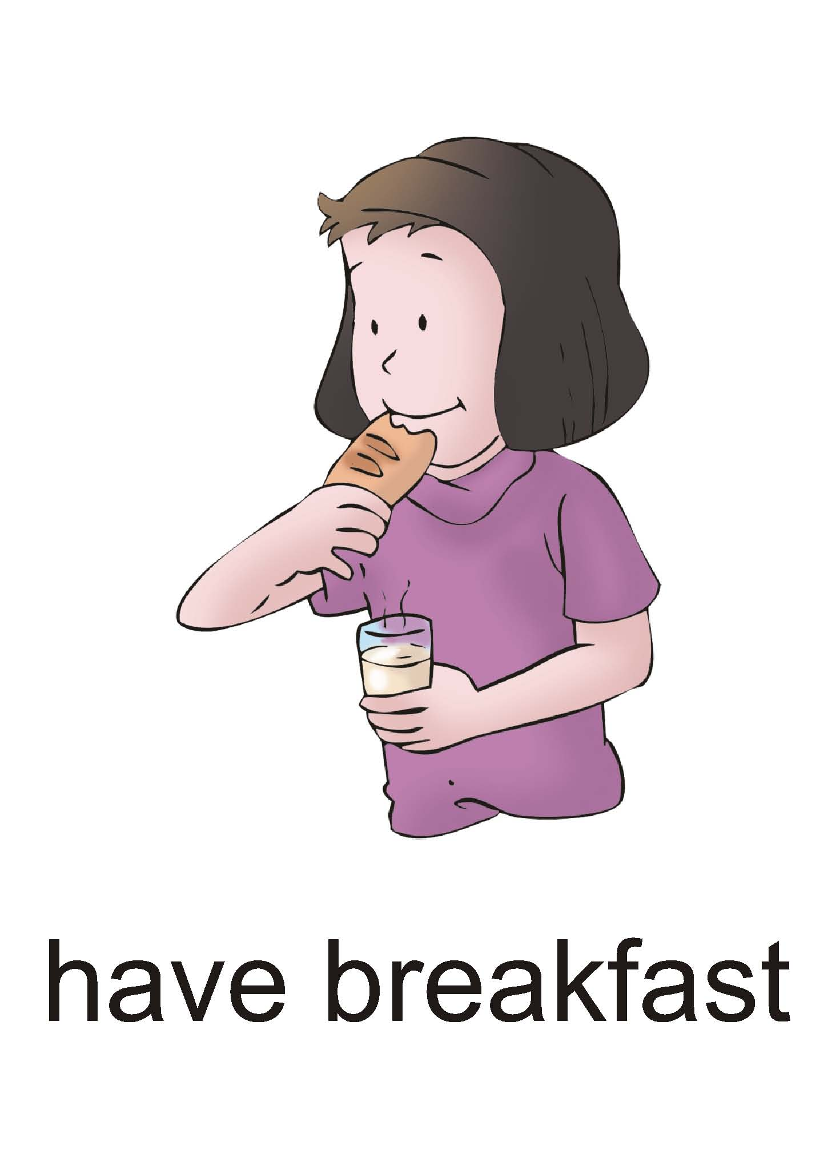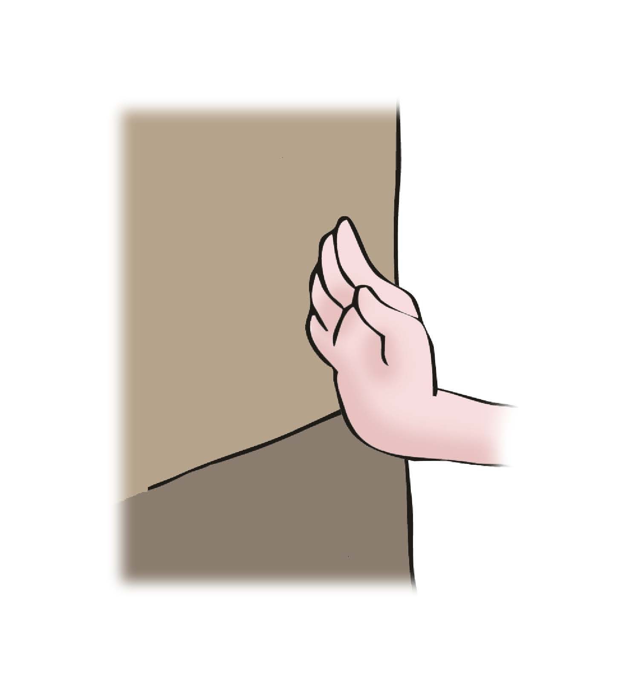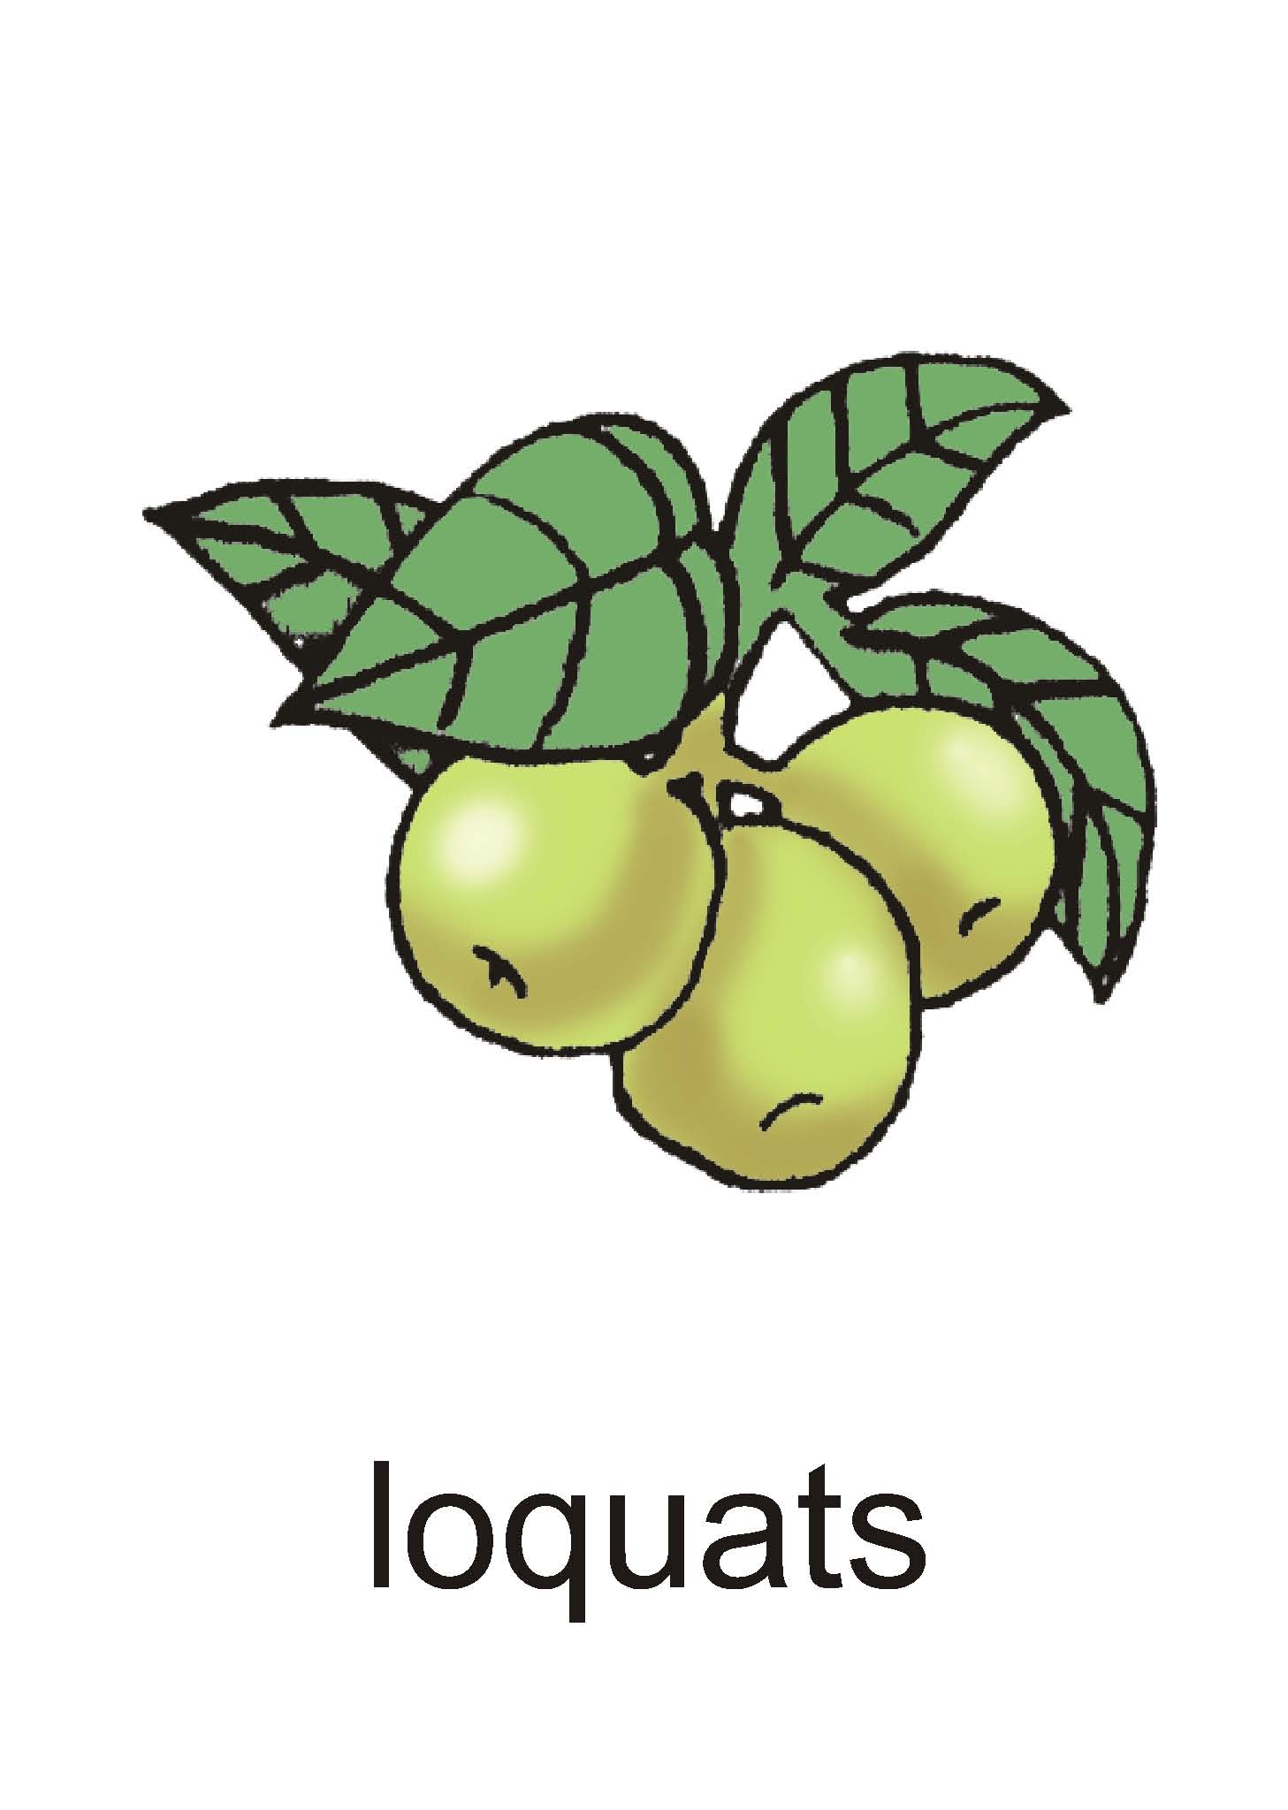
A B C D E

11-15

二、写（共计20分）
Ⅰ.写出字母Hh—Qq的大小写形式。（10分）
16--25
Ⅱ.观察A栏的图片，从B栏中找出与A栏图片类型相同的单词，将正确答案抄写在四线三格内。（6分）
A. 26-----31
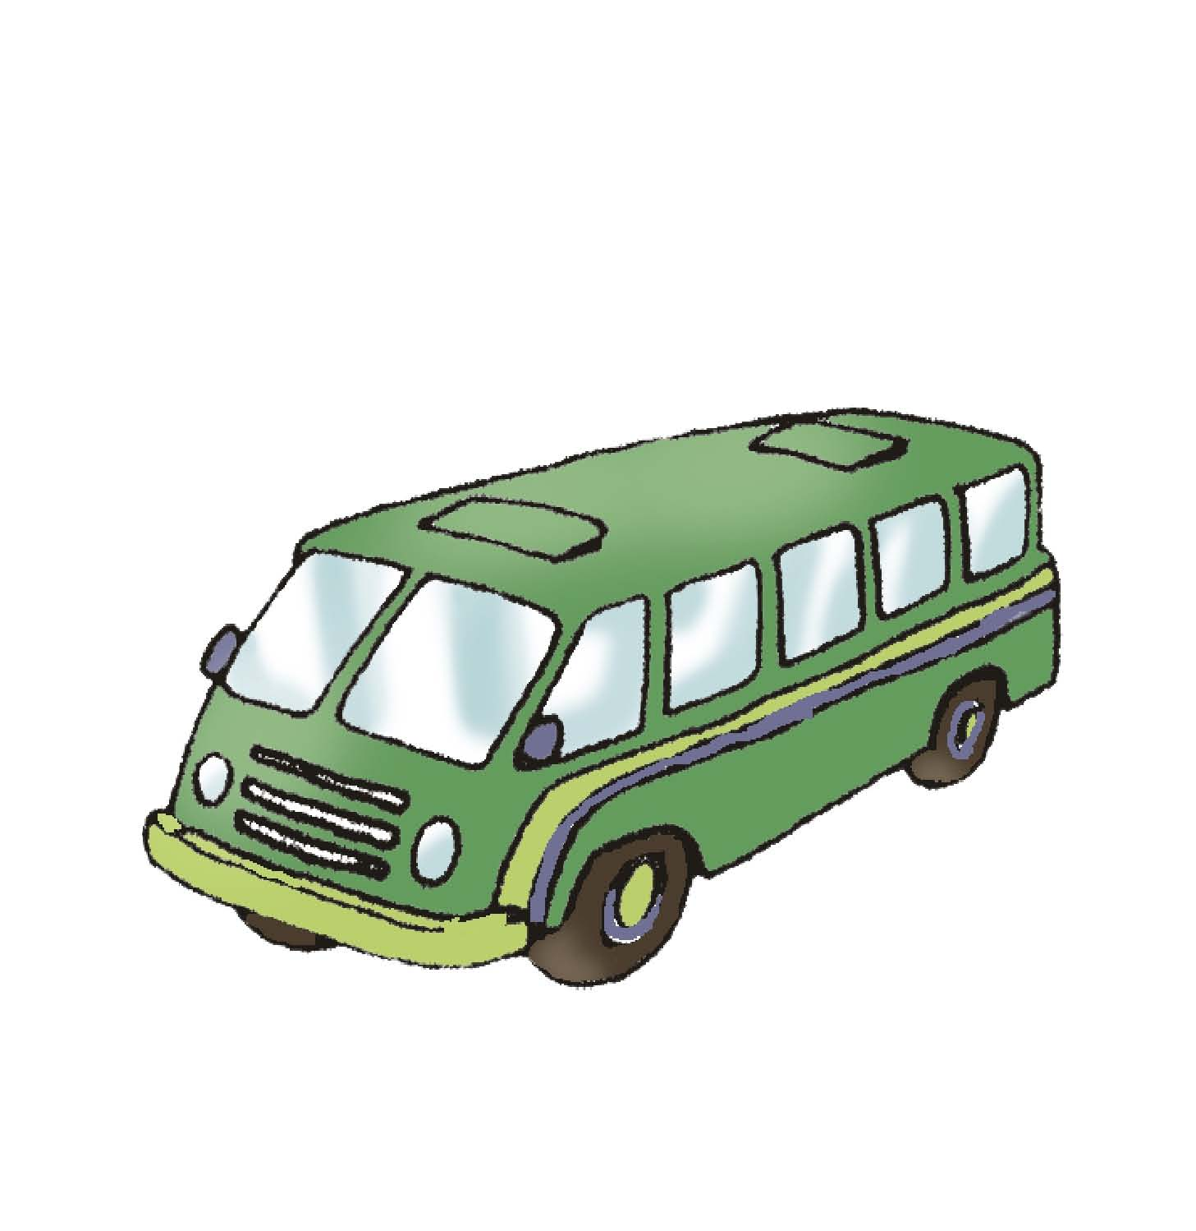

B.
plane water foot taxi artist car ship train
Ⅲ.根据问句，从A,B,C,D四个答句中选出合适的答语（每个只用一次），并将选出的答句抄写在四线三格内。（4分）

32. What does your sister do? 33. what is wrong with you?
34.How is the weather? 35. What shape is it?

A. It is a circle.
B. I have a cold.
C. She is a shop assistant.
D. It is fine.

三、单项选择（共计35分）
Ⅰ.选出下面每组中不属于同一类的单词，并将选出的答案番号填写在题前括号内。（5分）

( ) 36. A. yucky B. yummy C. laugh
( )37. A. you B. your C. my
( )38. A. smell B. look C. slow
( )39. A. headache B. cough C. doctor
( )40. A. hard B. rainy C. fine

Ⅱ. 根据情境选择正确的表达形式，并将选出的答案番号填写在提前括号内。（10分）

（ ）41. 你告诉别人要好好照顾自己，应说：
A．Take care of yourself B. You, too.
（ ）42. 婷婷打电话自我介绍时，应说：
A. This is Ting Ting speaking. B. I am Ting Ting,
（ ）43. 询问天气状况时，应问：
A．What is the weather like? B. How is the weather like?
（ ）44. 你想表达重庆天气晴朗，应说：
A．It is snowy in Chongqing. B. It is fine in Chongqing.
（ ）45. 当你想请别人坐下来时，可以说：
A．Take a seat, please. B.Have a rest, please.
Ⅲ.从A,B两个答案中选出一个可以填入横线上，组成正确意思的答案，并将选出的答案番号填写在提前括号内。（10分）
（ ）46. Let me a taste.
A. has B. have
（ ）47. It must sweet.
A. is B. be
（ ）48. Help to some fruit.
A. yourself B. your
（ ）49. I have big green orange.
A. the B.a
（ ）50. I will go to school foot.
A.on B.by
（ ）51. He hungry.
A. feel B.feels
（ ）52. You’d better go to school.
A. don’t B.not
（ ）53. It’s time get up.
A. to B.to
（ ）54.My father is artist.
A. a B.an
（ ）55. It like a circle.
A. look B.looks
Ⅳ. 根据问句选择合适的答句，并将选出的答案番号填写在提前括号内。（10分）
（ ）56. What’s the weather like?
- It’s sunny.
- Good.
（ ）57. How does it feel?
- They are sweet.
B. It feels smooth.
( )58. What do you do?
A. I’m a pupil.
B. She is a nurse.
( ) 59. What’s the matter with you?
A. I have a cough.
B. I have terrible.
( )60. Which one do you like?
A. I like the red one.
B. No.
四、配对。（10分）
Ⅰ 将图片与对应单词配对，并将配好的答案番号填在答题卡的相应位置。（6分）
56. cherry 57. porridge 58. monster
59. orchard 60. hunter 61. triangle
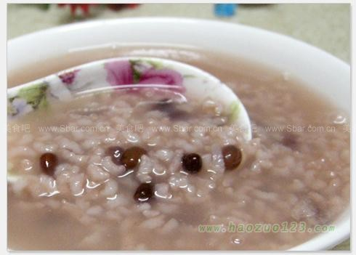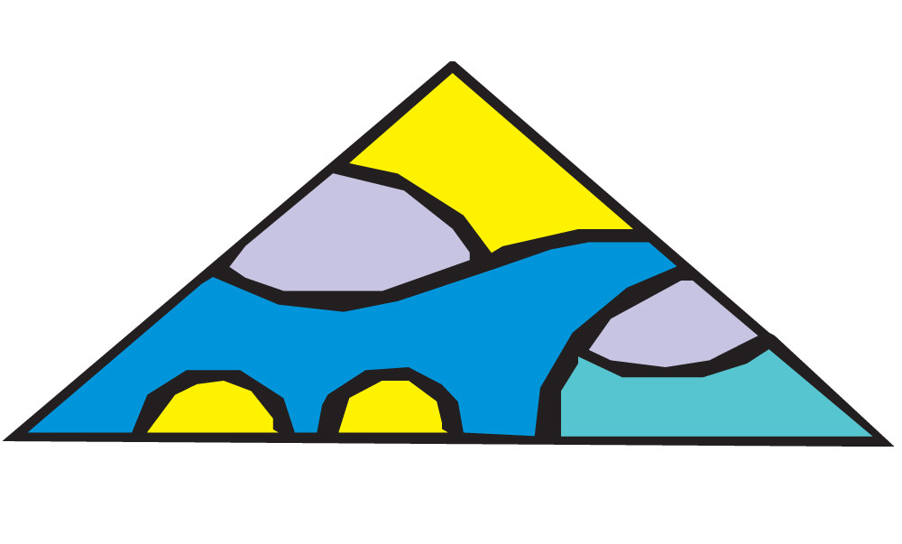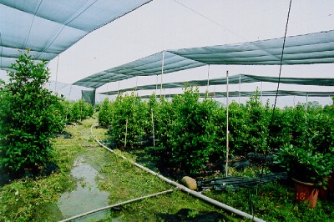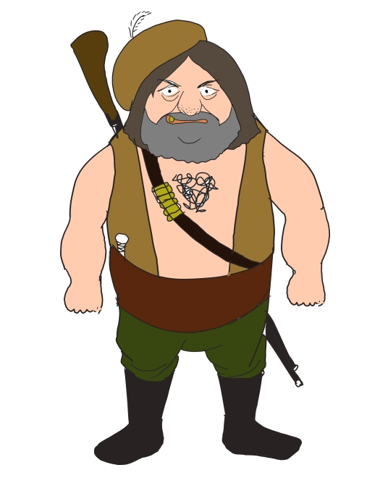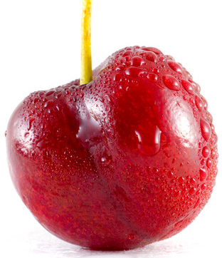
A B C D E F
Ⅱ 将B栏的词语与A栏的词语配对，并将配好的答案番号填在答题卡的相应位置。（4分）
A B
62. brush a. more clothes
63. have b. teeth
64. put on c. a fever
65. shop d. assistant
五、排序（6分）
Ⅰ 下面三个单词的字母被打乱了顺序，请同学们将字母重新排序，使其组成一个与图片意思相符的正确单词，并将其填入答题卡的相应位置。（3分）
66. 67. 68.
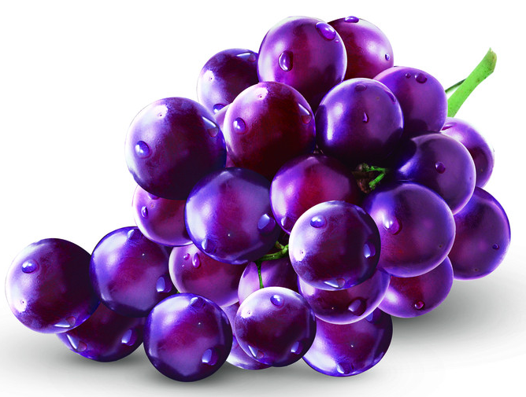
V l o a p e a r g t e a i r w
___________ ____________ ______________
Ⅱ 下面句子的单词被打乱了顺序，请同学们找出正确的顺序，使其组成一个意思正确的句子，并将其填入答题卡的横线上（3分）
69. pears some to help yourself __________________________________.
70. good bread the smells __________________________________.
71. up do get time you what __________________________________?
Ⅲ 将B栏的表达组成一个小对话，将对话的正确顺序番号填在答题卡的横线上（4分）。
A B
72. ______________ a. I like loquats best.
73. ______________ b. Thanks a lot.
74. ______________ c. Help yourself to some loquats.
75. ______________ d. What fruit do you like best?
六、正误判断（10分）
Ⅰ 看下列图片，判断下列句子是否与图片相符，如果相符请在答题卡的相应位置上填“T”，如果不相符填“F”(4分)。

76. He is a fireman.( ) 77.I have a cough.( )
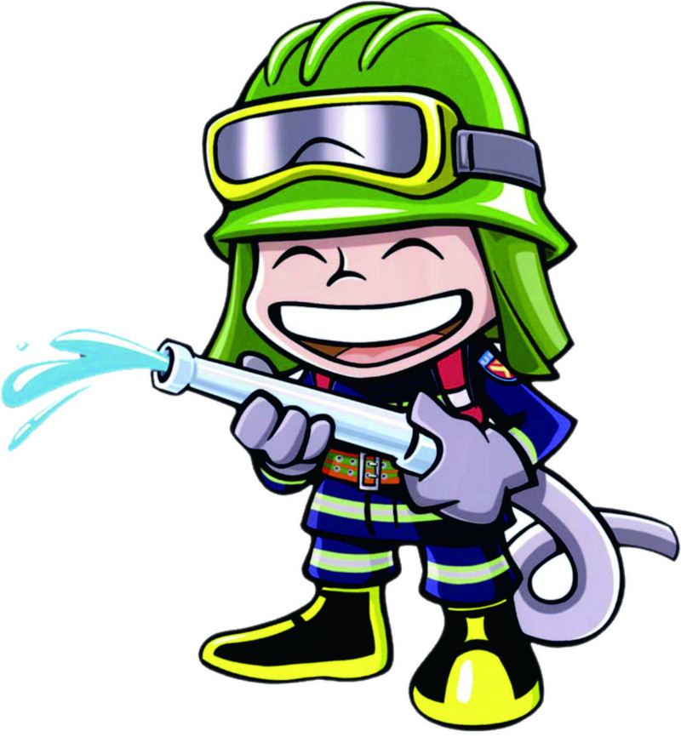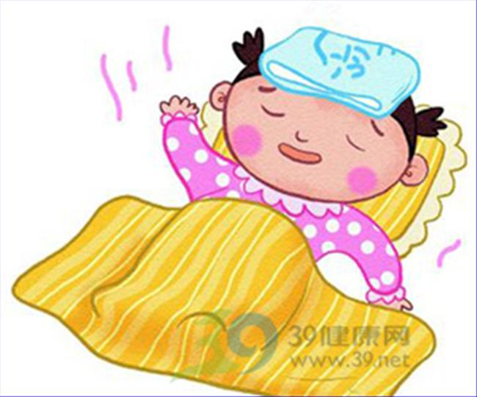
78.You`d better see a doctor.( ) 79. He brushes his teeth.( )
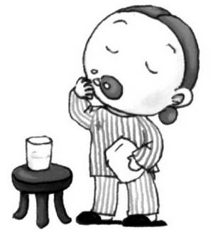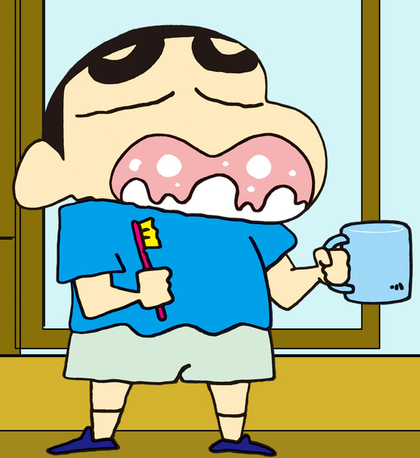
Ⅱ 阅读下列这则短文，判断下列句子的描述是否与短文内容相符，如果相符请在答题卡的相应位置上填“T”，如果不相符填“F”(6分)。
It’s nine o’clock in the evening. The family is at home. Jim’s father is sitting in a chair. He’s watching TV. Jim’s mother is standing near the window. She’s giving some food to a bird, Polly. Polly says, “Thanks! Thanks!”Where’s Jim? Oh, he’s behind the door. Kate, Jim’s sister is looking for him. They are playing games. They have no homework on Sunday evening.
( )80. There are five people in the family.
( )81.Jim’s mother is watching TV in a chair?
( )82. Jim and Kate are good friends.
( )83. The children don’t do their homework.
( )84. Kate’s playing games.
( )85. Polly is a polite boy.

