2015PEP小学英语六年级下册综合自测题(三)

Listening Part（听力部分）
一、Listen and choose. （听音，选出你所听到的单词或短语。）
( ) 1. A. tall B. taller C. tail
( ) 2. A. washed B. watch C. watched
( ) 3. A. doctor B. coach C. pilot
( ) 4. A. read B. reading C. reads
( ) 5. A. study B. studies C. stories
- Listen and number. （听音，给下列图片标序号。）
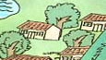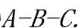
( ) ( ) ( ) ( ) ( )
三、 Listen and choose. （听音，选出正确答语。）
( ) 1. A. I'm 1.65 meters. B. I'm 50 kilograms. C. I'm 15.
( ) 2. A. Yes, I do. B. No, they didn't. C. No, I didn’t.
( )3.A. I went there by bike. B. I went to Sanya. C. They played football.
( ) 4. A. I am fine . B. It was fine. C. I watched TV yesterday.
( ) 5. A. He is a driver. B. He works in a gym. C. No, he wasn't.
四、Listen and fill in the blanks.（听音，填空，完成句子。）[来源:Zxxk.Com]
1、Amy likes__________.[来源:学。科。网Z。X。X。K][来源:学科网ZXXK]
2、My sister is 1 year old, she is________.
3、I______________ with my friends yesterday .
4、It’s cold outside ,you should _________ warm clothes.
5、We are going to _________________next weekend .
Writing Part （笔试部分）
五、Read and choose.（读一读，选出每组单词中不同类的一项。）
( ) 1. A. post office B. hospital C. post officer
( ) 2. A. by ship B. by subway C. better
( ) 3. A. goes B. tomatoes C. teaches
( ) 4. A. sleep B .drank C. had
( ) 5. A. smaller B. smarter C. farmer
六、 Fill in the blanks.（用所给词的适当形式。）
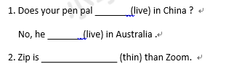
3. What ________ (do) you do last weekend?
I________ (go) fishing with my parents.
4. There ___________ (is) no gym in my school 3 years ago, but now there__________ (is)a new one.
5. I am going to _________(take) a trip next weekend .
七、 Read and choose.（单项选择。）
( ) 1. —What can you do for the party, Children ?
—I can play__piano and play ___basketball .
A / ,the B the ,the C the , /
( ) 2.Wu Yifan _____ an interesting dream last night .
A. have B. has C. had
( ) 3— are you going to the bookstore? — This afternoon.
A. What B. Where C. When
( ) 4. It was Amy’s birthday yesterday . Her parents many gifts for her.
A. buy B. bought C. buys
( ) 5. — ? — I have a cold.
A.What’s the matter? B. What did you do? C. How was your weekend?
八.Read and fill in the blanks.（根据图片和文字提示，将句子补充完整。）
- My favorite fruit are__________,they are __________ .(健康的)
- Summer holiday is coming .I will_______________with my parents . 
3.What does she do ? She is a _____________.
4.I went to Turpan over the winter holiday, I_______there.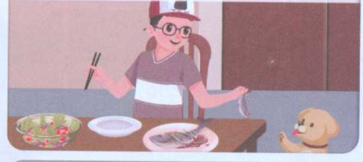
5.Last weekend, I stayed at home and _______________ .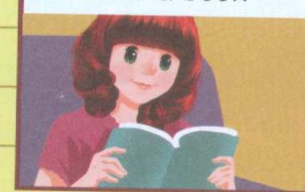
九、 Arrange the sentences.（连词成句。）
1、I shorter than am and stronger you (.)

- he does going like hiking doing and word puzzles (?)

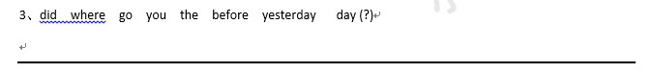
- how know do you that (.)

5、want I to the buy new film magazine (.)

十、Read and choose.（根据问句选答语，并把代号填在题前的括号内。）
( ) 1.What are you going to do this weekend? A. He likes cooking.
( ) 2. Are there any lakes? B. He works at the sea.
( ) 3. What are his hobbies? C. I went there by train.
( ) 4. Where does your uncle work? D. No, there aren’t.
( ) 5. How did you go there? E. I’m going to visit my grandparents .
十一、Read judge and answer.（阅读，判断正（T）误（F）,并回答问题。）
Sarah went to Dalian with her parents over the summer holiday by
plane .On Monday they went to the beach . It was beautiful .The weather was
nice .They had great fun playing in the sea. In the afternoon, they went
shopping .They bought some gifts. On Tuesday they went to a museum. It was
great.They saw many wonderful things there .On Wednesday it rained a
lot .They stayed at the hotel . They watched a funny show . On Thursday they
went to the zoo and saw many animals . Then they came back by train .
1.( ) Sarah and her friends went to Dalian by plane.
2.( ) They went to a museum on Monday .
3. ( )It was rainy on Wednesday .
4.What did Sarah do on Wednesday? .
5.How did they come back? .
十二 、Writing .(写作)
暑假就要来了，你是否有很好的计划呢？你还记得上个假期是怎么过的
吗？请向小伙伴们介绍一下吧。不少于5句话。
（提示词：go to Xinjiang, climb Mt. Tian ,eat good food, go to beach, swim)
Last Holiday[来源:学.科.网Z.X.X.K]
_______________________________________________________________________________________________________________________________________________________________________________________________________________
附：听力材料
一、Listen and choose. （听音，选出你所听到的单词或短语。）
1、I’m 1.65metres.I’m taller than you.
2、Last Saturday I watched TV at home .
3、What does your father do ?
He is a pilot.
- What are you doing ?I’m reading books .
- My pen pal lives in Australia ,but he studies Chinese .
- Listen and number. （听音，给下列图片标序号。）
1、The girl is very happy .
2、—What’s wrong ?
—Your father is ill . Let’s go to the hospital.
- I often go cycling with my friends.
4、There are many houses in the village .[来源:Z_xx_k.Com]
5、What do you have on Tuesdays?
We have English and P.E..
- Listen and choose.（听音，选出正确答语。）
- How tall are you? I’m 1.65 metres.
- Did you stay at home yesterday?
- Where did you go over the winter holiday?
- How was your weekend?
- What does your father do?
四、Listen and fill in the blanks.（听音，填空，完成句子。）
1、Amy likes dancing .
2、My sister is 1 year old, she is younger .
3、I saw a film with my friends yesterday .
4、It’s cold outside ,you should wear warm clothes .
5、We are going to ice_skate next weekend.

