2015年六年级质量监测模拟卷
英语试题卷
（试卷共6页，总分100分，考试时间60分钟）
听力部分 （30分）
一、听音，选择所听到的字母、数字或单词。（共6小题，计6分）
( ▲ ) 1. A. big B. bigger ( ▲ ) 2. A.walk B. work
( ▲ ) 3. A. hungry B. angry ( ▲ ) 4. A. JPQ B. GPK[来源:Zxxk.Com]
( ▲ ) 5. A. 13 B. 30 ( ▲ ) 6. A. straight B. street
- 听句子给图画标序号。（共6小题，计6分）
7. ▲ 8. ▲ 9. ▲ 10. ▲ 11. ▲ 12. ▲
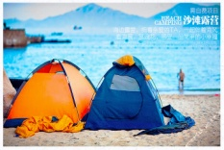


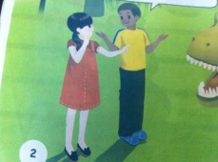

12
11


A B C D E F
三、听问句，选答句。 （共6小题，计6分）
( ▲ ) 13. A. I like singing. B. She likes flying kites.
( ▲ ) 14. A. I’d like some rice and fish. B. It’s yummy.
( ▲ ) 15. A. He likes football. B. He’s tall and strong.
( ▲ ) 16. A. I can see 12. B. It’s 12 yuan.
( ▲ ) 17. A. Go straight. B. It’s next to the bookstore.
( ▲ ) 18. A. It’s Monday. B. It’s 7:00 now.
- 听音，根据所听对话内容，判断下列句子正误。正确的在括号里写(T) ，
错误的写(F)。（共5小题，计5分）
( ▲ ) 19. It’s 10:20. It’s time for Chinese class.
( ▲ ) 20.You can get to the Dongshan Park by the No.42 bus.
( ▲ ) 21. I bought some comic books in the bookstore.
( ▲ ) 22. It’s very sunny and hot today. We go swimming together.
( ▲ ) 23. Zhang Peng is taller than John.
五、听小短文，选择词语将其序号填在横线上。（共7小题，计7分）
A. helped B. had C. tired D. younger
E. goes F. washed G. cooked
Chen Jie is a good girl. She is 24.▲ than her classmates. She usually 25.▲ to the park with her friends on the weekends. But last weekend, she 26.▲ her mother do housework. Because her mother was ill. She 27.▲ a cold. She 28.▲ food and29. ▲ her clothes. In the evening. She was very 30.▲ .But she is very happy.
（提醒：请别忘了将答案填涂到答题卡上哦！）
读写部分 （70分）
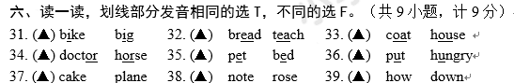七、选出下列每组单词中与其他两个不同类的单词。（共6小题，计6分）
（ ▲ ）40. A. sandwich B. juice C. cake
（ ▲ ）41. A. pants B. umbrella C. sweater
（ ▲ ）42. A. windy B. rainy C. summer
（ ▲ ）43. A. funny B. shy C. try
（ ▲ ）44. A. Monday B. Thursday C. Sydney
（ ▲ ）45. A. postman B. write C. cleaner
八、单项选择。（共15小题，计15分）
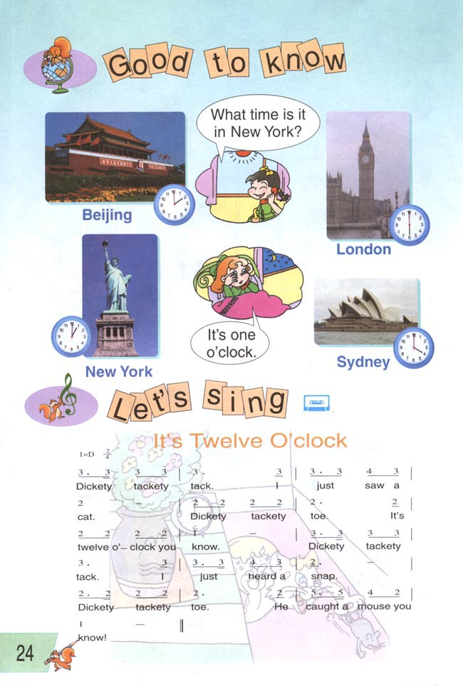A. 看图，读句子，选答案。（共5小题，计5分）
( ▲ ) —What’s the weather like in ▲ ? —It’s ▲ .
A. London, rainy B. New York, rainy C. Sydney, snowy
46.
1.
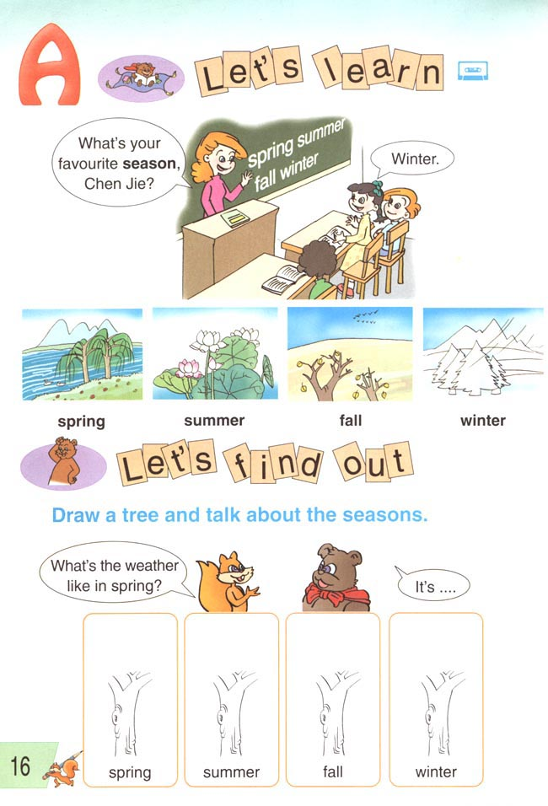
47.
( ▲ )—Which season do you like best? —I like ▲ .
A. spring B. summer C. winter

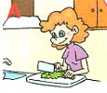
( ▲ ) —Is Miss White in the living room? — ▲ .
A. Yes, she is. B. No, he isn’t. C. No, she isn’t.
48.


( ▲ ) —How do you go to Beijing? —I go there ▲ .
A. by bus B. by ship C. by plane
49.


50.
( ▲ ) —What can you do at home? —I can ▲ .
A. helping other people B. cook good food C. do the dishes

B. 读句子，选择最佳答案。（共10小题，计10分）
( ▲ ) 51. I want to be ▲ businessman one day.
A. a B. an C. /
( ▲ ) 52. — ▲ are these books? — Thirteen yuan.
A. How much B. How about C. How many
( ▲ ) 53. I rode a horse ▲ .
A. next week B. last weekend C. tomorrow
( ▲ ) 54. —Where’s the pen? — ▲ .
A. It’s on the desk. B. I’m from Australia. C. I’m fine.
( ▲ )55. —What’s your favourite food? — ▲ . It’s tasty.
A. Hot dog B. Panda C. April
( ▲ ) 56. Mary’s aunt is a maths teacher. She ▲ maths.
A. teach B. teaching C. teaches
( ▲ ) 57. I’m 155 cm. You’re 159 cm. I’m ▲ than you.
A. taller B. shorter C. short[来源:学#科#网]
( ▲ ) 58. —How ▲ are you? —I’m 51 kilograms.[来源:学|科|网Z|X|X|K]
A. old B. tall C. heavy
( ▲ ) 59. Did you ▲ last weekend？
A. went swimming B. go swim C. go swimming
( ▲ ) 60. —What is your English teacher like? — ▲ .
A. She is kind and pretty. B. She is from Canada.
C. She likes reading books.
九、根据问句选择相应答句。（共9小题，计9分）
( ▲ ) 61. How old are you? A. Yes, there are.
( ▲ ) 62. What can you do? B. She often goes to work by car.
( ▲ ) 63. How does your mom go to work? C. I can draw pictures.
( ▲ ) 64. Does he live in Sydney? D. I am 13 years old.
( ▲ ) 65 .Are there any bridges in your city? E. It’s near the post office.
( ▲ ) 66. What’s your favourite day？ F. Yes, he does..
( ▲ ) 67. When is New Year’s Day? G. No, they aren’t. They are goats.
( ▲ ) 68. Are those sheep? H. It’s January 1st.[来源:学科网ZXXK]
( ▲ )69. Where is the bookstore? I. Wednesdays. I have a computer class.
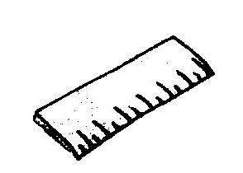
十一、看图，读句子，写单词。（共6小题，计6分）
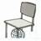
70. Look, I have a ▲ .

- There is a ball ▲ the chair.
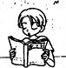
- The snake is ▲ than the fish.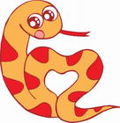

73. — What do you do on Sundays? — I often ▲ books.

74. — What are the tigers doing? — They are ▲ .
75.— Is your mother an singer?— No, she isn’t. She is a ▲ . 

十二、组词成句：把各题中的单词按正确的顺序排列组成句子，并以书写体形式书写在答题卡相应的四线格题号上，并注意标点和字母的大小写形式。（共5小题，计5分）
76. how, come, you, school, do, to (?)
77. what， are， shoes， size， your (?)

78. how, weekend, your, was (?)
- cat, angry, them, the, with, is (.)
80.birthday, my, mother’s, in, is, March (.)
十三、阅读理解 （共10小题，计10分）

A．读短文，判断对错，对的打“T”，错的打“F”。（5分）
Danny stayed at home last weekend. He ate a lot of chocolates，ice-cream，chips，apples and chicken wings. After a moment he felt sick. He had a stomachache(胃痛). His mother asked him to take some medicine. After about three hours, Danny felt better. His mother said to him:“You shouldn’t eat too much food. That’s not a good habit.”
（ ▲ ）81. Danny was at school last weekend.
（ ▲ ）82. Danny ate a lot of chocolates, ice-cream and eggs.
（ ▲ ）83. Danny had a headache.
（ ▲ ）84. Danny’s mother asked Danny to take some medicine.
（ ▲ ）85. Danny has a bad habit.

B. 阅读下面的短文，选择正确的答案。（5分）
My name is Mike. I’m eleven years old. I often go to the park with my friends. We often go there by bus. We like playing football in the park. It’s my favourite game. There are many people in the park. Some are taking pictures. Some are dancing. Some girls are playing games. Some young men are riding bikes. We are all very happy.
( ▲ ) 86. How old is Mike?
A. He is 7. B. He is 11. C. He is 12.
( ▲ ) 87. How do Mike and his friends go to the park?
A. By bus. B. By bike. C. On foot.
( ▲ )88. What game does Mike like best?
A. Computer games. B. Football. C. Basketball. ( ▲ ) 89. What are the girls doing?
A. Taking pictures. B. Dancing. C. Playing games.
( ▲ ) 90. What are the young men doing?
A. Playing football. B. Taking pictures. C. Riding bikes.
十四、书面表达：请参照下列表格中的信息，写一篇关于Mike 和John的周末计划。请在答题卡上作答。（共10分）
要求：1.语句通顺，表达正确，内容前后连贯。
2.不少于五句话，注意规范书写。
Name | Saturday | Sunday
Mike | Watch TV  Do homework | Go fishing[来源:Zxxk.Com]  Go hiking
John | Go to the gym  Play football | See a film
91.
（再次提醒：请别忘了将答案做到答题卡上哦！做好后请仔细检查！）

2015年小学六年级英语模拟卷
听力材料

一、听音，选择所听到的字母、数字或单词。（每题读二遍）
1.bigger 2.walk 3.angry 4.GPK 5. 30 6.straight
二、听句子给图画标序号。（每题读二遍）
（7）Let’s go fishing this weekend.
（8）The boy loves to ice-skate.[来源:学科网ZXXK]
（9）Don’ t turn left at the cinema.[来源:学科网ZXXK]
（10）Chen Jie is younger than John.
（11）I went camping on the beach last summer holiday.[来源:Z。xx。k.Com]
（12）I’m going to buy a dictionary.
三、听问句，选答句。将字母符号填在句子前面的括号里。（每题读二遍）[来源:学,科,网Z,X,X,K]
13.What are your hobbies?
14.What would you like for dinner?
15.What’s your PE teacher like?
16.How many birds can you see?
17.Where is the cinema?
18.What time is it now?
四、听音，根据所听对话内容，判断下列句子正误。正确的在括号里写( T ) ，错误的写( F)。（读二遍）
19. A: What time is it?
B: 10:20.
A: Oh! It’s time for maths class. Hurry up!
20. A: Excuse me. How can I get to Dongshan Park, please?21教育网
B: You can go by the No.24 bus.
A: Thank you.
21. A: I went to the bookstore yesterday.
B: Really? What did you buy then?[来源:学&科&网]
A: I bought some story books.
22. A: It’s very sunny and hot today. Let’s go swimming.【来源：21·世纪·教育·网】
B: Good idea. Let’s go.
23. A: Hi, Zhang Peng. How tall are you?
B: I’m 166cm. How about you, John?
A: Oh, You are 3cm taller than me.
五、听小短文，选择词语将其序号填在横线上。（读二遍）
Chen Jie is a good girl. She is younger than her classmates. She usually goes to the park with her friends on the weekends. But last weekend，she helped her mother do housework. Because her mother was ill. She had a cold. She cooked food and washed her clothes. In the evening. She was very tired , but she is very happy.

