重滩小学2013年六年级下学期英语综合复习题
班级 姓名 得分
一、听力测试。（共计15分）
Ⅰ.听音，判断图片与内容是否一致，如果一致，圈“”，如果不一致，圈“”。（5分）
1、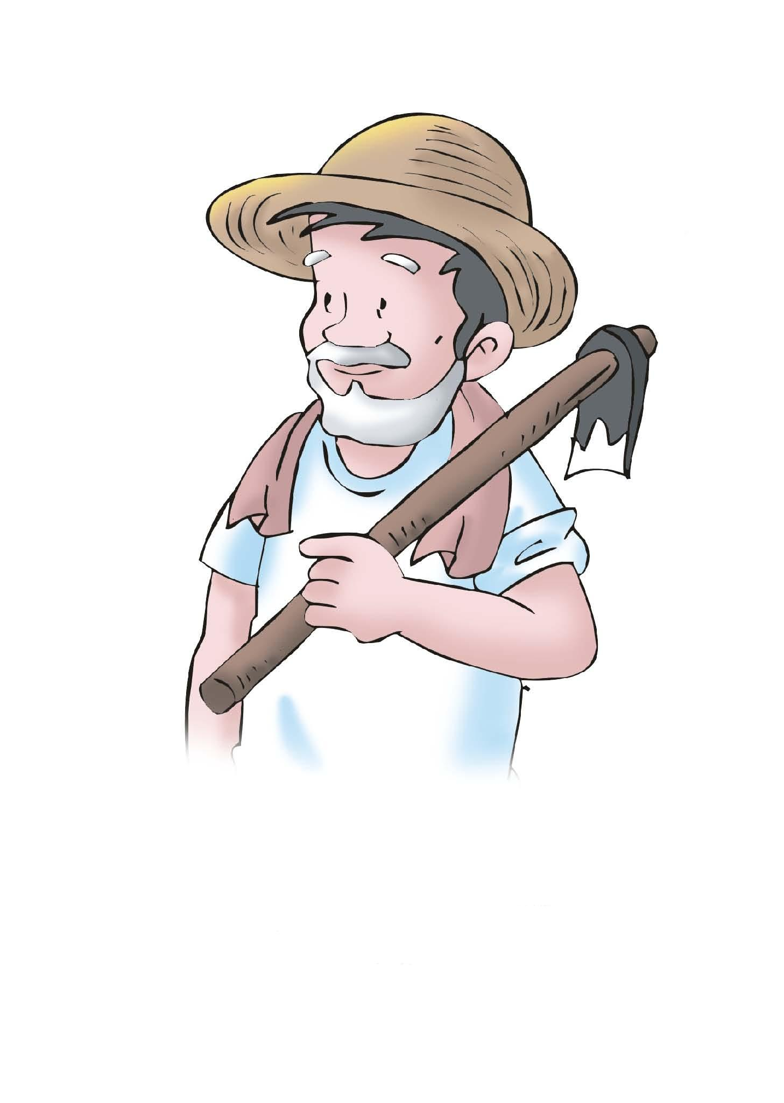 2、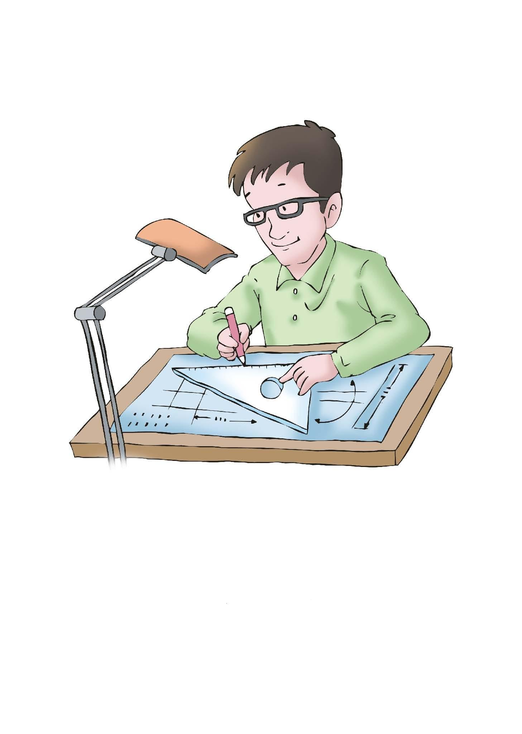 3、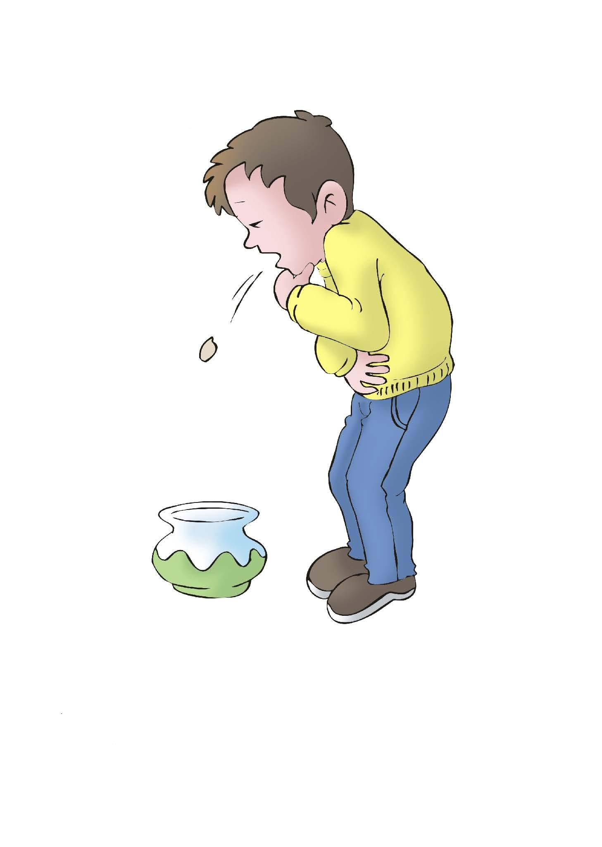 4、 5、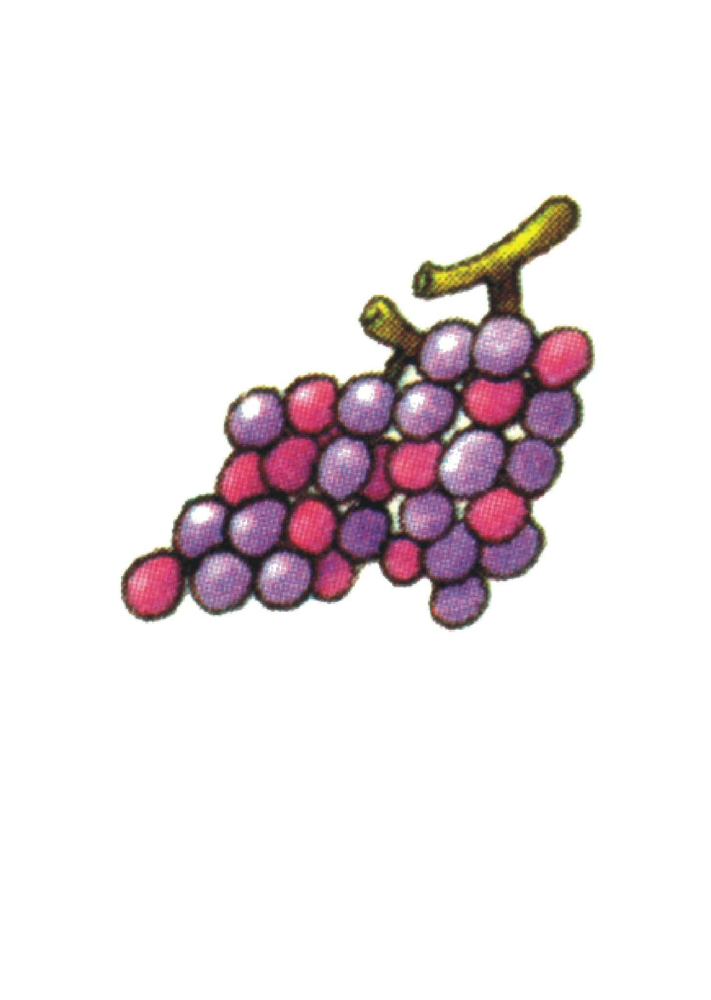
Ⅱ.听音，根据所听内容配对，请将配好对的答案番号填写在下面相应的位置上,每个句子读三遍。（5分）

- Betty 7、 We 8、 Sara  9、The music 10、Tom
①sounds ②are ③likes ④is ⑤ has

A、cherries best B、nice C、sleeping D、a fever E、taller

Ⅲ.听音，按照所听到的先后顺序用A—E为下面的图片标号，并把排好的顺序号填写在相应的位置，每个句子读三遍。（5分）
-  12、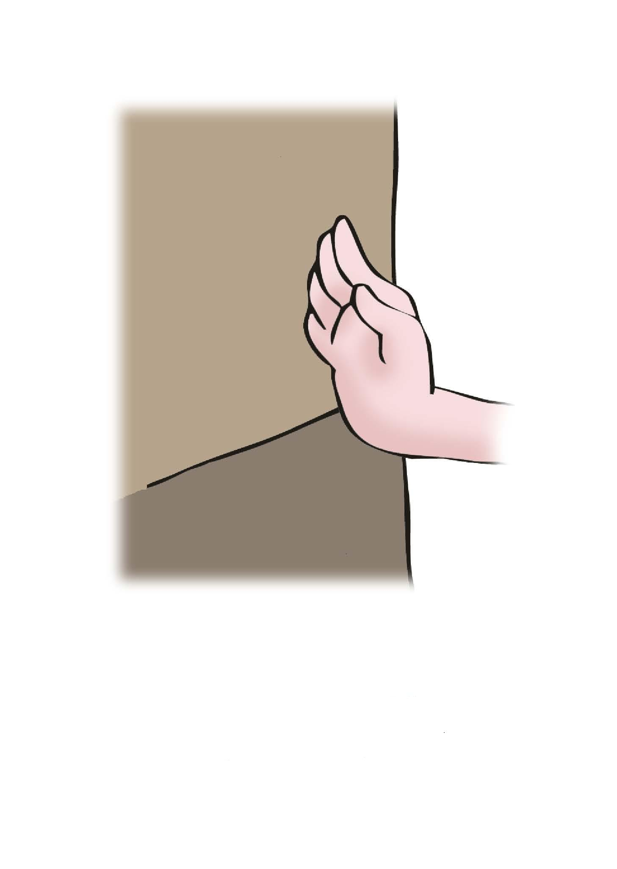 13、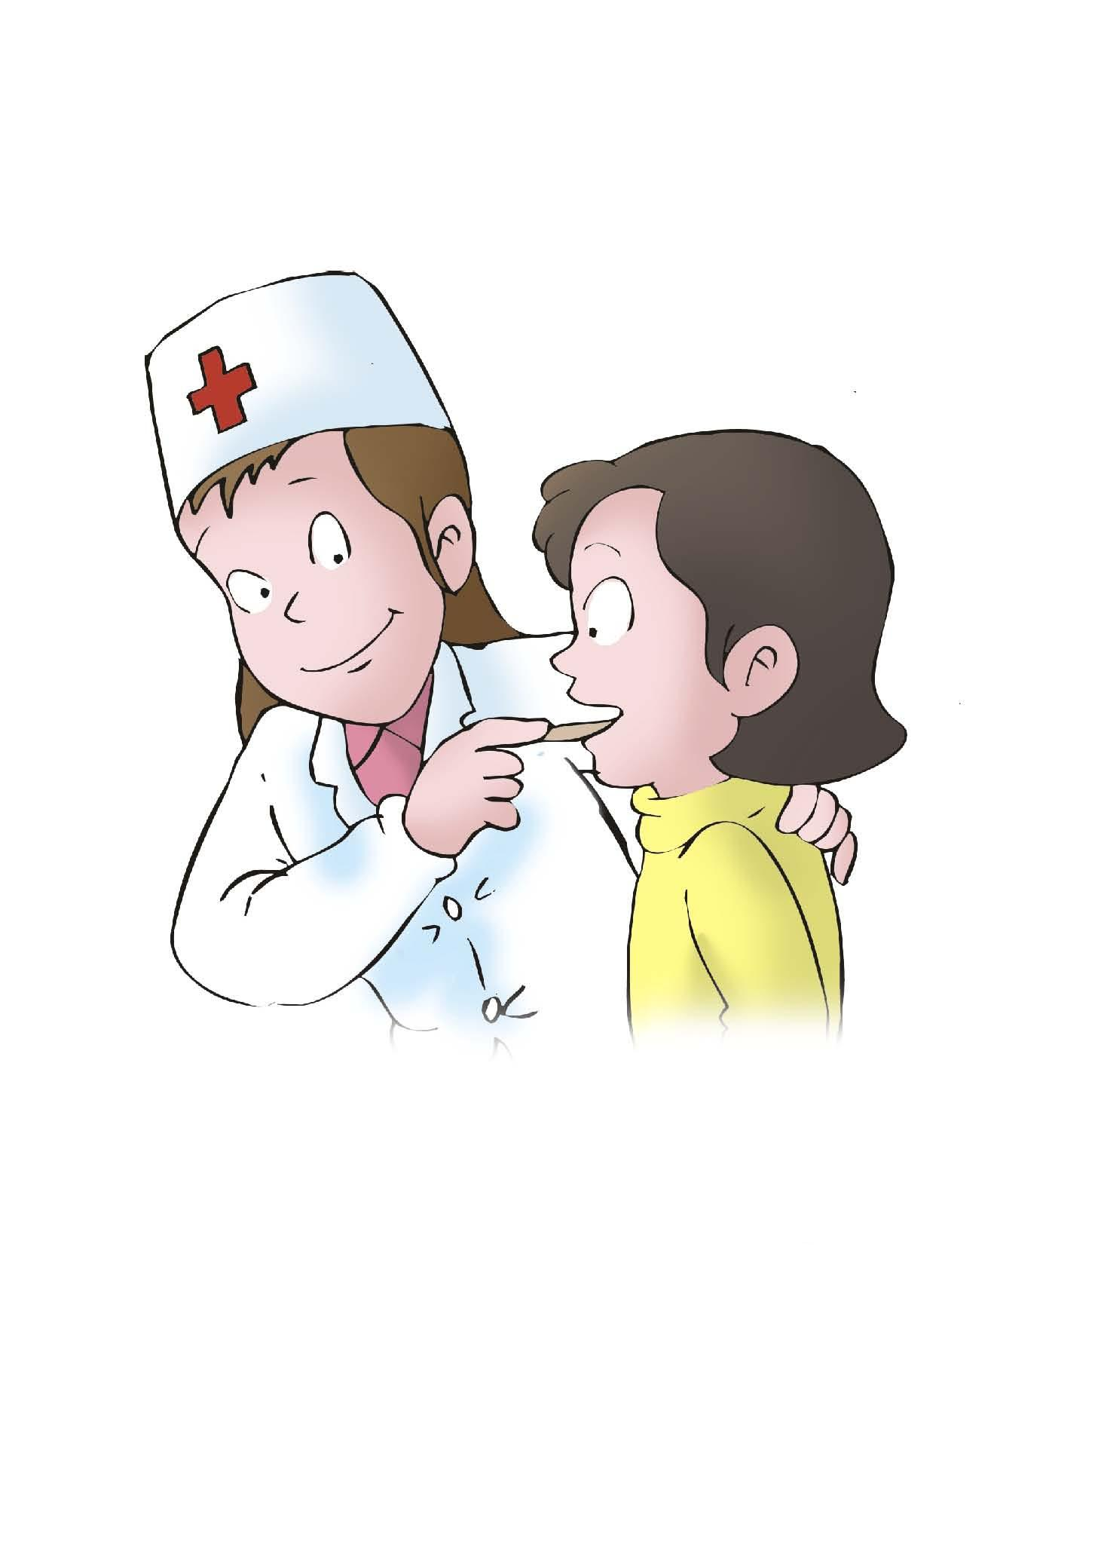 14、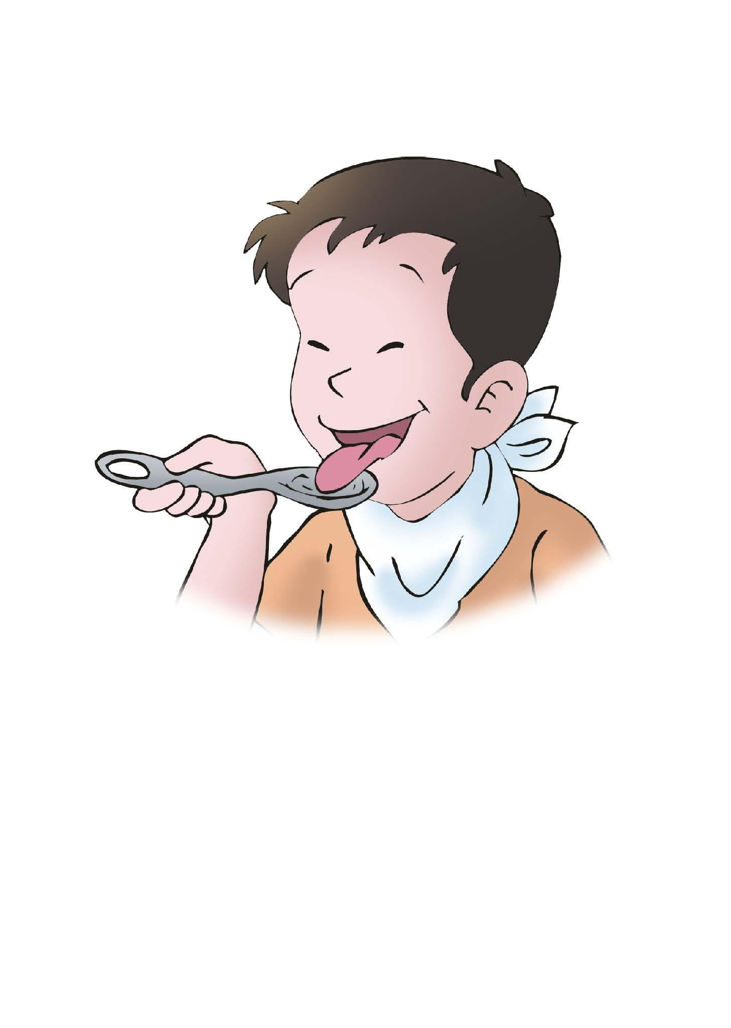 15、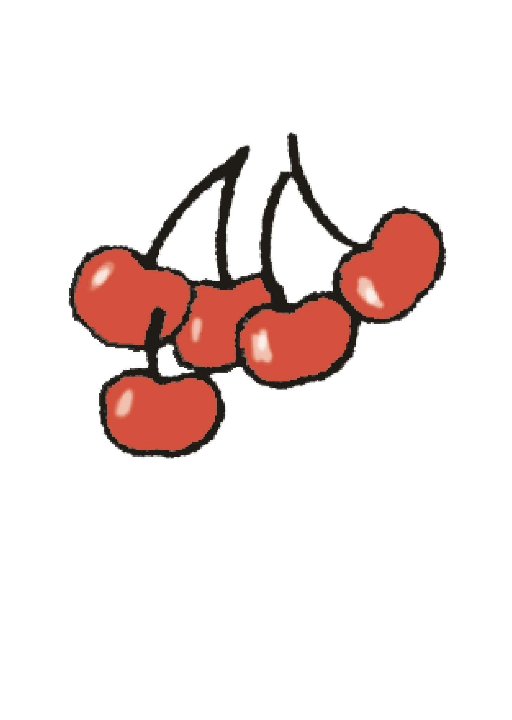
A B C D E
11—15：
二、写（共计20分）
Ⅰ.根据英语字母表的顺序，写出L―U的大写字母。（10分）
16、 17、 18、 19、 20、

21、 22、 23、 24、 25、
Ⅱ.从B栏中找出与A栏要求一致的单词，将答案抄写在四线三格内。（6分）
- It looks like a star. 26、 27、 28、

29、 30、 31、
B、
circle
rectangle
square
oval
moon
diamond
fireman
heart

Ⅲ、根据问句，从A、B、C、D四个答句中选出合适的答句（每个只用一次），并将选出的答句抄写在四线三格内。（4分）
- Which one do you like? 33、Help yourself to some pears.

34、How does it feel? 35、What's the weather like in London?

- I like the pink one. B、It’s cloudy.
C、It feels round and soft. D、Thanks a lot.[来源:学科网ZXXK]
三、单项选择。（共计35分）
Ⅰ.选出下面每组中不属于同一类的单词，并将所选番号填在括号内。（5分）
( )36. A. sunny B. foggy C. rainy D. Paris
( )37. A. bigger B. teacher C. doctor D. engineer
( )38. A. June B. Monday C. Saturday D. Wednesday
( )39. A. rectangle B. oval C. salad D. diamond
( )40. A. bike B. bus C. cherry D. train

Ⅱ.根据情景选择正确的表达，并将所选出的答案番号填在题前括号内。（10分）
( ) 41. 当你问别人什么时间起床时，应该说：
A．What time do you get up? B. Which time do you get up?
( ) 42. 当你打电话叮嘱对方照顾好自己时，应该说：
A．How are you? B. Take care of yourself.
( )43. 当你想询问“我们如何去那里？” 时，应该说：
A．What can we go there? B. How can we go there?
( ) 44. 当你有好吃的，想让朋友尝尝时，应该说：
A．Have a taste.. B. You can taste.
( ) 45. 当你对朋友的提议没意见时，应该说：
A．No problem. B. I like.
Ⅲ.选择填空，请将选出的答案番号填在题前括号内。（10分）
( ) 46. you marry me?.
A. What B. Will
( ) 47. Is it eagle?
A.a B. an
( ) 48. What do you ?
A. do B. does
( ) 49. It’s time_____ work
A. to B.for
( ) 50. My school bad is heavier than .
A. your B. yours
( ) 51. It you well.
A. suits B. suit
( ) 52. You’re_____ than me.
A. taller B.short
( ) 53. I at 9:20 in the evening.
A.goes to bed B. go to bed
( ) 54. is it?
A. How much B. How many
( ) 55. Look, they are____ the insects carefully.[来源:学#科#网Z#X#X#K]
A. watch B. watching
Ⅳ.根据问句选择合适的答语，请将选出的答案番号填在题前括号内。（10分）
( ) 56. What time does she get up?
A. She get up at 7:30. B. She gets uo at 7:30.
( )57. How do they smell?
A. They smell sweet. B. They feel sweet.
( )58. Help yourself to some pears.
A. They looks great. B. They feel sweet. [来源:学科网ZXXK]
( ) 59. Where is she going?
A. She goes to an orchard. B. She is going to visit The Great Wall.
( ) 60. What’s the matter with you?
A. I have a headache and a cough. B. You’d better go to see a doctor.
- 配对。（共计10分）
Ⅰ.将图片与相应的单词配对，请将正确答案的番号填在横线上（A-F）。（6分）
61. 62. 63. 64. 65. 66.
artist
sound
noisy
longer
dates
hot

61、 62、 63、 64、 65、 66、
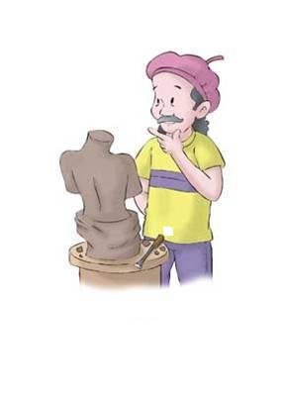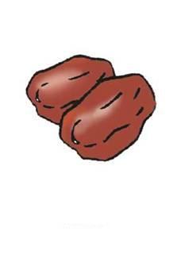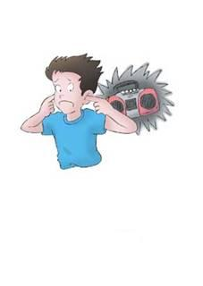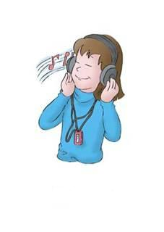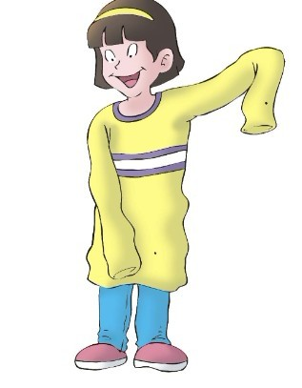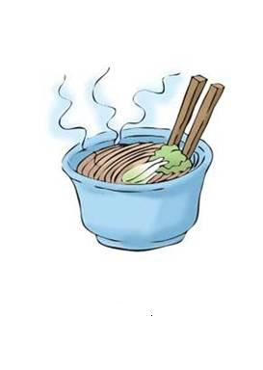
A B C D E F
Ⅱ.将下列A栏和B栏的单词配对，并将配好对的答案番号填在下面横线上。（4分）
A B
- sale
- assistant
- supper
- train
67.shop
68.on
69.have
70.by

67. 68. 69. 70.
- 排序。（共计10分）
Ⅰ.将下列字母排成与图片意思相符的单词。（3分）
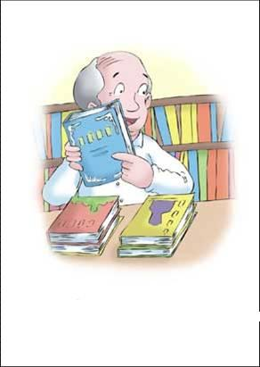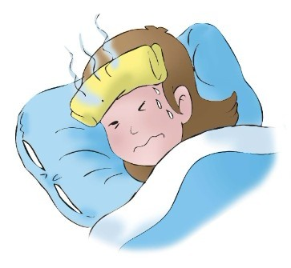
71. ellesrkboo 72. f v r e e 73. t s a e t
Ⅱ.连词成句。（3分）
74. can we go How there ?

75. my favourite is It .

76. See then you .[来源:学_科_网]
[来源:学&科&网Z&X&X&K]
Ⅲ.将B栏的表达组成一个小对话，将小对话的正确顺序番号填写在A栏的横线上。（4分）
A B
77. a. It’s sunny.
78. b. Are you in New York now?
79. c. What’s the weather like?
80. d. Yes.
- 正误判断。（共计10分）
Ⅰ.看下列图片，判断下列句子是否与图片相符，如果相符请填上“T”，如果不相符请填上“F”。（4分）
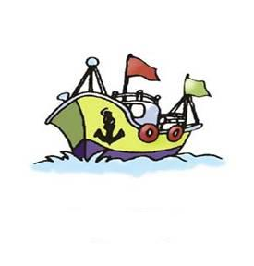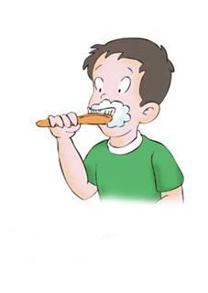

81.( )We’ll go there by boat. 82. ( )He brushes his teeth every day.
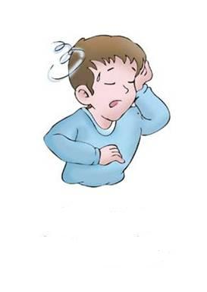

- ( ) You shoud stay in bed.. 84. ( ) He takes some medicine.
Ⅱ.阅读下面这则短文，判断85-90这六个句子的描述是否与短文内容相符。如果相符，请在题前括号内填上“T”，如果不相符填“F”。（6分）
Mary has a cousin. She is Betty, and Betty is thirteen years old. She is two years older than Mary. So Mary is eleven years old.
Mary and Betty are good runners. But Mary runs faster. Betty runs slower. They both like to play basketball. But Betty plays better than Mary. And they study in a middle school. They work hard at school. But Betty works harder.
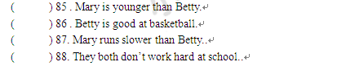
( ) 89. .Mary works harder than Betty.
( ) 90. Betty is good runner..

