浙江衢州小学六年级英语下学期期末试卷

姓名 班级 分数

听力部分 （40分）
May

一、听录音，选出与你所听内容相符的图片。（10分）

1. A B 2. A B
48kg
116cm
45kg
160cm

3. A B 4. A B
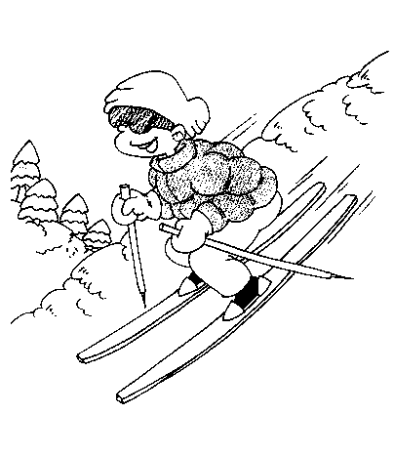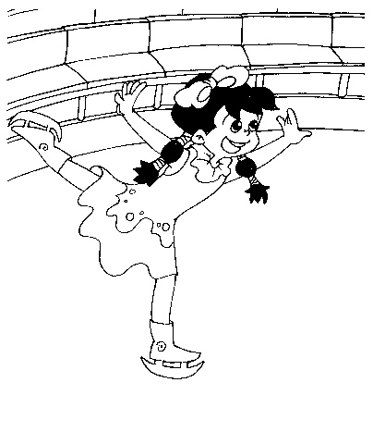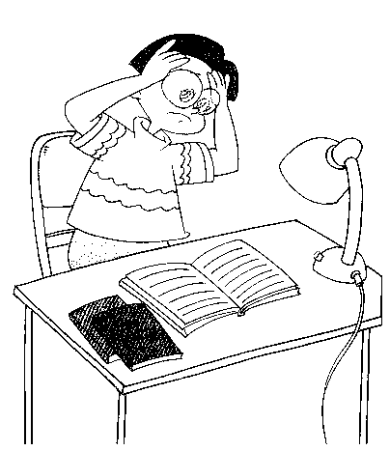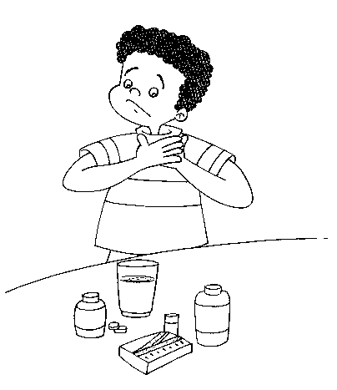
5. A B 6. A B
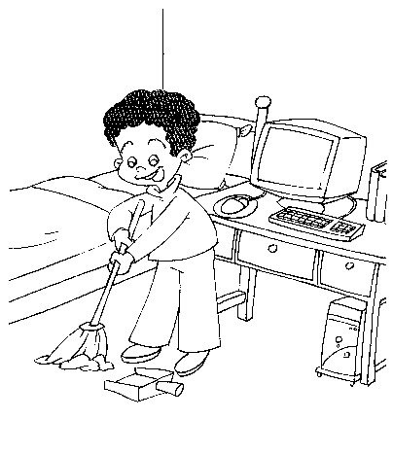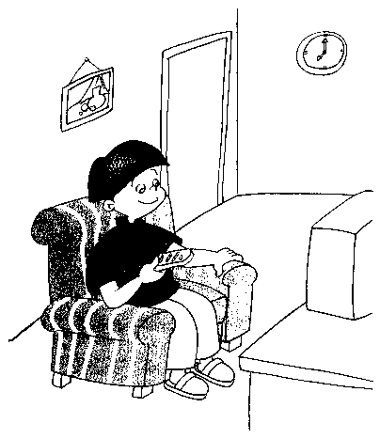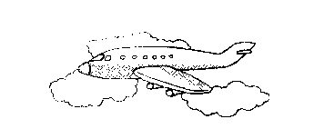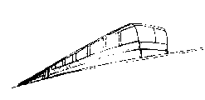

7. A B 8. A B

March

9. A B 10. A B
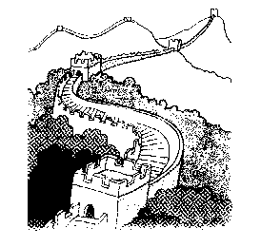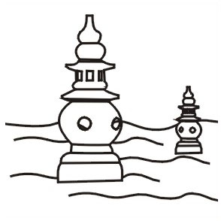
May
May
二、听录音，判断所听内容是否与图片相符。（10分）

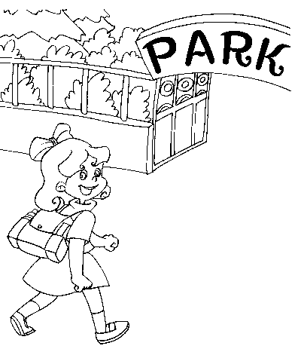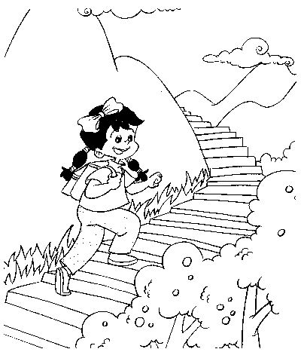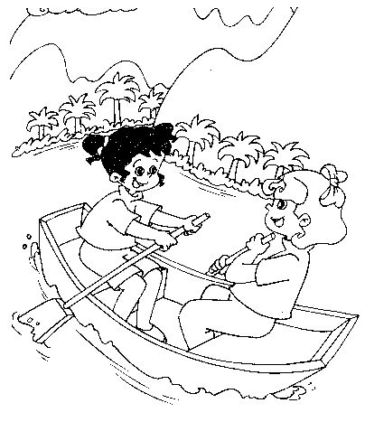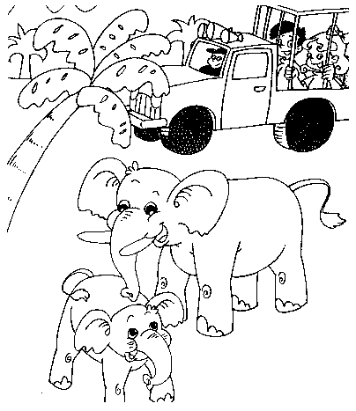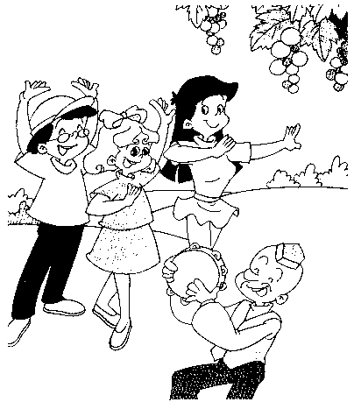
（ ） （ ） （ ） （ ） （ ）

三、听录音，标序号并连线。（10分）

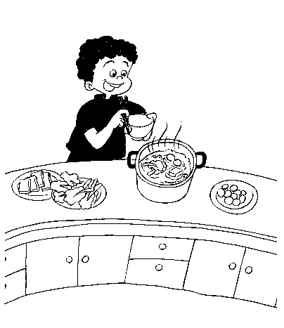
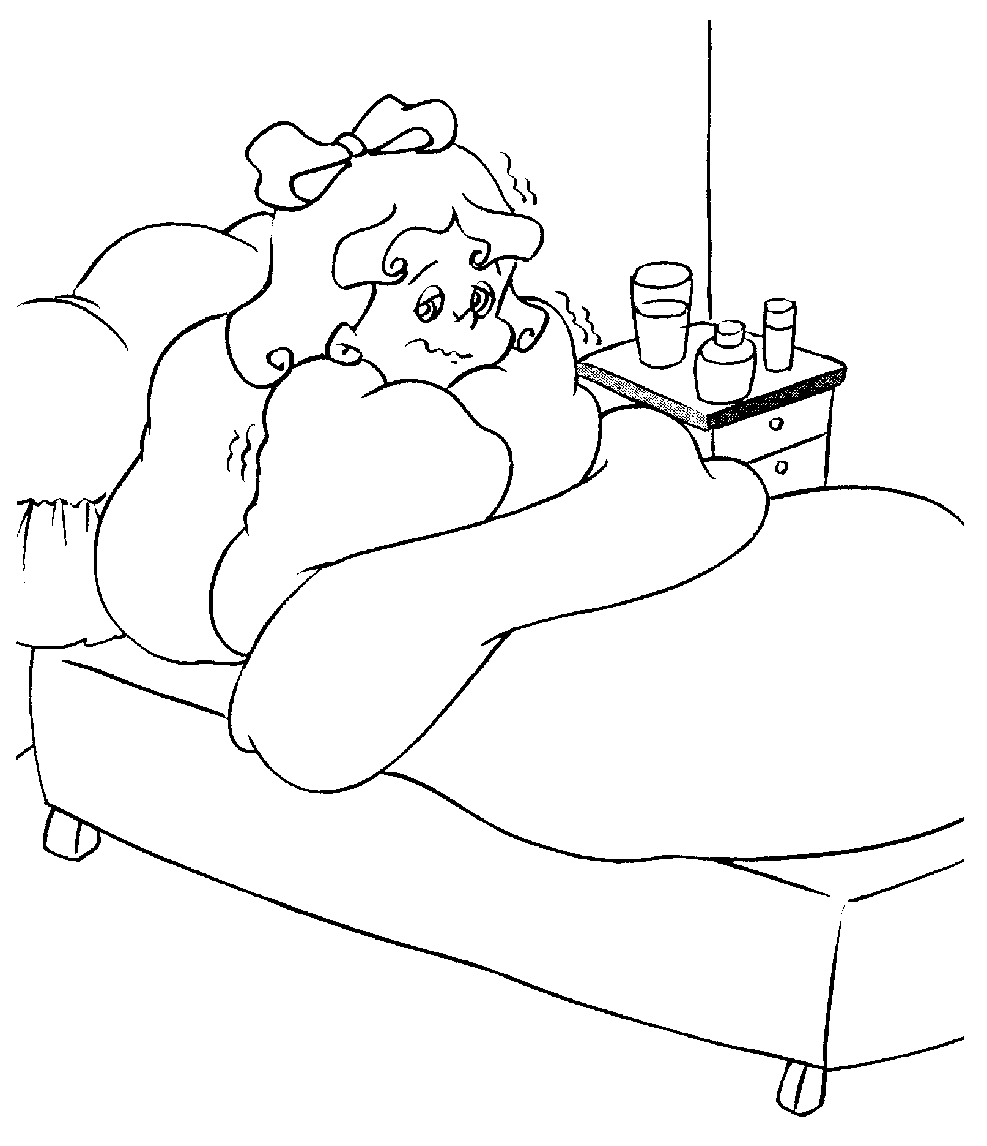
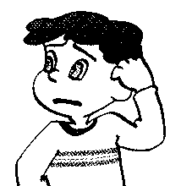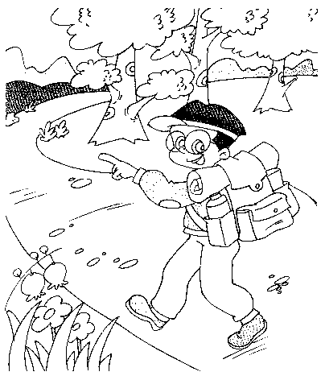
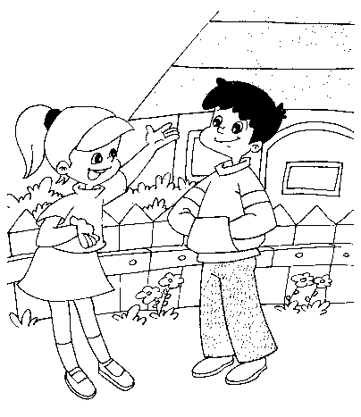
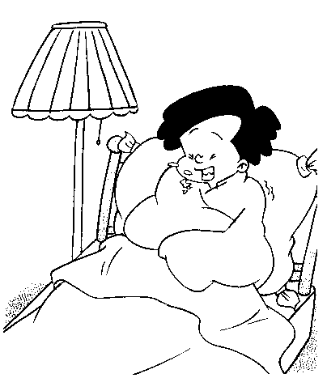

四、听录音，补全短文，每空一词。（10分）

Summer is coming. All of my friends are so . They are planning how to spend their holiday. Sarah is going to a boat. She is going to Hangzhou by bus. Amy is a quiet girl. She doesn’t like sports. She likes going shopping with her . They are going to Shanghai by plane. _________ are you going to do?

读写部分 （60分）

一、选择填空，将其序号填入题前括号内。（20分）

( ) 1. What’s he doing? He’s books.
A. read B. reading C. reads
( ) 2. I’m than you.
A. strong B. tall C. stronger
( ) 3. I usually to school at 7:00.
A. go B. goes C. went
( ) 4. I from China.
A. is B. am C. are
( ) 5. I a book last weekend.
A. buy B. buys C. bought
( ) 6. Mike often TV in the evening.
A. watch B. watches C. watched
( ) 7. did you go on your holiday?
A. Where B. What C. When
( ) 8. did you go there?
A. Where B. How C. Who
( ) 9. The sun is than the earth （地球）.
A. big B. smaller C. bigger
( ) 10. students are there in your class?
A. How many B. How much C. How

二、读句子，从方框内找出正确的词或短语并填写在横线上。（20分）

swimming / football / policeman / hospital / grandparents
morning exercises / singer / homework / piano / hurt

John is a student. His mother is a 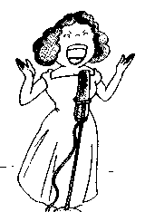and his father is a ___________He loves his family very much. He often does _______________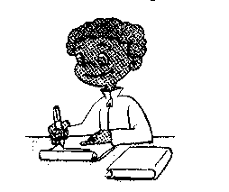at home and does 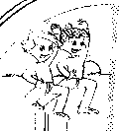 in the morning. He likes 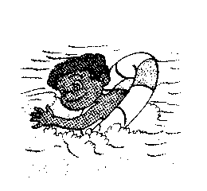and playing 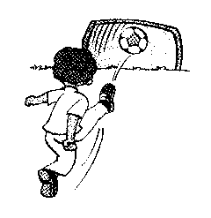. But he _________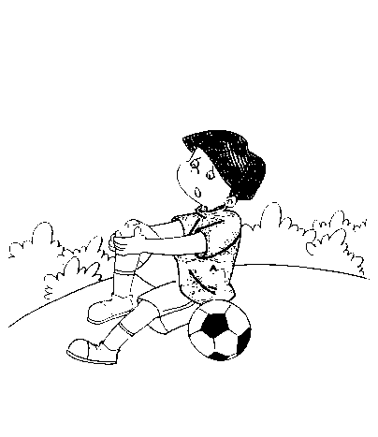his leg and he went to 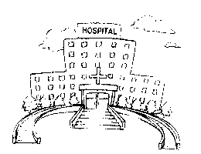to see the doctor. He wants to visit his 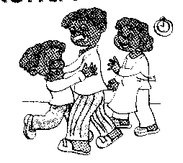and play the _ 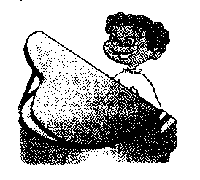for them..

三、读句子，从右边选择正确的序号并将其填如括号内。（10分）

( ) How tall are you ? A. I’m sorry to hear that.
( ) What’s the matter? B. I went by bike.
( ) How big are your feet? C. I’m 155cm tall.
( ) How does she feel ? D. I went fishing.
( ) Where are you going this weekend? E. Thank you!
( ) How did you go there? F. I have a cold.
( ) What did you do there? G. I wear size 17.
( ) I failed the Chinese test. H. She’s bored.
( ) Why do you like spring? I. Because I can fly kites.
( ) Good Luck! J. I’m going to Wenzhou Paradize（乐园）

四、阅读理解，判断正误，用 或 表示。（10分）

Dear Sarah,
Last Monday was a school holiday. My friends and I had a great day at the Zhongshan Park. The park is very big. We can do many things there. I flew kites with John and Zhang Peng. Liu Yun, Amy and Chen Jie sang and danced. We were all very happy.
At 12 o’clock, we had lunch. We had some fruit, some juice and hamburgers. In the afternoon, we drew some pictures of the trees and flowers in the park. On Tuesday we put the pictures on the wall in our classroom. Do you like going to the park?
Love
Wu Yifan

( ) 1. Wu Yifan flew kites with John and Zhang Peng.
( ) 2. The boys sang some songs.
( ) 3. In the afternoon, we drew some pictures of the trees and flowers in the park.
( ) 4. We put the pictures on the wall near our school gate.
( ) 5. We had a good time.

英语口试卷（卷面总分20分）

说明：以下两道口试题可提前一周告之学生题型，让他们作好准备。

一、根据你的实际情况介绍自己并做简单描述。（10%）

内容涉及姓名，年龄，身高，体重，外形，兴趣爱好等。除姓名外，每描述一个内容为2分，
如：My name is Sarah, I’m 12 years old. I’m 145cm tall. I’m 35kg. I’m thin and short. And I have long hair…. I like drawing pictures and listening to music….
二、根据图片回答问题。（10%）

Which one do you like? ( I like No.1. )
Who is the boy / girl? ( She is Amy. )
Where did he / she go on his / her holiday? ( I went to Beijing. )
What did he / she do in Beijing / … ? ( She climbed a mountain. )
How did he / she go there? ( She went by train.)
Which | Who | Where | what | How
1 | 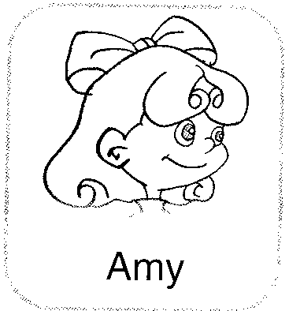
2 | 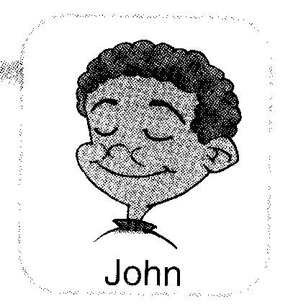 | 
3 |  | 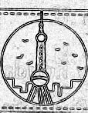 |  | 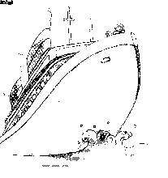
4 |  |  | 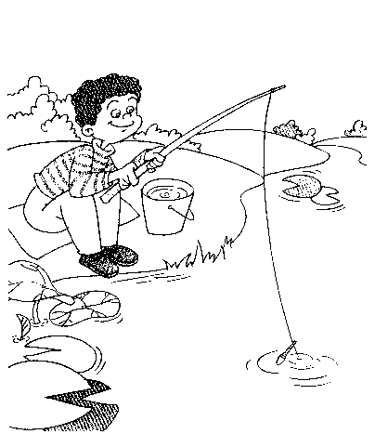 | 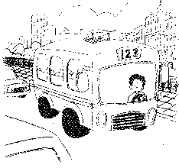

英语听力材料

一、听录音，选出与你所听内容相符的图片，每句听两次。
1、I’m taller than you. I’m 160cm tall.
2、You’re stronger than me. I’m 48 kg.
3、Yesterday I went ice-skating.
4、I feel sick. I have a sore throat.
5、John often cleans his room on Saturday.
6、They went there by plane.
7、My birthday is in March.
8、I will go to the cinema this evening.
9、I’m going to Xinjiang for my holiday.
10、I visited Beijing last Summer.

二、听录音，判断所听内容是否与图片相符，每小段对话听两次。
1、How do you go to a park, Amy? ----I go by bike.
2、What did you do on Sunday, Chen Jie? ----I climbed a mountain.
3、Liu Yun, let’s row a boat together! ----OK!
4、Did you see elephants? ----No, I didn’t. I saw pandas.
5、Did you sing and dance in Xinjiang? ----Yes, we did.

三、听录音，标序号并连线，听两次。
No.1 I’m angry, because I have a fever.
No.2 John is happy. because he ate good food.
No.3 Sarah is bored, because she can’t learn Chinese well.
No.4 Amy is sad, because she has a fever.
No.5 Wu Yifan is tired, because he went hiking.

四、听录音，补全短文，每空一词，全文听三次。
Summer holiday is coming. All of my friends are so excited. They are planning how to spend their holiday. Sarah is going to row a boat. She is going to Hangzhou by bus. Amy is a quiet girl. She doesn’t like sports. She likes going shopping with her parents . They are going to Shanghai by plane. What are you going to do?

英语试卷参考答案

（一）听力部分

一、1、B 2、A 3、B 4、B 5、A
6、A 7、B 8、A 9、A 10、B
二、1、 2、 3、 4、 5、
三、2 5 3 1 4
四、1、holiday 2、excited 3、row 4、parents 5、What

（二）读写部分

一、1、B 2、B 3、A 4、B 5、B
6、B 7、A 8、A 9、C 10、A

二、 singer / policeman / homework / morning exercises / football
hurt / swimming / hospital / grandparents / piano

三、C F G H J B D A I E

四、1、 2、 3、 4、 5、

