辽宁省大连市小学六年级英语下学期期末检测试卷

姓名 班级 分数

A. Listening Part听力部分（40分）

一、听音，在地图上用气象符号画出所听到城市明天的天气情况。（6分）

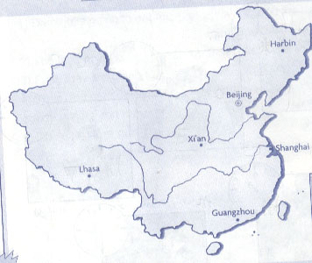
二、听音，把所听到相匹配的问答句连接起来。(15分)

1. What does Simon want to eat? A: She couldn’t see and hear.
2. What’s the weather like? B: Simon’s mum gave it to me.
3. What couldn’t Helen do? C: It’s raining.
4. Who gave the book to you? D: He wants a hot dog.
5. Where was your father born? E: He was born in Dalian.
6. What are the children doing? F: They’re jumping in the water.
7. When are they going to go swimming? G: Because there is a snake.
8. Why is he scared? H: They’re going to go swimming at nine.
9. How is Iris going to go to work? I: She’s going to go to work by bus.
10. Are you going to go to middle school this September? J: Yes, we are.
1--D 2-- 3-- 4-- 5-- 6-- 7-- 8-- 9-- 10--

三、听音，写出所听到物品的价钱。(5分)

 |  |  |  | 
( $___) | ( $___) | ( $___) | ( $___) | ( $___)

四、根据所听短文内容判断下列句子正（T）误（F）。(8分)

1. People lived with dinosaurs. T F
2. There were dinosaurs before people came. T F
3. All dinosaurs were very big. T F
4. There were no small dinosaurs. T F
5. Dinosaurs were planes. T F
6. All dinosaurs ate meat. T F
7. There are dinosaurs now. T F
8. We can see dinosaur bones. T F

五、听音，把所听到歌词中所缺的单词填写在横线上。(6分)

LOOK UP AT THE SPACESHIP
Look up at the spaceship, the spaceship , the spaceship.
Look up at the spaceship flying in the sky.
Shenzhou went into ________. It made a loud sound. It
went to new places and __________ round and round.
_______ inside the spaceship, ________ ______a Chinese man.
I want to meet him and I want to shake his ______.

B. Written Part 笔试部分（60分）

一、根据汉语提示，写出句中所缺的单词或短语 。（10分）

1. The Olympic Game will open on August ,2008 in ______ _______(中国北京).
2. Oh, it’s a very interesting picture! What are those? They are little __ （鸭子）.
3. They made a _______ of ____ ______ _________（中国宇宙飞船的模型）.
4. Which ________ _________(中学) will you go to ? Sorry, I don’t know.
5. Look, the apples are falling down the __________ (楼梯).

二、从ABC三个选项中选择一个正确的答案，将序号写在括号内。(20分)

( ) 1. Hi, Fangfang, don’t worry about it .I can help ______.
A. your B. you C. yours
( ) 2. We are going to _____ at half past twelve.
A. ate B. eat C. tea
( ) 3. Yang Liwei made a video _____ now he is very famous.
A. but B. and C. or
( ) 4. Helen Keller was born in _______ in _______.
A. America…1880 B. England…1880 C. America…1808
( ) 5.Why are you wearing cups ____ your heads?
A. for B. with C. on
( ) 6.It’s easy to make mistakes _____ English.
A. for B. with C. on
( ) 7.A: I’ll _____ you. B: I’ll miss you ,______.
A. miss…two B. miss…to C. miss…too
( ) 8. He is playing the trumpet, but then the telephone _________.
A. ring B. rings C. rang
( ) 9. What’s the matter?
A. 你怎么了？ B.你好吗？ C. 你多大了？
( ) 10. He’s riding ______ bike, _____ it’s starting to rain.
A. his…but B. his…But C. her…but

三、选择正确的动词形式完成下列句子。(10分)

speak / is / fly / couldn’t / took /bought/ has /was /were
1. In America, I ________ some beautiful photos.
2. Helen Keller _________ see and she ________ hear.
3. Look, all the balloons are ___________ away.
4. How much_____ the computer?
5. We are going to_______ English.
6. I _______ a book for you , my son.
7. Xiaogang _______ a very funny day.
8. There _____ a big lake and there _______ lots ducks.

四、阅读理解。

A. 阅读短文，根据短文内容判断下列句子的对（√）错（X）。(10分)
It’s nine o’clock in the morning. Lingling is reading in bed. She doesn’t usually read in bed at nine o’clock in the morning. Usually she gets up at half past six. But today she is ill. She is not getting up this morning. She is going to stay in bed all day. Today her mother is giving her breakfast in bed. She doesn’t usually do this.
( ) 1.Lingling is sleeping in bed at nine o’clock in the morning.
( ) 2.Lingling usually gets up at 6:30 in the morning.
( ) 3.Today Lingling is at home.
( ) 4.Lingling’s mother usually gives her breakfast in bed.
( ) 5.Beacause Lingling is ill , her mother doesn’t go to work.
B. 阅读短文，然后完成文后问题。(5分)
A parrot
A man wanted to give his mother a birthday present. He bought a parrot. The parrot was very expensive. It was $50 000. This was all because the bird could talk in English, Japanese, Chinese and other nine languages. What was more, it could also sing ten famous songs! On her birthday, the mother got the bird. However, she did not know all this. Early the next morning, the telephone rang in her house, and the woman answered. It was her son.
“Do you like the bird, Mother?” there came her son's voice on the other side.
“Oh, yes, very much!” answered the mother. “It was delicious!”
1. Was the parrot expensive or cheap?

2.How much is it?

3.Could it talk in English, Japanese, Chinese and other nine languages?

4.How many famous songs could it sing?

5.Was it dead in the end?

五、根据图片所提供的情景，来描写图片的内容。（5分）

要求: 1.用现在进行时来进行描写，可作适当的发挥；
2.条理清晰,意思明确、连贯,句子通顺,标点正确,书写工整、规范;
3.不少于6句话。
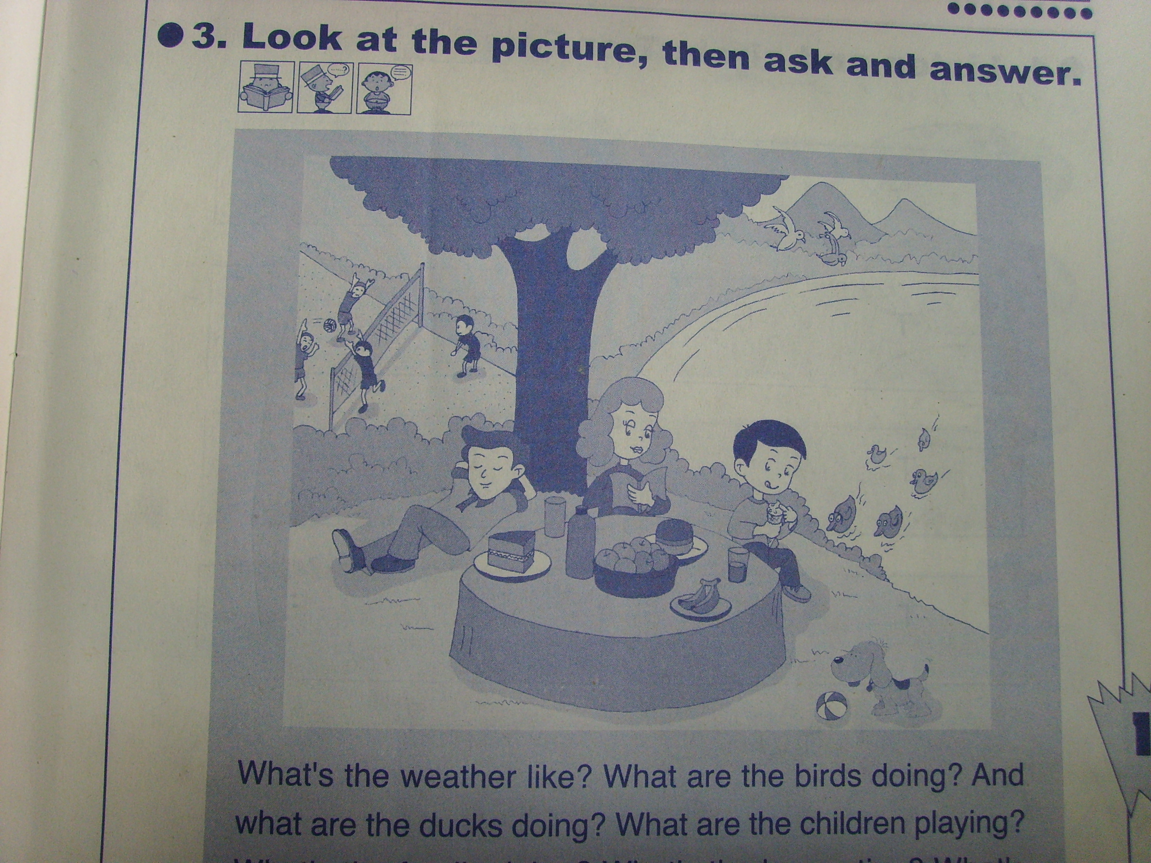

Today is….

