辽宁省大连市庙岭小学六年级英语下学期期末检测试卷

姓名 班级 分数

Listening Part 听力部分（40’）

I. Listen and complete.（听音补全句子）(5’)

1.She couldn’t hear. She was_________ .
2.Yang Liwei spent about 21 hours in ________ . Everyone in China was very ________.
3.I had a very _______ day on Saturday.
4.I’m going to study History, __________, Science,…lots of new things.

II. Listen and choose . (听音选择) （5’）

1. He saw his father in space and he _________ him.
A. is proud of B. was proud of C. are proud of D. were proud of
2. All the balloons _________.
A. flying away B. is flying away C. are flying away D. were flying away
3. I will ________at the party.
A .make a cake B. sing a song C. take photos D. play the trumpet
4. I often _______ in English.
A. make mistakes B. makes mistakes C .making mistakes D. made mistakes
5. She’s going to go to her new school _________.
A. by bike B. by bus C. by car D. on foot

III. Listen and number. (听音标号) （5’）

（ ）Yang Liwei wanted to go into space.
( ) He spent about 21 hours in space.
( ) Then his dream came true.
( ) Everyone in China was very excited and now Yang Liwei is very, very famous.
( ) In October 2003, Shenzhou V flew into space.

IV. Listen and circle “T” or “F” (听并判断正误，圈T或F) （10’）

1.Helen Keller was born in 1890 in England. T F
2.She couldn’t see. But she could hear. T F
3.She could talk. T F
4.Her life was very sad. T F
5.She was a very clever girl and she could learn. T F

V. Listen and number. (听音排序) （15’）

( ) He starts again. He is playing his favourite song and everyone is listening and clapping.
( ) Today is Daming’s birthday. He is having a birthday party.
( ) He stops and everyone waits.
( ) This time, Simon’s dog runs in and now the dog is singing with the trumpet.
( ) Now Daming is playing his trumpet, but then the telephone rings.

Written Part 基础知识与综合运用部分 （60’）

I. Look and write.(看图填单词，完成句子)。（5’）

1.What do you want? I want a h_ _ _ _ _.


2.We were wet, hungry and a_ _ _ _ with the ducks.
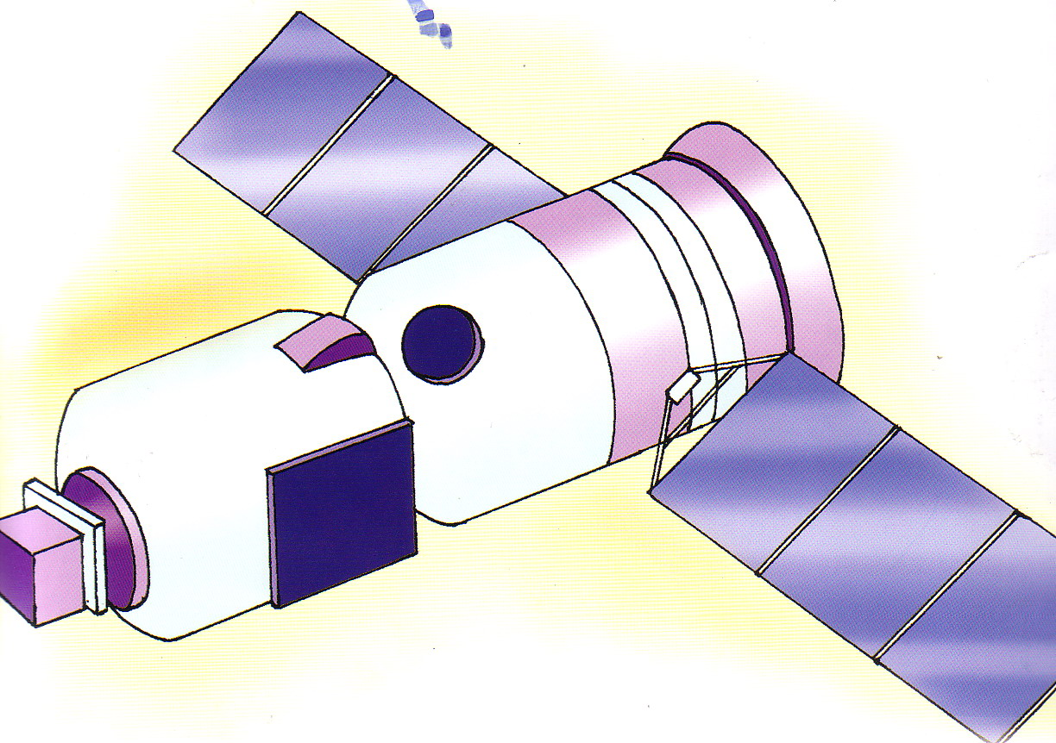

3.They made a Chinese s_ _ _ _ s_ _ _.

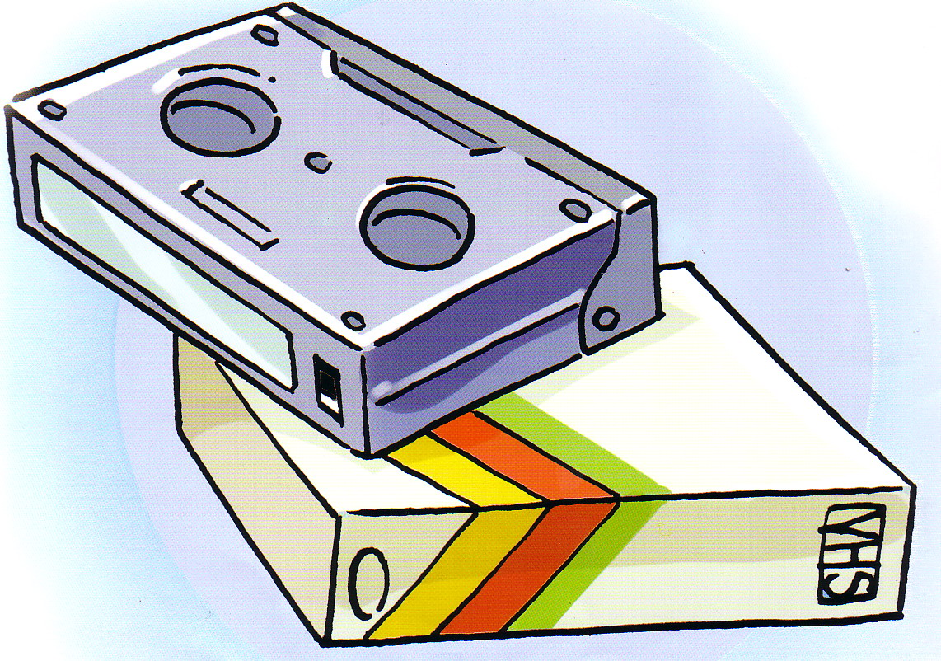
4. I’ve got lots of v_ _ _ _ _ about Chinese music.

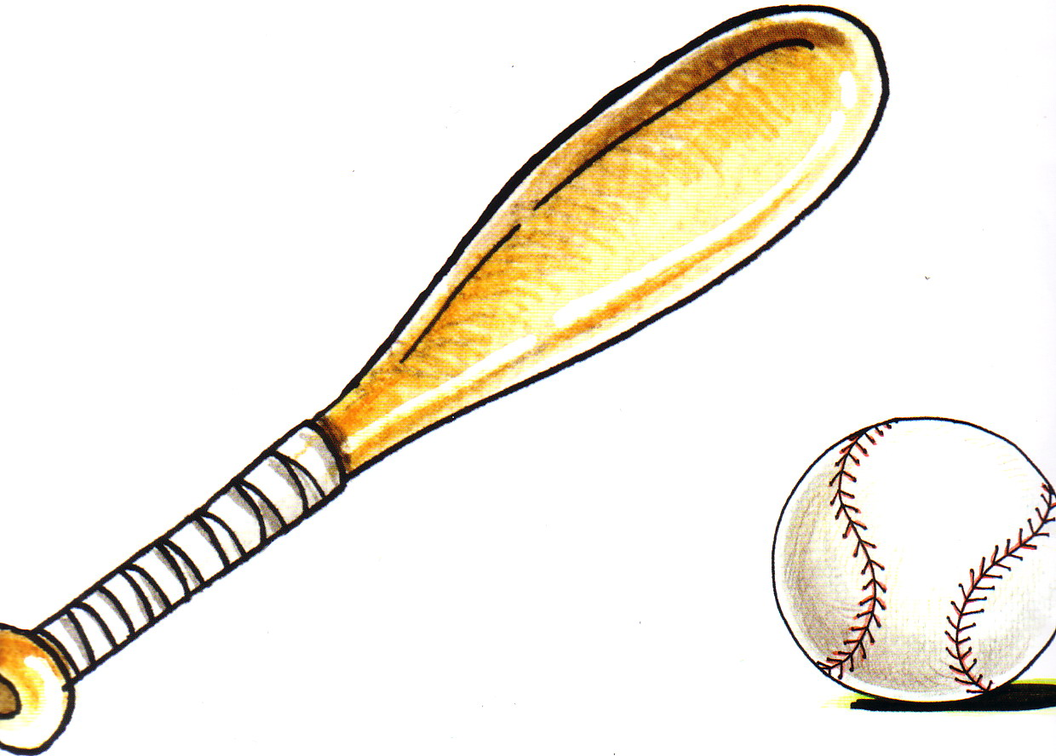
5. We’re going to have a b_ _ _ b_ _ _ match this weekend.

II. Put the word into sentences. (连词成句)。 （5’）

1.you/going/to/are/to/middle school/go/? ___________________________________
2.is/famous/Nikang’s/dad/. ___________________________________
3.name/of/Shenzhou/the/spaceship/is/the/. ___________________________________
4.are/you/why/scared/? ____________________________________
5.a/we/picnic/are/have/going/to/. ____________________________________

III. Read and choose the correct sentences.（选择正确的句子，将序号填入括号里）（10’）

( ) 1.When are we going to eat? _____________
A. At half past twelve. B. Last year. C. Yesterday. D. In 2003.
( )2.How many students are there at the school?________________
A. There is 2500 student. B. There are 2500 students.
C. There is 2500. D. There were 2500.
( )3. ______________ It’s 6 dollars in all.
A. How many? B. How much is it? C. How can I do ? D. What’s the matter?
( )4.What’s the weather going to be like tomorrow?
A. It’s sunny. B. It rains. C. It going to be windy. D. It’s going to be cloudy.
( ) 5.She was blind. ______________
A. She could see B. She couldn’t see. C. She could hear. D. She couldn’t hear.

IV. Read and choose the correct answer. (读一读，选择正确的句子。)10’

( )1._________? I want a cola.
A.What do you want to eat? B. What do you want to drink? C. What’s the matter?
( )2. I had a very funny day. I went to a park . ________________.
A. There are lots of ducks. B. There is a big lake. C. There were lots ducks.
( )3.A: Why are you laughing? B: _____________
A.Because I’m sad. B. Because I’m ill. C. Because I’m angry. D. Because I’m happy.
( )4. A: ______________ B: Your mum gave it to me.
A.Who gave it to you? B. Who gave it to me C. What did you do?
( )5._____________ Because there is a snake.
A. Why are you laughing? B. Why is it here? C. Why are you scared?
( )6._______________ to tell her story.
A. Helen went around the world B. Helen went to the world C. Helen walked to the world.
( )7.A:______________________ B: Sorry, I can’t. I’m doing my homework.
A. Can I help you? B. Who can help me? C. What can I do for you?
( )8.___________________. So I’ve got lots of books about space travel.
A. I’m interested in English. B. He’s interested in Chinese. C. I’m interested in space travel. ( )9.When was he born? ____________________
A. He was born in America. B. He was born in 1978. C. He was born in the hospital.
( )10. In this photo, _____________________
A. We’re haveing our picnic. B. We’re having our picnic. C. We having our picnic.

V. Read, then circle.(读短文判断，圈出T或F)( 10’)

I had a very funny day on Sunday. I went to a park with my friends. We took lots of food and we wanted to have a picnic. There was a big lake in the park and there were many ducks. We took some photos together. We had a good time that day.
1. I had a funny day on Saturday. T F
2. I went to a park with my friends. T F
3. We wanted to have a baseball match in the park. T F
4. There was a small lake and there were lots of ducks. T F
5. We took some photos. T F

VI. (15’)
1.Look, then circle.( 读短文判断，圈出T或F)(5’)

There is a boy at Zhongguancun No.1 Primary School in Beijing. His name is Ningkang. Ningkang has a very famous dad. It is Yang Liwei. Yang Liwei spent about 21 hours in space in October 2003. So Yangliwei is famous in the world. Ningkang loves writing. He wrote a story about his dad. The story was in the newspapers. He wants to go into space too someday.

1.Ningkang is at Zhongguancun No.1 Primary School. T F
2.Yang Liwei spent about 21 hours in space in September 2003. T F
3.Ningkang loves singing. T F
4.Ningkang wrote a story about his dad. T F
5.The story wasn’t in the newspaper. T F

2.Read then fill in the blanks.(阅读并填空)（10’）
Dear Peter,
How are you? I’m going to start a new school. I’m going to study at Qibao Middle School. It’s near my home. I’m going to study History, Science, Geography and other new things. I like Physics and Chemistry, and I am going to be a scientist when I grow up. Are you going to start middle school? What subjects are you going to study?
Yours,
Li Ming

1.Li Ming writes this letter to ________________.
2.Li Ming is going to___________________.
3.Li Ming is going to study at _____________________.
4.He is going to study____________________ and other new things.
5.He likes Physics and Chemistry, and he wants to be _________________.

VII.小作文（至少写5句）5

自选其中一个题目，完成小练笔。注意语句要通顺，书写要工整啊。
1．Where are you? What are you doing? What are the people around you doing?
2. My Last Weekend

听力材料

I. Listen and complete.（听音补全句子）
1. 1.She couldn’t hear. She was deaf.
2. Yang Liwei spent about 21 hours in space. Everyone in China was very excited.
3. I had a very funny day on Saturday.
4. I’m going to study History, Geography, Science,…lots of new things.

II. Listen and choose . (听音选择)
1. He saw his father in space and he is proud of him.
2. All the balloons are flying away.
3. I will take photos at the party.
4. I often make mistakes in English.
5. She’s going to go to her new school by bus.

III. Listen and number. (听音标号)
No.1 In October 2003, Shenzhou V flew into space.
No.2 Yang Liwei wanted to go into space.
No.3 Then his dream came true.
No.4 He spent about 21 hours in space.
N0.5 Everyone in China was very excited and now Yang Liwei is very, very famous.

IV. Listen and circle “T” or “F” (听并判断正误，圈T或F)
Helen Keller was born in 1880 in America. She was blind. So she couldn’t see. She was
deaf.So she couldn’t hear. And she couldn’t talk. Her life was very sad.. But she was a very
clever girl and she could learn.

V. Listen and number. (听音排序)
Today is Daming’s birthday. He is having a birthday party. Now Daming is playing his trumpet,
but then the telephone rings. He stops and everyone waits. He starts again. He is playing his
favourite song and everyone is listening and clapping. This time, Simon’s dog runs in and now
the dog is singing with the trumpet.

